EECS 498-007 Deep Learning for Computer Vision

Contents

Lecture 1 – Introduction 6

Lecture 2 – Image Classification 7

Challenges 7

Data-driven approach 7

*Collect a dataset of images and labels* 8

*Use machine learning to train a classifier – E.g. Nearest Neighbour Classifier* 9

Lecture 3 – Linear Classifiers 12

The Algebraic Viewpoint 12

The Visual Viewpoint 13

The Geometric Viewpoint 13

Loss Functions 14

Cross-Entropy Loss 14

Multiclass Support Vector Machine (SVM) Loss 15

Regularisation 16

Motivation 16

Implementation 16

Lecture 4 – Optimisation 18

Numeric Gradient 18

Analytic Gradient 19

Gradient Descent 19

Batch Gradient Descent (or Full Batch Gradient Descent) 19

Minibatch Gradient Descent / Stochastic Gradient Descent 19

Second Order Optimisation 23

Lecture 5 – Neural Networks 25

Feature Transforms 25

Image Features: Color Histogram 26

Image Features: Histogram of Oriented Gradients (HoG) 26

Image Features: Bag of Visual Words (Data-Driven!) 26

Image Features: Continued 27

Neural Networks 28

Activation Functions 29

Universal Approximation Theory 30

Convex Functions 30

Lecture 6 – Back Propagation 32

Derive gradients on paper 32

Computational Graphs 32

Patterns in Gradient Flow 33

Backprop Implementation: “Flat” gradient code 34

Backprop Implementation: Modular API 34

Vector and Tensor Backpropagation 35

Vector Backpropagation 36

Tensor Backpropagation 37

Automatic Differentiation 38

Higher-order Derivatives 38

Lecture 7 – Convolutional Networks 39

Convolution Layer 39

Receptive Fields 41

Convolution Output Size 41

1x1 Convolution – Pointwise Convolution 41

1D and 3D convolution 42

Convolution Layer Summary 42

Pooling Layers 42

Pooling Summary 43

Example Conv. Network – LeNet-5 44

Normalisation 44

Batch Normalisation – Fully Connected Networks 45

Batch Normalisation – Convolutional Networks 46

Batch Normalisation – Uses and Summary 47

Layer Normalisation + Instance and Group 47

Lecture 8 – CNN Architectures I 49

AlexNet (Winner 2012) 49

Calculating Memory, Num. Parameters, and FLOPs 50

ZFNet (Winner 2013) – A Bigger AlexNet 51

VGG (Runner-up 2014) – Deeper Networks, with Regular Design 51

GoogLeNet (Winner 2014): Focus on Efficiency 51

Stem Network 51

Inception Modules 52

Global Average Pooling 53

Auxiliary Classifiers 53

Residual Networks (Winner 2015) 53

Motivation and Residual Blocks 53

Residual Networks – ResNet-18 and ResNet-34 54

Bottleneck Blocks – ResNet-50, ResNet-101, and ResNet-152 55

Improving ResNet Block Design 56

Summary 57

Lecture 9 – Training Neural Networks I 58

One-time Setup 58

Activation Functions 58

Data Preprocessing 63

Weight Initialisation 66

Regularisation 68

Lecture 10 – Training Neural Networks II 74

Training Dynamics (i.e. during training) 74

Learning Rate Schedules 74

Choosing Hyperparameters 77

NOTE: Ratio of Weight Update to Weight Magnitude 81

After Training 81

Model Ensembles 81

Transfer Learning 82

Lecture 11 – CNN Architectures II 84

Model Ensemble (Winner 2016) – Inception, Inception-ResNet, ResNet, Wide ResNet 84

ResNeXt (2017) 84

Grouped Convolution 86

ResNeXt Performance 87

Squeeze-and-Excitation Networks (SENet) (Winner 2017) 88

Tiny Neural Networks for Mobile Devices 88

MobileNets 88

ShuffleNet 90

Neural Architecture Search (NAS) 91

Model Scaling 92

EfficientNets 92

NFNets – Normaliser-free ResNets 93

Scaled Residual Blocks 93

Weight Standardisation 94

NFNets: Other Tricks 94

ResNets: Revisited 95

ResNet-RS: Rescaled ResNets 95

RegNets 95

CNN Architectures Summary 96

Lecture 12 – Deep Learning Hardware & Software 98

GPU Hardware 98

CUDA Cores 98

Tensor Cores 98

CUDA Language 99

Deep Learning Frameworks 99

PyTorch 99

TensorFlow 100

Lecture 13 – Object Detection 101

Bounding Boxes 101

Intersection over Union (IoU): Comparing Bounding Boxes 102

Detecting a single object 102

Detecting Multiple Objects 103

Sliding Window 103

Region Proposals 103

Overlapping Boxes: Non-Maximum Suppression (NMS) 105

Evaluating Object Detectors: Mean Average Precision (mAP) 106

Lecture 14 – Object Detectors 109

Fast R-CNN (2015) 109

Cropping Image Features 110

Fast R-CNN vs “Slow” R-CNN 113

Faster R-CNN (2015): Learnable Region Proposals 113

Region Proposal Network (RPN) 113

Faster R-CNN Performance 115

Two-Stage Detectors 115

Dealing with Scale 115

Image Pyramid 116

Multiscale Features 116

Feature Pyramid Network (FPN) 117

Single Stage Detectors 117

RetinaNet (2017) 117

FCOS (2019): Fully Convolution One-Stage 118

Lecture 15 – Image Segmentation 120

Semantic Segmentation 120

Sliding Window 121

Fully Convolutional Network 121

Instance Segmentation 125

Mask R-CNN (2017) 126

Beyond Instant Segmentation: Panoptic Segmentation 127

Beyond Instance Segmentation: Human Keypoints 128

Beyond Instance Segmentation: Dense Captioning 129

Beyond Instance Segmentation: 3D Mesh Prediction 129

Lecture 16 – Recurrent Networks 130

# Lecture 1 – Introduction

Some basic definitions:

* *AI*: a set of technologies that allow computers to perform tasks that typically required human intelligence.
* *Computer Vision*: building artificial systems that process, perceive, and reason about vision data.
* *Machine Learning*: building artificial systems that learn from data and experience.
* *Deep Learning*: hierarchical learning algorithms with many “layers”, (very) loosely inspired by the brain.
* Not all AI is based on machine learning, “*symbolic AI*” or “*Good Old-Fashioned AI (GOFAI)*” mainly relies on explicitly programmed rules and logic to behave like a human.

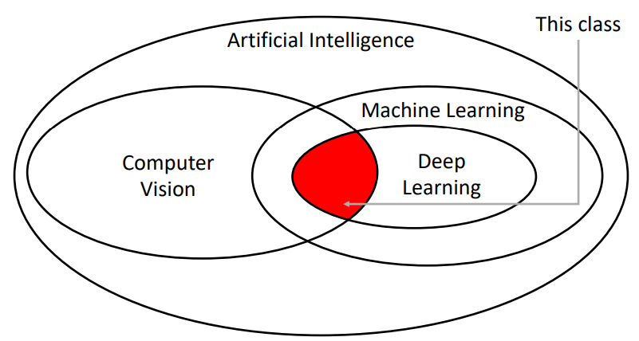Below is a Venn diagram illustrating the taxonomy of the above fields, and highlighting the area which the following notes cover:

# Lecture 2 – Image Classification

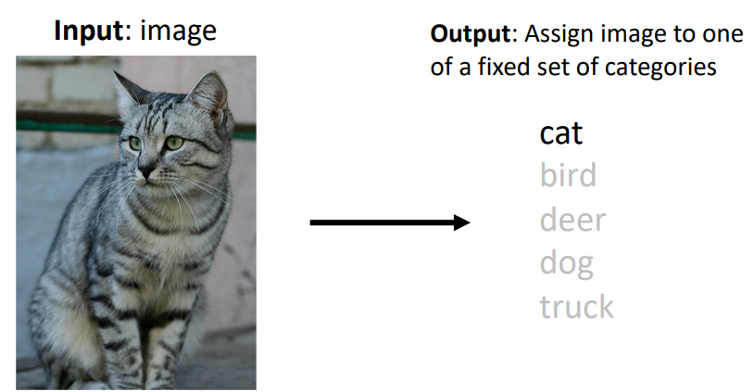Image classification is a core computer vision task, where the goal is to assign a label from a fixed set of categories to an input image. An RGB colour input image is simply some 3D array of red, green, and blue intensity values.

## Challenges

Whilst image classification is relatively trivial for people, there are many challenges involved with developing an image classification algorithm, including but not limited to:

* Viewpoint variation: Even a slight shift in the camera’s position will change all the pixel values in the image.
* Fine-grained categories: e.g. There are many different breeds of cats with different appearances.
* Intraclass variation: e.g. cats of the same breed still look different to one another due to their unique markings.
* Background clutter: Objects may blend into their background, making them hard to identify.
* Illumination conditions: The exact same scene with different lighting conditions produces a completely different image array.
* Deformation: Many objects are not rigid bodies and can be deformed in extreme ways.
* Occlusion: Sometimes only a portion of the object is visible.
* Scale variation: Objects exist as different sizes both in the real-world and in terms of their extent in the image.

## Data-driven approach

Whilst it may technically be possible to write an algorithm that encodes some of the techniques humans use to identify cats for example (e.g. extract edges, then search edges for pointy ears, whiskers, etc.), this approach is brittle and not easily adapted to classify different classes of images. Instead, we can use a **data-driven approach**, where we:

1. Collect a dataset of images and labels
2. Use machine learning to train a classifier
3. Evaluate the classifier on new images

### *Collect a dataset of images and labels*

Some commonly used image classification datasets include:

* 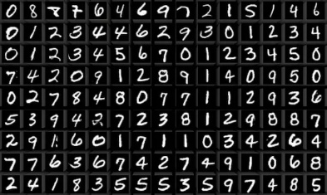MNIST – a dataset of handwritten digits
  + Classes: 10, digits 0 to 9
  + Image size: 28x28 grayscale
  + Num. training: 50k
  + Num. test: 10k
  + Sometimes called the “drosophila (fruit fly) of computer vision” due to it being a simple baseline. **Results from MNIST often do not hold for more complex datasets.**
* 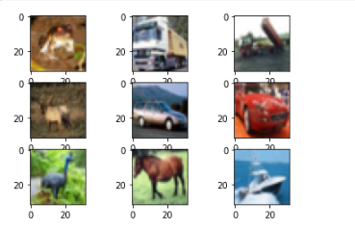CIFAR10
  + Classes: 10, e.g. airplane, automobile, cat, deer, dog
  + Image size: 32x32 RGB
  + Num. training: 50k
  + Num. test: 10k
* CIFAR100
  + 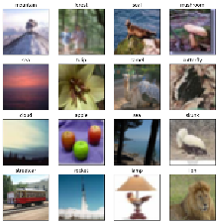Classes: 100, with 20 “superclasses” e.g. aquatic mammals, trees, etc.
  + Image size: 32x32 RGB
  + Num. training: 50k
  + Num. test: 10k
* 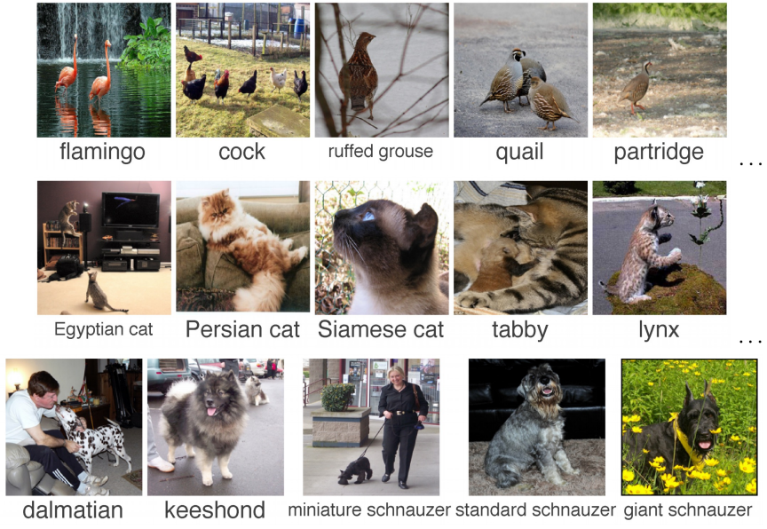ImageNet
  + Classes: 1000
  + Image size: Variable, often resized to 256x256 for training
  + Num. training: ~1.3M
  + Num. validation: 50k
  + Num. test: 100k
  + Due to the large number of classes, the **Top 5 accuracy** is often used as the performance metric, where the algorithm predicts 5 labels for each image and one of them needs to be right
  + Often still used as the standard for benchmarking a classification model, however, it can be expensive to train on.
* 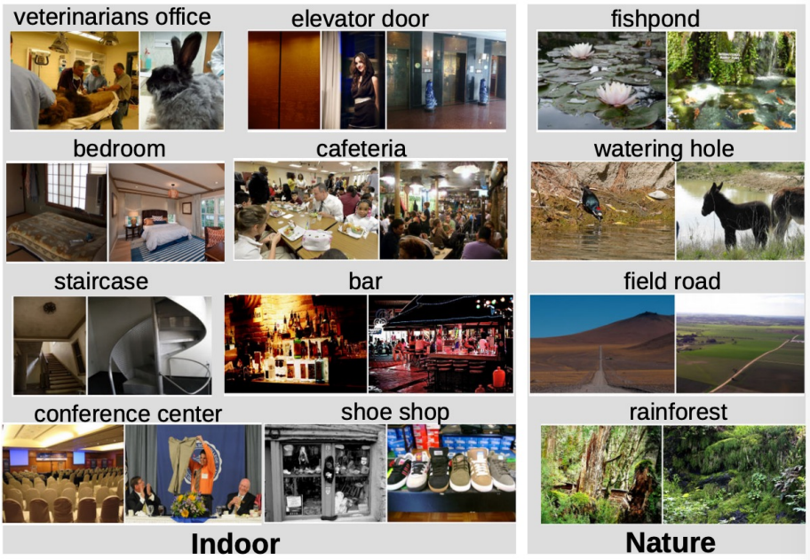MIT Places
  + Classes: 365, scenes like “bedroom”, “bar”, “rainforest”
  + Image size: Variable, often resized to 256x256 for training
  + Num. training: ~8M
  + Num. validation: 18.25k
  + Num. test: 328.5k
  + Like ImageNet but with scenes rather than objects
* Omniglot
  + Classes: 1623, characters from 50 different alphabets
  + Image size: 105x105
  + Num.: **Only 20 images per category**
  + Used to test few-shot learning

### *Use machine learning to train a classifier – E.g. Nearest Neighbour Classifier*

The Nearest Neighbour Classifier simply takes a test image and compares it to every single one of the training images, and returns the label of the closest training image. This makes training very quick (O(1) for simply copying pointers) and testing very slow (O(n) to compare against every image in the training set). This is **bad**.

There are many methods for fast / approximate nearest neighbours, [example](https://github.com/facebookresearch/faiss).

We can use different distance formulas to compare two different images, to provide different results. For example, the L1 distance is:

$$d_{1}\left(I_{1},I_{2}\right)=\sum_{p}{\left|I_{1}^{p}-I_{2}^{p}\right|}$$

Where the sum is taken over all of the pixels $p$.

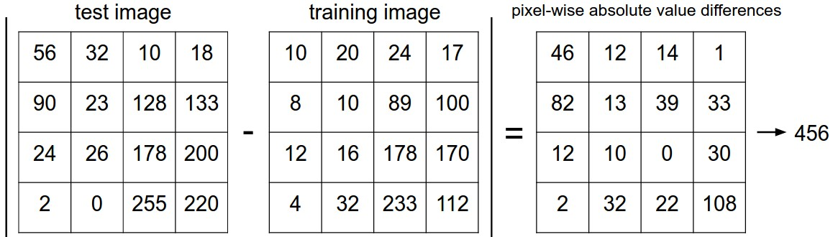Visually, the L1 distance procedure is:

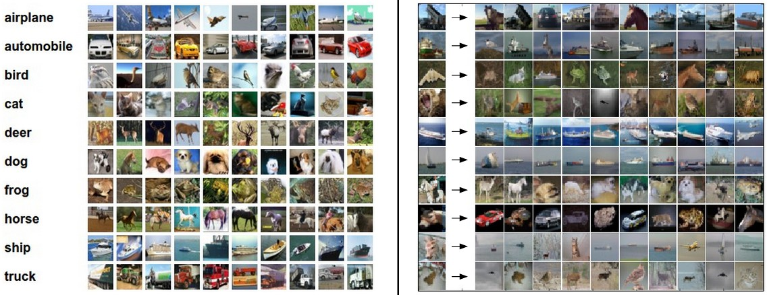An example is given below for test images in the left-hand column, the top 10 nearest neighbours are returned. Notice that while the nearest neighbours are visually similar, they’re not the correct class most of the time.

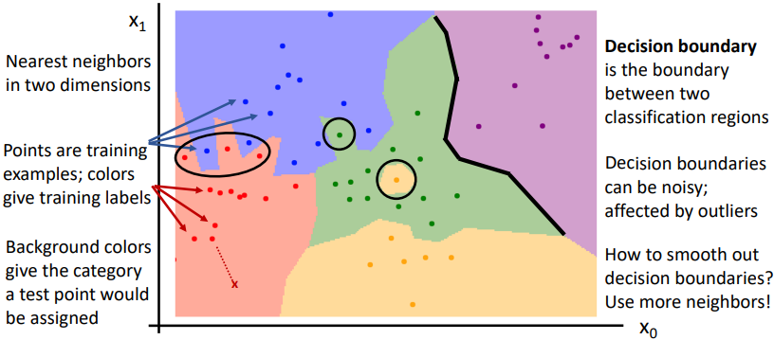If you plot the regions which are closest to the training examples and then colour them according to their training label, you can visualize the **decision boundaries**.

Instead of finding the nearest single neighbour, you can take a majority vote from the K closest points. For example, K=3 means you find the closest 3 images in the training set to the test image and then take the majority vote to classify the test image. This is referred to generally as **k Nearest Neighbour** (**kNN**). Using more neighbours helps to smooth decision boundaries and reduces the effect of outliers.

The **L2 (Euclidean) distance** is another choice for the distance calculation:

$$d_{2}\left(I_{1},I_{2}\right)=\sqrt{{\sum_{p}{\left(I_{1}^{p}-I_{2}^{p}\right)}}^{2}}$$

#### Hyperparameters – What is the best K value, what distance metric do I use?

Selecting a K value and the distance metric for the Nearest Neighbour Classifier Hyperparameters are very problem dependent. Outlined below is the common train-validation-test method for choosing hyperparameters and then evaluating the model:

1. The model is trained on the training set
2. Its performance is tested on the validation set
3. Steps 1 and 2 are repeated with differing hyperparameters
4. The model that performs the best on the validation set is then tested on the test set. No changes should be made based on the performance on the test set (to avoid contamination of the data).

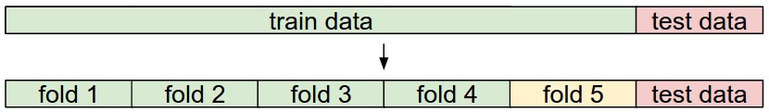**K-fold cross validation** extends this idea by first separating the test set, and then splitting the remaining data into training and validation sets in k different ways. The steps are then the same as before, except the model’s performance is the average of its performance on each validation fold.

#### The Problem with the Nearest Neighbour Classifier

As the number of training samples goes to infinity, the Nearest Neighbour Classifier can represent any continuous function! (If the number of training samples was infinite, any test sample would also be in the training set). *However, the number of training samples that you need for a dense coverage of the sample space increase exponentially with dimension*. For example, the number of possible 32x32 binary images is:

$$2^{32×32}≈{10}^{308}$$

Clearly, having enough training samples to give good results for even very small binary images is impossible.

Therefore, Nearest Neighbour Classifiers are seldom used on raw pixels. **They do however work well on ConvNet features**.

# Lecture 3 – Linear Classifiers

Many machine learning models take a parametric approach to classifying images by defining some function $f$ that takes in the **image $x$** and a matrix of **parameters $W$** to output a vector of **scores** that represent the classifier’s prediction for each class. Arguably the most simple function, as used in a **linear classifier**, is a linear mapping:

$$f\left(x_{i},W,b\right)=Wx_{i}+b$$

Where, using the CIFAR10 dataset with 32x32x3 sized images as an example:

* $f\left(x_{i},W,b\right)$ outputs a vector equal in size to the number of classes $\left(10,1\right)$
* The weights matrix $W$ therefore, has size $\left(10, 32×32×3\right)=\left(10, 3072\right)$
* And the **bias** vector has size $\left(10,1\right)$

There are three common different viewpoints we can use to view the linear classifier:

* The algebraic viewpoint
* The visual viewpoint
* And the geometric viewpoint

## The Algebraic Viewpoint

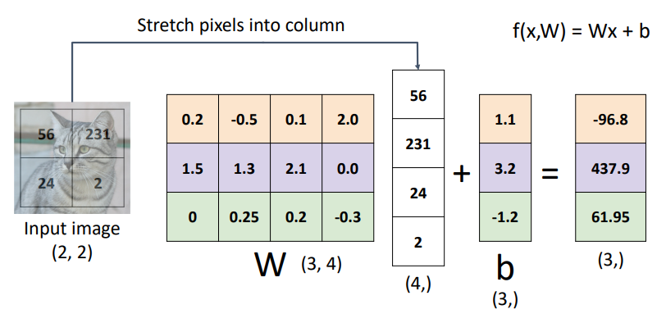Using a simple $2×2$ grayscale image to be classified as one of three classes as an example. The weights matrix $W$ has size $\left(3, 4\right)$ and the bias vector has size $\left(3, 1\right)$. We can see below that each row of $W$ and $b$ are effectively their own classifier in parallel, one for each class.

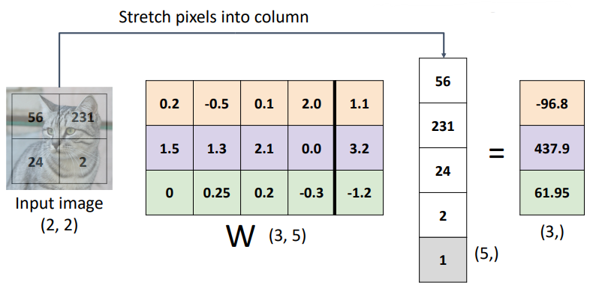Note: a common trick known as the **bias trick** can be used to combine the bias terms into the weights matrix as an additional column, as long as the input vectors are appended with a $1$, as shown below:

## The Visual Viewpoint

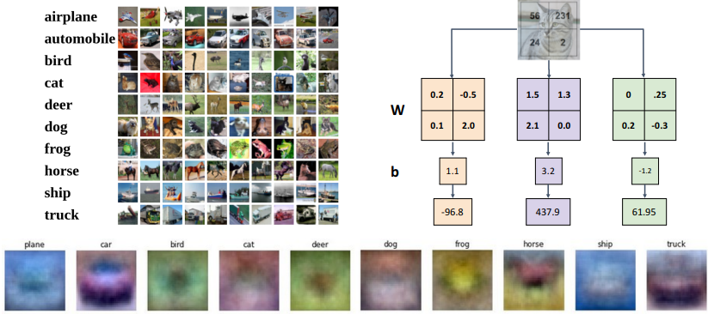Instead of stretching the pixels of the image into a column, we can imagine reshaping each row of the weights matrix $W$ into an image! After training the linear classifier, each of these rows is essentially a learned “template” to be used for matching against its corresponding class. You can actually plot each row of the weights matrix $W$ as an image to visualize what the learned “templates” look like, as seen at the bottom of the image below.

In this way, a linear classifier can be thought of in a similar manner to a kNN Classifier, except the test image is compared to only a single “template” learned from the dataset instead of every dataset image directly, and the negative of the inner product is used as the distance instead of the L1 or L2 distance.

## The Geometric Viewpoint

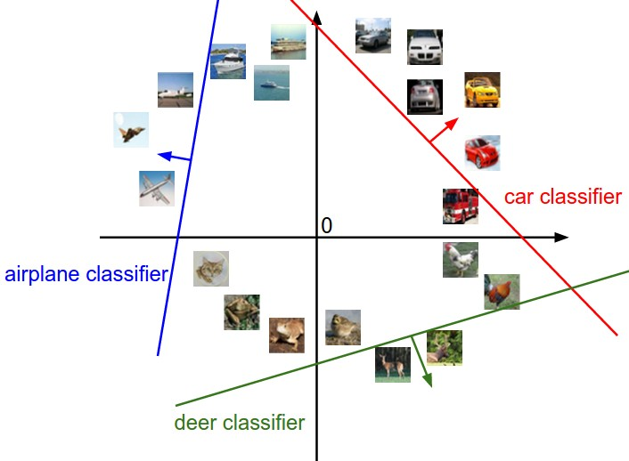Since CIFAR10 images are represented by 3072 values, we can image each image in our dataset as a point in a 3072-dimensional space. Each class score of a linear classifier is then a linear function over this space, providing some score for each possible 3072-dimensional image.

The above is an imagining of this 3072-dimensional space as a 2D plot. The red line shows all of the points in the plot which get a score of zero for the car class, whilst the red arrow shows the direction of increase, so all points to the right have linearly increasing scores.

As we saw above, every row of $W$  is a classifier for its corresponding class. The geometric interpretation of these rows is that as we change them, the corresponding line in the pixel space will rotate. The biases $b$ , on the other hand, allow our classifiers to translate the lines. In particular, if we do not include any bias terms, plugging in $x_{i}=0$  would always give a score of zero regardless of the weights, so all lines would be forced to cross the origin.

## Loss Functions

So far, we have described the weights matrix $W$ and the bias vector $b$, but how do we quantify how good our $W$ and $b$ are for our classification task? A loss function (also called an objective function or cost function) tells us how good our current classifier is. A high loss indicates poor performance.

For a single sample in our dataset $\left(x_{i}, y_{i}\right)$ where $x_{i}$ is the image and $y_{i}$ is the known label, the loss is some function $L_{i}$:

$$L_{i}\left(f\left(x_{i},W\right),y_{i}\right)$$

And the loss for the dataset is the average of the per-example losses:

$$L=\frac{1}{N}\sum_{i}{L_{i}\left(f\left(x_{i},W\right),y_{i}\right)}$$

### Cross-Entropy Loss

Cross-entropy (CE) loss is used in multinomial (multiple classes) logistic (i.e. classification) regression when we want to interpret raw classifier scores as probabilities. We use the **softmax** function to take our output score vector of arbitrary real-valued numbers and transform them to an output vector of values between 0 and 1 that sum to 1. These output values can be interpreted as probabilities, representing the classifier’s confidence in each class being the correct classification.

For the output scores of a linear classifier $s=f\left( x_{i},W\right)$, softmax $P$ for class $k$ is defined as:

$$P\left(Y=k | X=x_{i}\right)=\frac{\exp{s_{k}}}{\sum_{j}{\exp{s_{j}}}}$$

The **cross-entropy loss** is then defined as the negative log of the softmax’s output for the correct class, i.e;

$$L_{i}=-\log{P\left(Y=y_{i} | X=x_{i}\right)}$$

* What is the minimum and maximum possible loss $L_{i}$?
  + Minimum: $0$ when $P\left(Y=y_{i} | X=x_{i}\right)=1$
  + Maximum $∞$ as $P\left(Y=y_{i} | X=x_{i}\right)→0$
* If all scores are small random values upon initialization, what loss can we expect?
  + We expect the softmax output probabilities to be approximately equal. Therefore, for $C$ number of classes:
 $$L_{i}=-\log{P\left(Y=y_{i} | X=x_{i}\right)}=-\log{\frac{1}{C}}=\log{C}$$

 + For 10 classes in the CIFAR10 dataset, we can expect the initial CE loss to be $L_{i}=\log{10}≈2.3$

### Multiclass Support Vector Machine (SVM) Loss

SVM loss “wants” the correct class for each image to have a score higher than the incorrect classes by some fixed margin $Δ$. The multiclass SVM loss for the $i$-th image in the dataset is defined as:

$$L_{i}=\sum_{j≠y_{i}}{\max\left(0, s_{j}-s_{y_{i}}+Δ\right)}$$

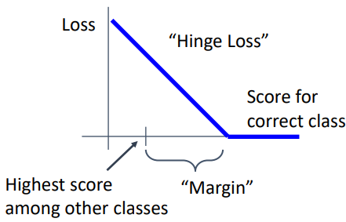This type of loss function is also referred to as **hinge loss** and can be visualized as:

* What is the minimum and maximum possible loss $L_{i}$?
  + Minimum: $0$ when $s_{j}-s_{y_{i}}>Δ$
  + Maximum $∞$
* If all scores are small random values upon initialization, what loss can we expect?
  + We expect the scores to also be random, so the differences between them should be approximately zero. Therefore, for $C$ number of classes, we sum $C-1$ lots of $Δ$:

$$L_{i}=\left(C-1\right)Δ$$

## Regularisation

### Motivation

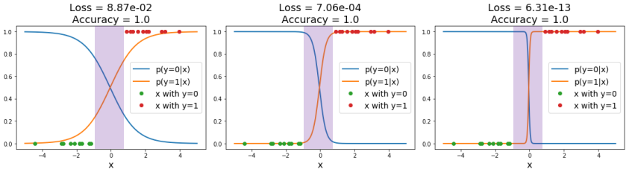Loss functions encourage good performance on *training data* but ultimately, we really care about *test data*. We say a model is **overfit** when it performs too well on the training data and has poor performance on unseen data. For example, the below three plots show the same training data in green and red, and the models’ predicted scores for the two classes in orange and blue respectively. The rightmost model has the lowest loss, but it is way too confident in the purple region with no training data, which can lead to poor generalisation on unseen data.

Additionally, if using SVM loss it is possible to have many different weights matrices $W$ and bias vectors $b$ which give the exact same loss. How do we differentiate between these models?

### Implementation

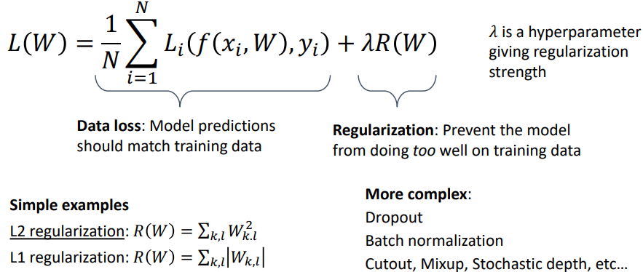We can add an additional term to our loss function to express preferences about the weights $W$ and to prevent our model from doing *too* well on the training data:

#### Expressing Preferences

Regularisation allows us to penalise model behaviours that we consider undesirable. For example:

* If we have the input $x=\left[1, 1, 1, 1\right]$
* and two different weights matrices $w_{1}=\left[1, 0, 0, 0\right]$ and $w_{2}=\left[0.25, 0.25, 0.25, 0.25\right]$
* both models give the same prediction: $w_{1}^{T}x=w_{2}^{T}x=1$, so data loss will always be the same.
* However, model 1 only uses the first input dimension and completely disregards the other dimensions.
* If we use L2 regularisation, which sums the square of each weight and adds this to the loss while training, we can encourage the weights to be smaller and more spread out.

#### Preventing overfitting

Penalising large weights also tends to improve generalisation, as no input dimension can have a disproportionately large influence on the scores.

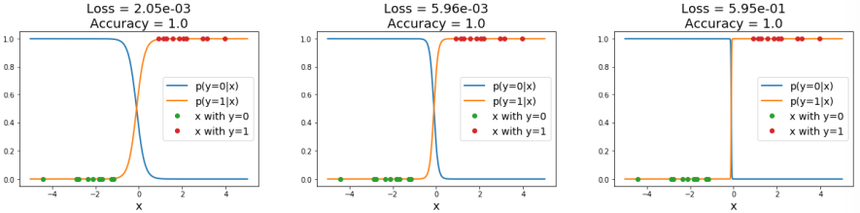For example, using L2 regularisation on the previous classification example causes loss to actually *increase* for the overfit model.

Note that biases do not have the same effect since, unlike the weights, they do not control the strength of influence of an input dimension. Therefore, it is common to only regularize the weights $W$  but not the biases $b$ . However, in practice this often turns out to have a negligible effect.

# Lecture 4 – Optimisation

Very generally, the process of optimisation usually refers to finding the weights $W$ that minimize the loss function $L$, i.e. the optimal weights $W^{*}$ are:

$$W^{*}=\arg{\min_{W}{L\left(W\right)}}$$

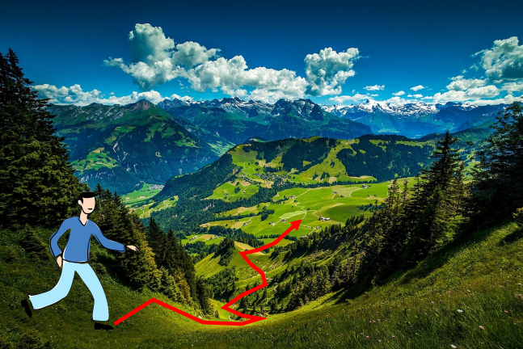And a common way to visualize the search for these optimal weights is traversing a high dimensional landscape to find the lowest valley. We are doing this with no sight, i.e. no way to determine $W^{*}$ from afar, but we can feel around our local position for information.

By feeling around our local position, we can determine the direction of steepest decent and then traverse down that direction and then repeat for each step we take. Functionally this is equivalent to calculating the derivative of the loss function with respect to the weights $\frac{dL}{dW}$, and then moving in the negative direction of the gradient.

## Numeric Gradient

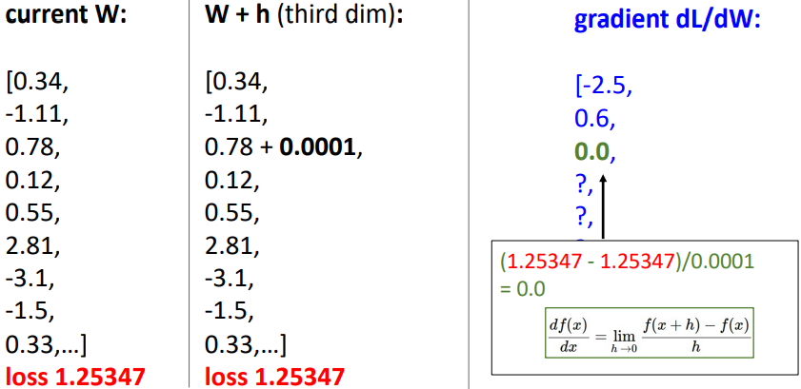A naïve approach to calculating $\frac{dL}{dW}$ is to perturb each element in $W$ by a small amount and then determine the change in loss, then use rise-over-run to approximate the derivate for that element of $W$, repeating for all elements in $W$. This approach is **slow** (O(n-dimensions)) and **approximate**.

## Analytic Gradient

Alternatively, we can use calculus to actually compute the analytic gradient based on the model and the formula of our selected loss function and regularisation technique. This method is **exact**, **fast**, but can be **error-prone** due to needing to calculate the derivatives analytically.

In practice, we should always use analytic gradient, but we should check our implementation using the numerical gradient. This is called a **gradient check**.

## Gradient Descent

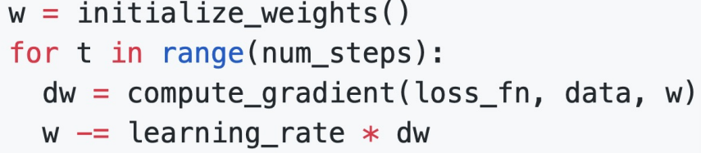The method described above of “feeling around our local position” and then iteratively stepping in the direction of steepest descent (i.e. the negative gradient) is known as **gradient descent**. The basic vanilla function looks like:

Where the weight initialisation method, number of steps, and learning rate are all hyperparameters.

### Batch Gradient Descent (or Full Batch Gradient Descent)

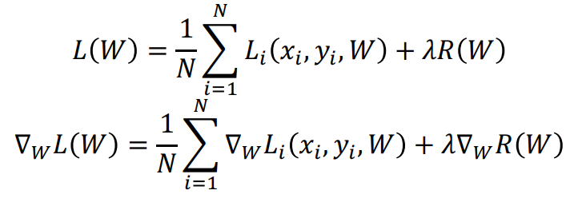Recall that our loss at each step is the average of the loss of the model on the entire training set. Then the gradient of the loss with respect to the weights is the average of the gradients on the entire training set. That is:

This can be very expensive and impractical when the training set is very large. Do we need to calculate the gradient on every single training data point?

### Minibatch Gradient Descent / Stochastic Gradient Descent

Stochastic Gradient Descent approximates the gradient at each step by using a **minibatch** of examples, commonly 32, 64, 128, or 256 (technically SGD only refers to the case where the minibatch is a single example, however people now commonly use it to refer to minibatch 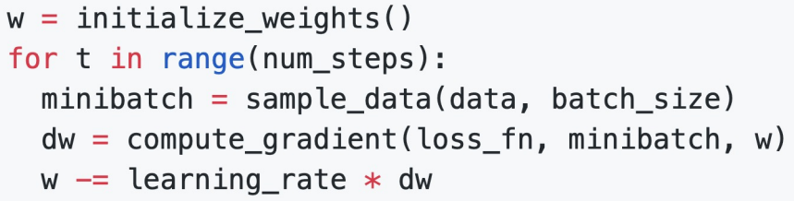gradient descent). The basic function looks like:

Where the batch size and sampling method are additional hyperparameters.

Training is generally not super sensitive to batch size, and in practice you generally make the batch size as big as you can fit on the GPU(s).

There are some problems with the above implementation of SGD however:

* If the loss changes quickly in one dimension and slowly in another, there is unlikely to be an optimum step size which doesn’t cause very slow progress along the shallow dimension and oscillations along the steep direction. Note: this is usually indicated by a high **condition number**, the ratio of largest to smallest singular value of the Hessian matrix.
* The SGD algorithm can get stuck at points where the gradient is zero, at:
  + Local minimums, where the loss function curve curves upwards in all directions. These are rare in very high dimensional space.
  + Saddle points, where the loss function curve curves upwards in some directions and downwards in others. Much more common in very high dimensional space.
* The gradients are approximations from minibatches so they can be noisy

#### Stochastic Gradient Descent + Momentum

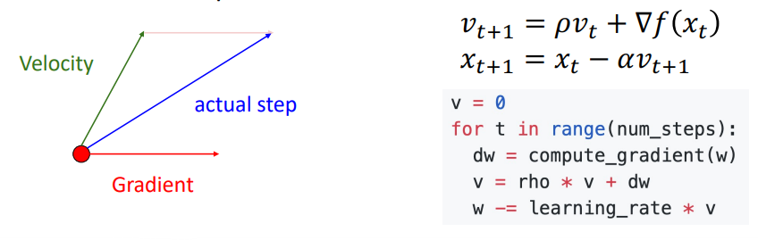Momentum is the idea of “building up a velocity” as the running mean of previous gradients. The step used to update the weights then comes by combining the gradient at the current step with the velocity. This gives similar behaviour to a marble rolling down a hill. The velocity is usually reduced by some “friction” value $ρ$ (typically 0.9 or 0.99). The formula for SGD+Momentum is:

SGD+Momentum addresses some of the problems with SGD outlined above:

* The velocity acts to smooth out oscillations by acting as a moving average.
* The velocity helps to carry the weights over local minima and saddle points, thanks to the momentum.
* The velocity acts to smooth out the gradient noise that comes from using minibatches.

#### Nesterov Momentum

Nesterov momentum uses a slightly different method to calculate the “actual step” from the gradient at the current point, and the velocity. The gradient is computed at the point where updating using only the velocity would take us, and it is then mixed with the velocity to give the actual update direction.

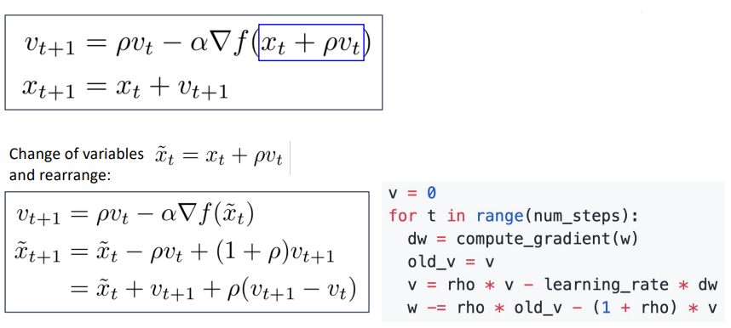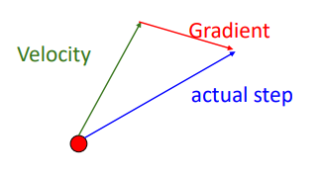

#### AdaGrad

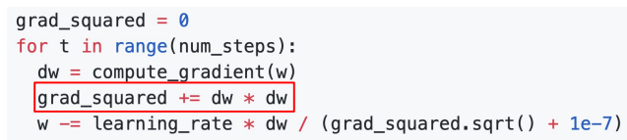AdaGrad is not a momentum-based optimisation algorithm like SGD+Momentum and Nesterov Momentum. Rather than tracking the historical sum of gradient values, we keep track of the historical sum of squared gradient values. Then, when updating our weights matrix, we divide the current gradient by the square root of the historical squared gradient values. This effectively gives an adaptive learning rate (AdaGrad = adaptive gradient):

This technique addresses the problem of having large gradients in one direction and small gradients in another direction. Large gradients divide through to cause small step sizes, and small gradients divide through to cause large step sizes. Progress along “steep” directions is damped, progress along “flat” directions is accelerated.

As the historical sum of squared gradients keeps accumulating (due to the squared gradients always being positive), learning can slow dramatically over time as you divide the step by larger and larger numbers.

#### RMSProp: “Leaky AdaGrad”

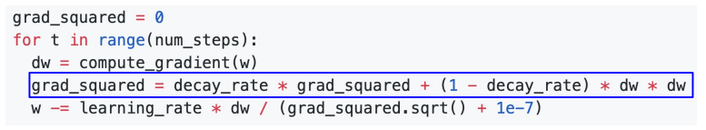To fix the problem of AdaGrad halting over time due to the squared gradients becoming too large, RMSProp (AKA. Leaky AdaGrad) adds a decay rate term to not accumulate squared gradients so fast.

#### Adam): RMSProp + Momentum + bias correction

Adam (adaptive moment estimation) is a very common optimisation algorithm that effectively combines the idea of momentum and adaptive learning rate from AdaGrad/RMSProp. In statistics, the first moment of a distribution is simply the mean, and the second moment is the variance.

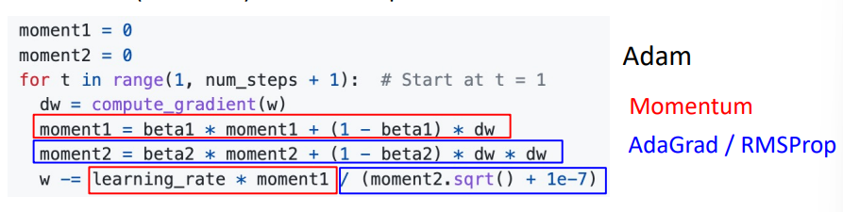Combing RMSProp and Momentum gives:

Where:

* The first moment​ is the running average of the gradients. It smooths out the fluctuations in the gradient and captures the general direction in which the gradient is pointing over time.
* The second moment is the running average of the squared gradients. This moment captures how large or small the gradients are over time, helping the optimizer adjust the step size (learning rate) based on how "volatile" the gradients are.

The above form has the problem that the first and second moment estimates start at zero and $β_{1}$ and $β_{2}$ are generally $≈0.999$, so the very first step size can be very large (if the second moment is near zero after the first update, you divide by the square root of near zero, taking a very large step). Essentially, the estimates for the first and second moments are biased towards zero at the start of training.

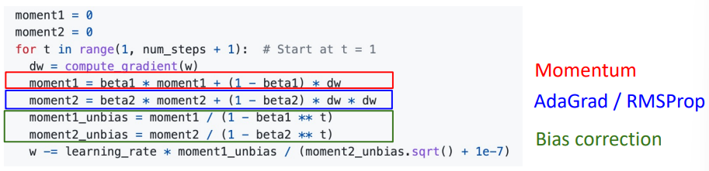A **bias correction** is used to counter this. Giving the full form of:

#### AdamW: Decoupled Weight Decay

Recalling L2 regularisation from the previous lecture: in practice, instead of adding a $λ{\left|W\right|}^{2}$ term to the loss function and then adding a $2λW$ term to the gradient during backpropagation, it is common to just add a $ηλW$ term (where $η$ is the learning rate) to the update step (this is called **weight decay**).

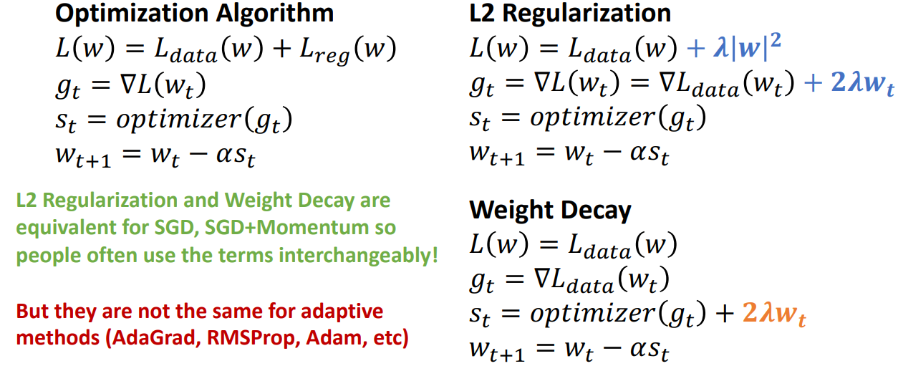In some optimisers, L2 regularisation and weight decay are equivalent (e.g. SGD, SGD+Momentum), so weight decay is often implemented by adding L2 regularisation. However, **L2 regularisation and weight decay** **are not the same for adaptive methods** (AdaGrad, RMSProp, Adam, etc.).

AdamW is the Adam optimiser with the weight decay term “decoupled”, i.e. added to the update step instead of to the gradients. **“AdamW should probably be your *default* optimiser for new problems”** – Justin Johnson.

Note: SGD+Momentum can outperform Adam but may require more tuning.

#### Comparison of Optimisation Algorithms

### Second Order Optimisation

The above optimisation algorithms are all first order algorithms, they only use the first derivation to approximate the loss surface (e.g. a line in 2D space, hyperplane in high dimensional space). Second order optimisers use the gradient and the Hessian matrix (the matrix of second order partial derivatives) to approximate the loss function surface. This takes into account the loss’ curvature, taking bigger steps in regions of low curvature.

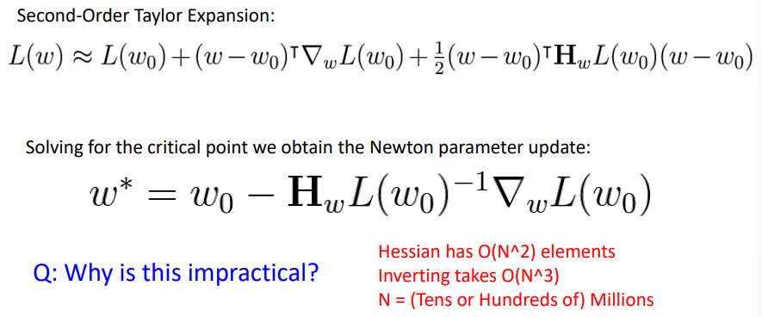Second order Newtonian algorithms require inverting the Hessian matrix which is very expensive.

In practice, approximate methods such as BFGS are used instead (calculates the approximate inverse Hessian with rank 1 updates over time, $O\left(n^{2}\right)$ each). **L-BFGS**, limited memory BFGS, does not form/store the full inverse Hessian.

L-BFGS works very well in full batch, deterministic mode. i.e. if you have a single, deterministic $f\left(x\right)$ then L-BFGS will probably work very nicely. However, it does not transfer very well to mini-batch setting. Adapting second-order methods to large-scale, stochastic setting is an active area of research. If you can afford to do full batch updates then try out L-BFGS (and don’t forget to disable all sources of noise)

# Lecture 5 – Neural Networks

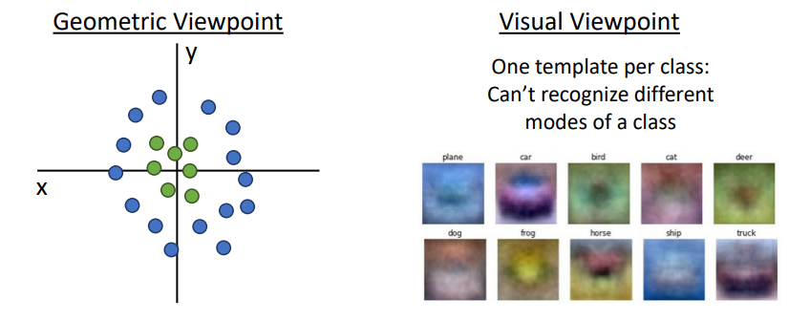Whilst linear classifiers are easy to understand (see Lecture 3), they are limited in their performance. For example, using the geometric viewpoint, a linear classifier is unable to model data that isn’t linearly separable. Or using the visual viewpoint, due to only being able to learn one template per class, a linear classifier is unable to recognize different modes of the same class (e.g. a horse facing either left OR right).

## Feature Transforms

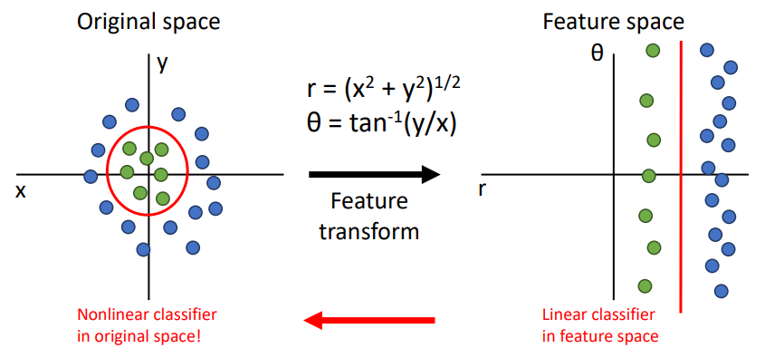One potential solution to these shortcomings is the use of **feature transforms**. We essentially transform our original data into a form that is better suited to our linear classifier, i.e. a form that is linearly separable. As an example, take the data arranged in a circular manner below:

By applying some cleverly chosen mathematical transformation, chosen manually using our intuition, we can convert the above data from cartesian form in the original data space into polar form in “feature space”. The learned linear decision boundary in the feature space can then be transformed back into a *non-linear* decision boundary in the original data space!

### Image Features: Color Histogram

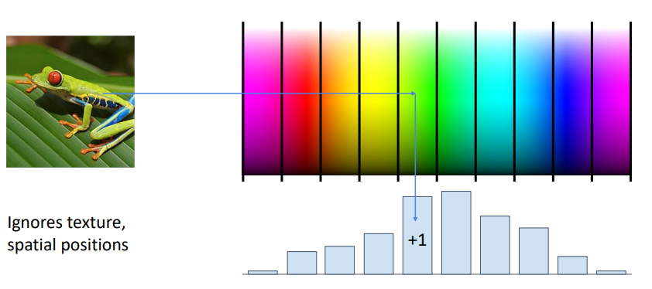One example of a feature transform that we may use in computer vision is the notion of a **colour histogram**. This technique involves discretising the colour space into discrete bins, and then for each pixel in the image, calculating in which bin that pixel is, and then constructing a normalised histogram across the whole image.

This colour histogram representation of the input image throws away any spatial information and only cares about what colours are present in the image, i.e. it is spatially invariant (can recognise a red car anywhere in the image as long as the colours are the same).

### Image Features: Histogram of Oriented Gradients (HoG)

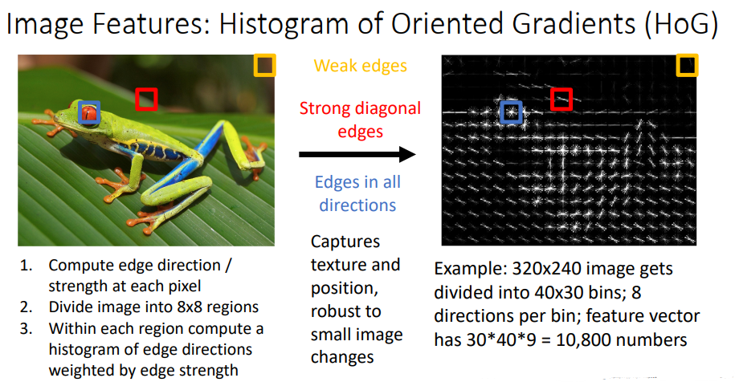HoG does essentially the opposite of the colour histogram; it throws away colour information and encodes the edge directions and strengths at different points in the image.

### Image Features: Bag of Visual Words (Data-Driven!)

Whilst the above two feature transforms require some case-by-case decision making and understanding of the problem, we can use data-driven approaches that are informed by the specific data contained within the training dataset.

One such feature transform is the Bag of Visual Words (BoVW), which follows these steps:

1. **Feature Extraction:** extract feature patches within the image using a feature detector like SIFT, such that each image is represented by a number of patches
2. **Clustering:** group similar patches from the training dataset together using somethinglike K-means clustering, such that each centroid is a “codeword”, i.e. a representation of several similar patches.
3. 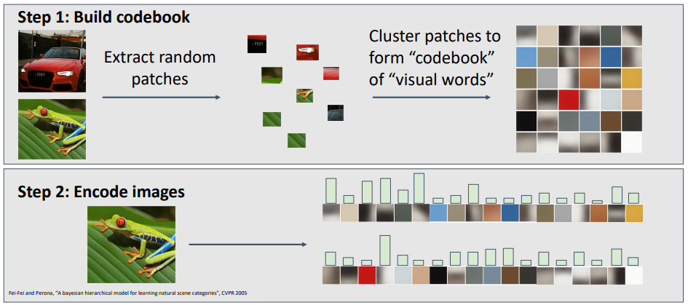**“Codebook” Histogram:** each image can be represented by a “codebook” histogram of how often each “codeword” appears in it.

### Image Features: Continued

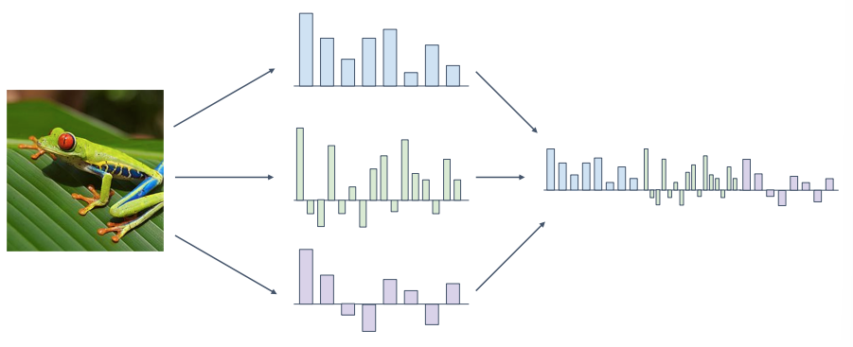You do not have to settle for one feature representation of your images. Instead, you may want to use many feature transforms and concatenate them together into a long high-dimensional feature vector.

For example, the ImageNet 2011 challenge winner combined SIFT features with colour features, and then later Fisher vector features to enhance their dataset before training on a SVM linear classifier with SGD.

## Neural Networks

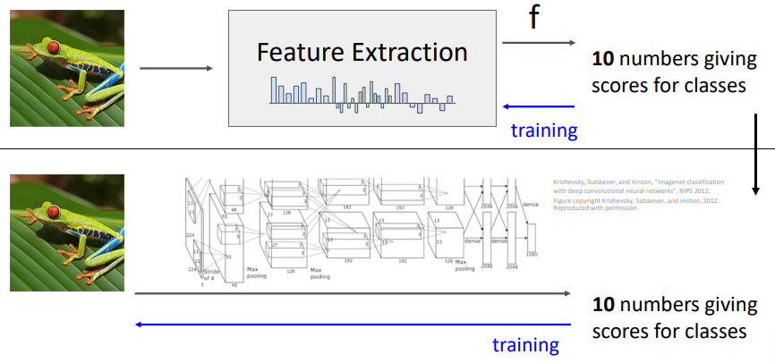Whilst a feature extraction classifier system does most if not all of it’s learning in the classifier portion of the system, *neural networks can be thought of as a combined feature extractor and classifier in one where the feature extraction behaviour is also learned during training*.

A linear classifier has the form:

$$f\left(x\right)=Wx+b$$

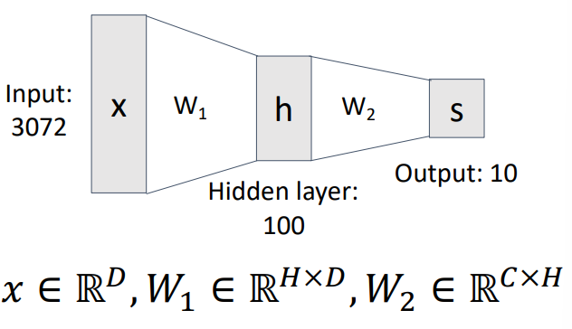We can create a two-layer neural network using the form:

$$f\left(x\right)=W_{2}\max\left(0, W_{1}x+b_{1}\right)+b_{2}$$

Where $max$ is the **activation function**, and the first layer can be thought of as doing feature extraction, whilst the second layer is the linear classifier.

As every neuron in the hidden layer is connected to every neuron in the input and output, this type of neural network is called a **fully connected** neural network or a **multi-layer perceptron**.

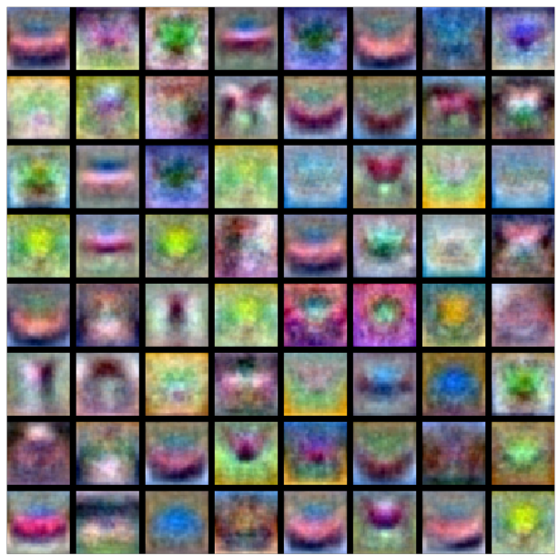Extending the visual viewpoint discussed above, the first layer in a two-layer fully connected neural network can be thought of as a bank of templates, rather than simply one template per image class. Where the templates can look something like:

The second layer then recombines the templates into a classification score. The bank templates are often not visually interpretable (some above look like horses or cars, some look like nonsense), they form more of a “distributed representation”. Notice above that there is a template of a left-facing horse and a right-facing horse, covering multiple modes of a single class!

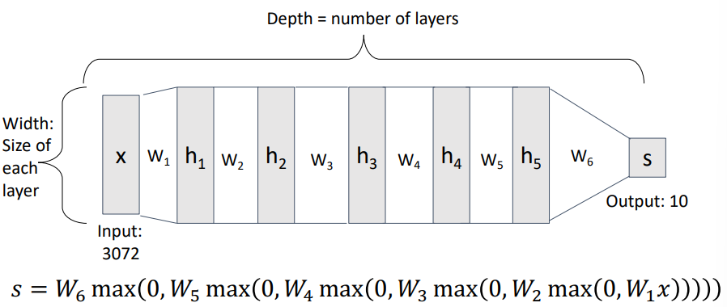The fully connected neural network idea can be extended to deep neural networks with many layers:

### Activation Functions

A fully connected neural network with no activation function between the layers is simple a linear classifier! For example:

$$f\left(x\right)=W_{2}\left(W_{1}x+b_{1}\right)+b_{2}=\left(W_{1}W_{2}\right)x+\left(W_{2}b_{1}+b_{2}\right)$$

Activations functions are required to enable the neural network to model non-linear systems.

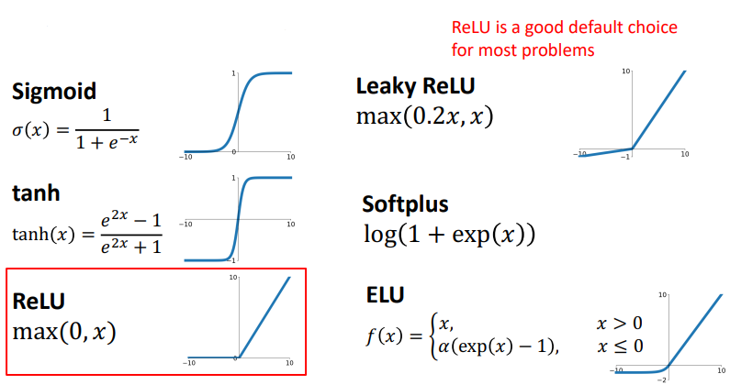Some common activation functions are given below:

ReLU is often a good default choice for most problems.

#### Activation Functions: Space Warping

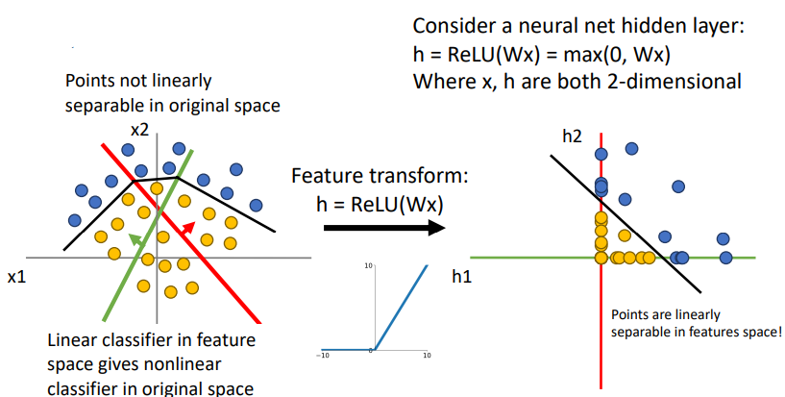Consider transforming a bunch of classified points (blue and orange) from x1, x2 coordinate axes to h1, h2 coordinate axes. If the points are not linearly separable in the original space then if the transformation is linear, they will not be linearly separable in the new space. However, if the transformation is a ReLU transform, any points with a negative x1 or x2 value will become 0 in h1 or h2 respectively. This is illustrated below:

### Universal Approximation Theory

“A neural network with one hidden layer can approximate any function with arbitrary precision.” This tells us that neural networks can represent any function, however it DOES NOT tell us whether we can actually learn any function with SGD, or how much data is actually required to learn a function (recall that kNN is technically a universal approximator, given ridiculously large quantities of data).

### Convex Functions

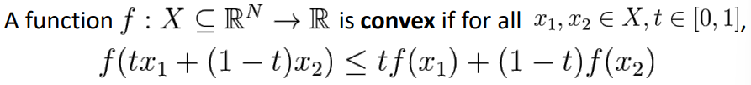A function is convex in the region $x_{1}$ to $x_{2}$ if it satisfies the following:

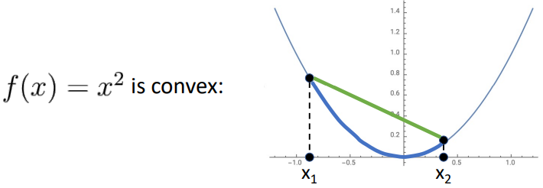**I.e. the function is convex in the region $x_{1}$ to $x_{2}$ if all of its values in that region sit below the secant joining the two points (a convex function is a multidimensional bowl).**

Generally speaking, convex functions are easy to optimise; we can derive theoretical guarantees about converging to global minimum.

Linear classifiers optimise a convex function; therefore, they can be shown to be guaranteed to converge.

Neural networks on the other hand need nonconvex optimisation, so there are few or no guarantees about their convergence. Empirically however, they seem to work anyway. The theory of the mathematics behind their optimisation is still an active area of research.

# Lecture 6 – Back Propagation

The optimisation algorithms described above rely on understanding the gradients of the model’s parameters with respect to the loss function.

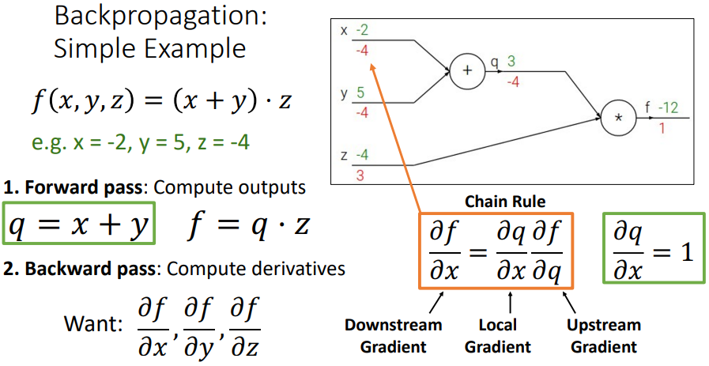Back propagation provides a method for computing gradients via recursive applications of the chain rule.

## Derive gradients on paper

Whilst writing down the full form of the loss function in terms of the model parameters and then calculating their gradients is technically possible, it is infeasible in most cases due to:

* Involving lots of matrix calculus
* Being non-modular, i.e. switching from SVM to softmax loss would require rederiving from scratch
* Too complex and time intensive for large, complicated models

## Computational Graphs

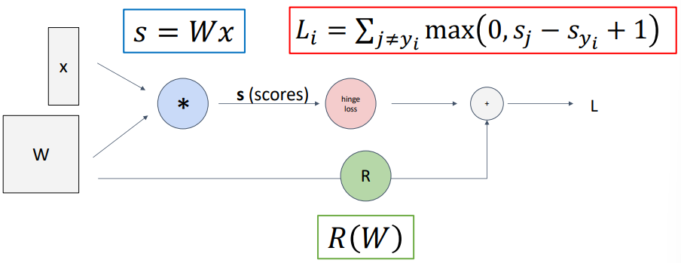Computational graphs are directed graphs that represent the computations that are occurring within the model:

Below is a very simple example of how to use a computational graph to calculate the gradients of a simple function. The steps are:

1. Complete the **forward pass** to find the outputs at each step along the model
2. Complete the **backward pass**, calculating the derivatives of the output $f$ with respect to each input $x$, $y$, $z$, using the chain rule.

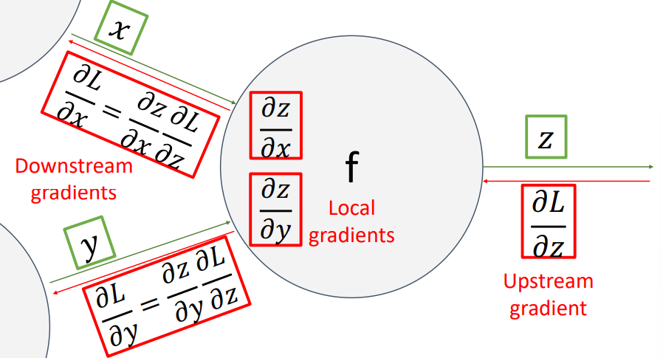Referencing some specific layer in the model (i.e. node in the graph) as “local”, the gradient of the model’s output with respect to the layer’s output is called the **upstream gradient**. The gradients of the layer’s output with respect to each of the layer’s inputs are the **local gradients**, and the gradients of the model’s output with respect to each of the layer’s inputs are the **downstream gradients**.

### Patterns in Gradient Flow

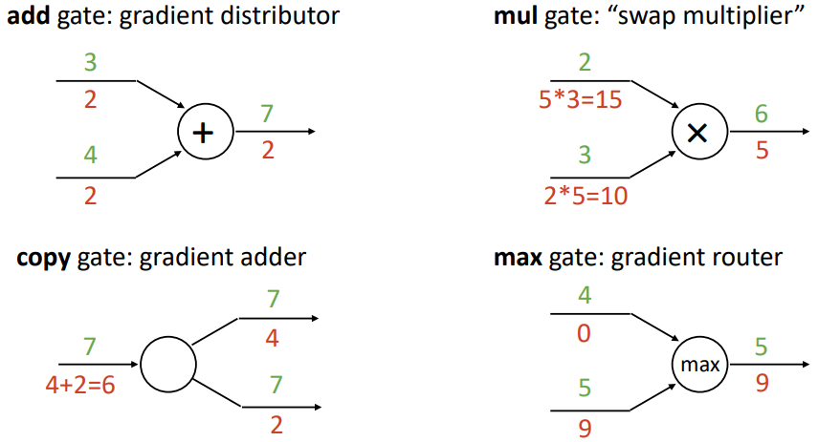Gradients flow back through the network and are affected by different operations (“gates”) in the following ways:

### Backprop Implementation: “Flat” gradient code

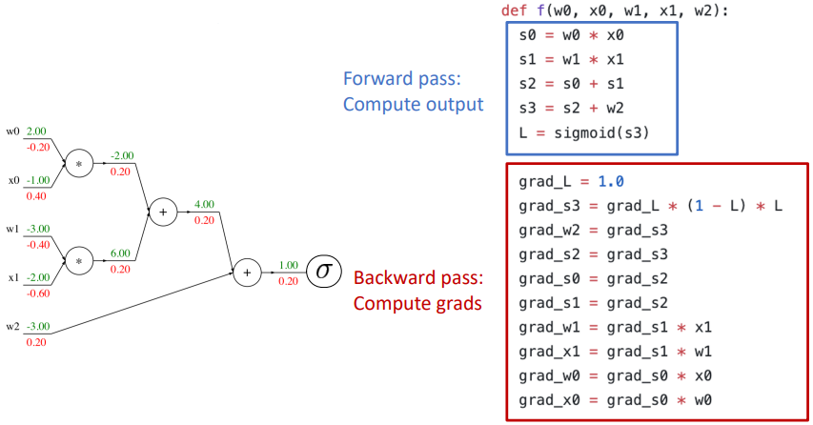The above general rules can be used to write “flat” gradient code, where the forward pass is written first from start to finish, and then the backward pass is written immediately after from finish to start. The gradient code is essentially a reversed version of the forward pass, where each operator in the forward pass has its corresponding gradient effect. E.g.

### Backprop Implementation: Modular API

“Flat” gradient code is not modular; it must be rewritten manually if the structure of the network changes. Instead, we can construct a modular API to conduct backpropagation, with the following steps:

1. 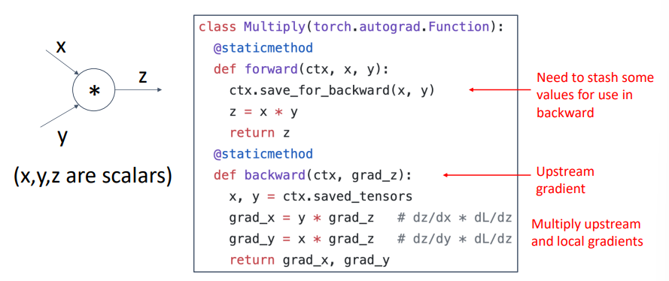Create a node object for every input gate / node (i.e. each individual “add”, “multiply”, “max” instance, etc.) and assign them to the computational graph
2. Sort the nodes in the computational graph topologically (i.e. in the order that the inputs travel through the graph)
3. Perform the forward pass by traversing through the sorted nodes, calling each of their .forward() methods and storing any information that will be required for the backward pass
4. 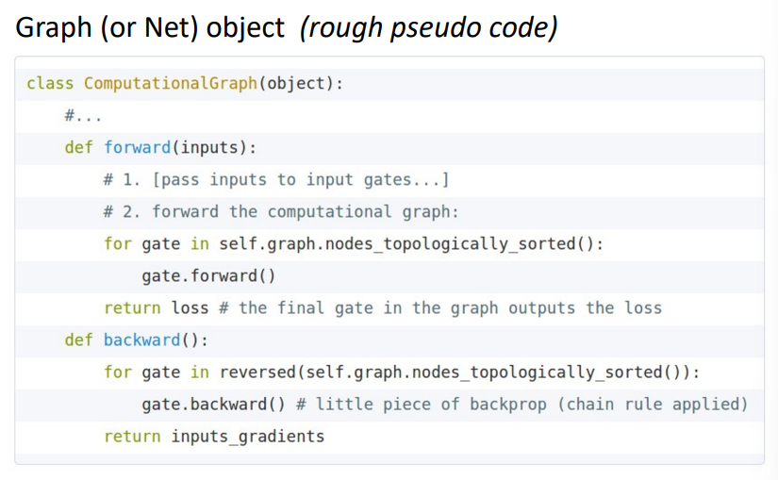Perform the backward pass by traversing through the reverse of the sorted nodes, calling each of their .backward() methods, retrieving the previously stored information from the forward pass

## Vector and Tensor Backpropagation

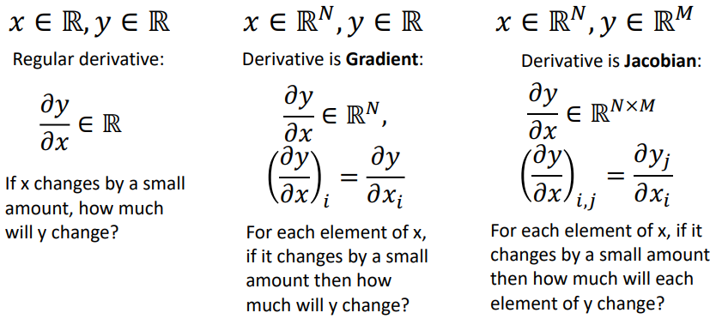So far, we have only considered backpropagation with scalar values. To backprop with vectors and tensors, we will need to recall the definition for the gradient and for the Jacobian:

### Vector Backpropagation

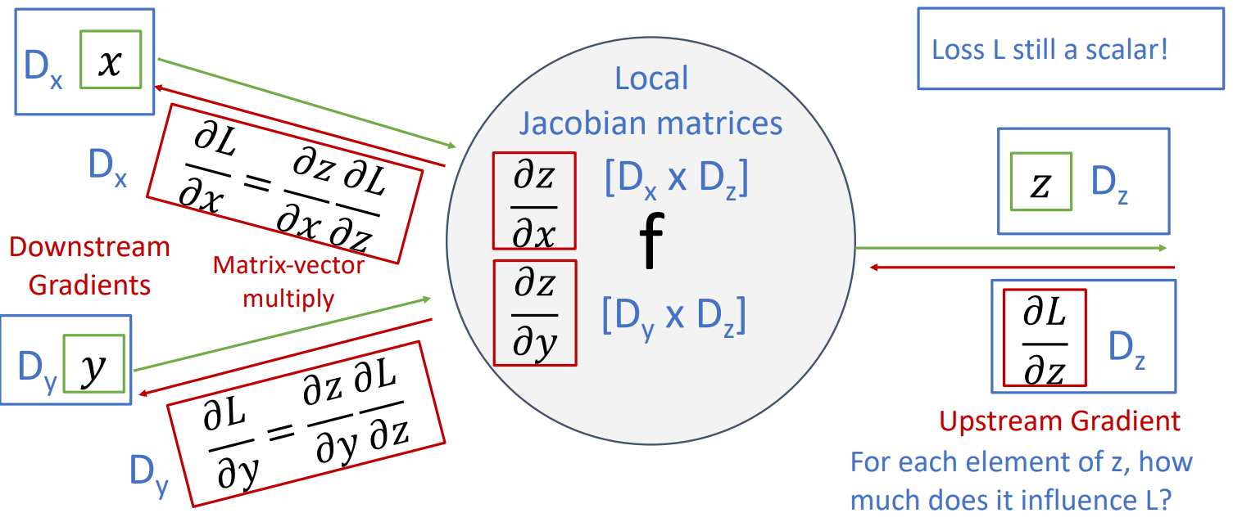Loss $L$ is a scalar, regardless of the form of the model inputs. If the inputs $x$ and $y$ are vectors of dimension $D_{x}$ and $D_{y}$ respectively, and the output $z$ is a vector of dimension $D_{z}$:

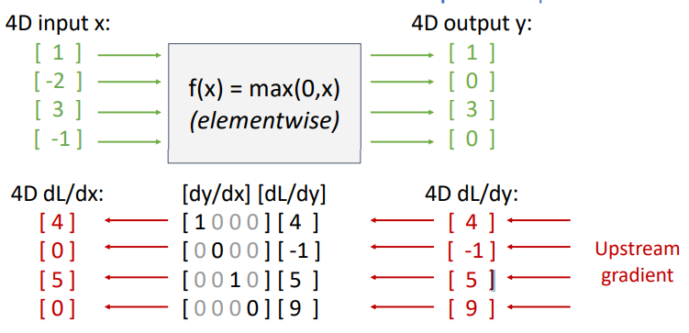Explicitly constructing the Jacobian matrices can quickly become expensive as the input dimensions grow. Luckily, it is often possible to never explicitly form the Jacobian and instead perform **implicit multiplication** where the Jacobian would typically be used, i.e. the local gradient is never formed. For example, the element-wise ReLU function $f\left(x\right)=\max\left(0, x\right)$ has the effect of zeroing the gradient of any negative input and simply passing through the gradient of any positive input. Constructing the Jacobian for this function gives a sparse diagonal matrix; all off-diagonal values are zero.

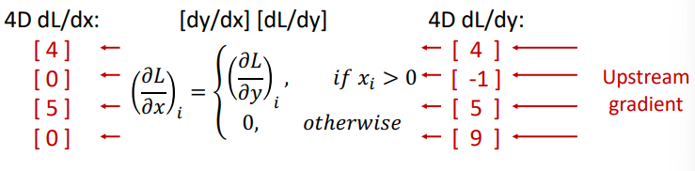Instead of using the Jacobian explicitly, we can perform an equivalent but much more efficient implicit operation:

### Tensor Backpropagation

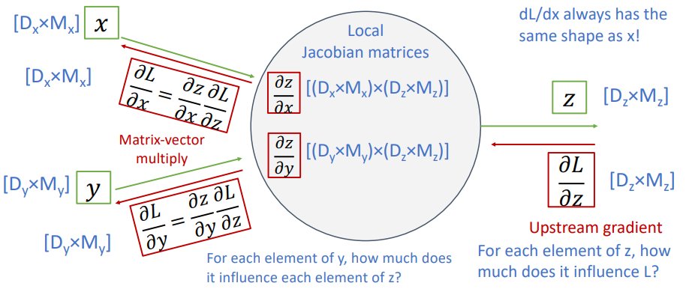Again, loss $L$ is a scalar. Constructing a similar diagram to that given for vector backpropagation above, gives:

Forming the Jacobians in this case is infeasible (for a neural network with $N=64$, $D=M=4096$, each Jacobian requires 256Gb of memory), we must work with them implicitly.

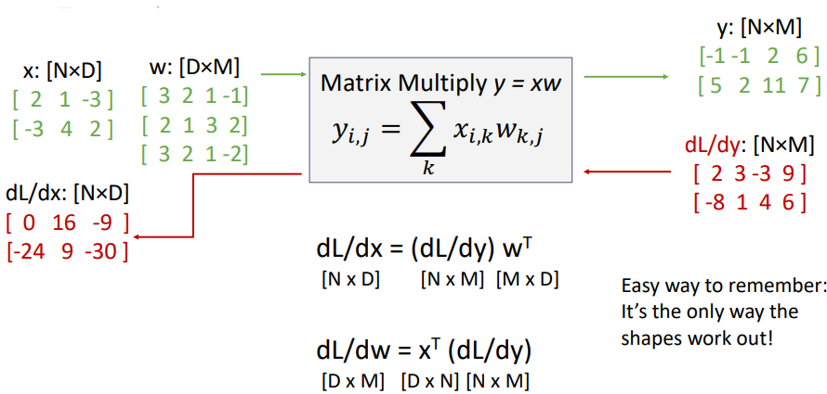Matrix multiplication in backpropagation is done implicitly – to calculate the downstream gradient directly from the upstream gradient – in the following manner (see Lecture 6 slides for derivation technique):

### Automatic Differentiation

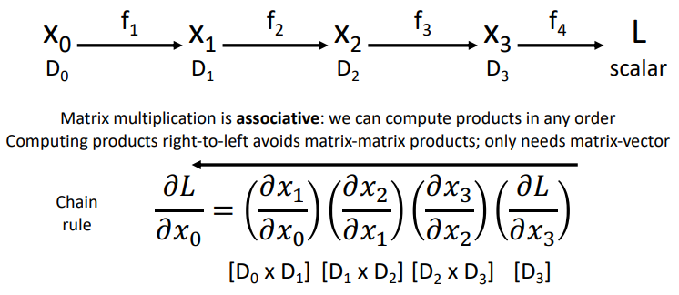Say we have some vector input $x_{0}$ and any series of functions $f$ that give a scalar output $L$, **reverse-mode automatic differentiation** (aka backpropagation) can be performed as:

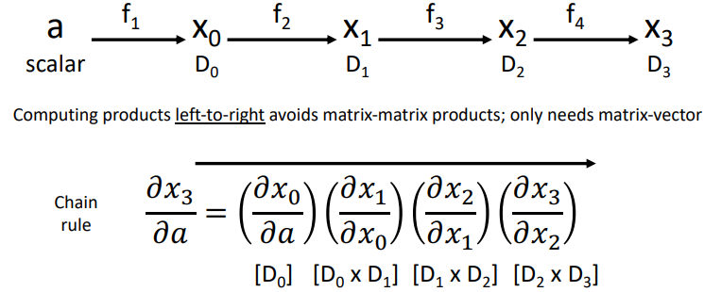If instead we have some scalar input $a$ and any series of functions $f$ that give a vector output $x_{3}$, **forward-mode automatic differentiation** can be performed as:

### Higher-order Derivatives

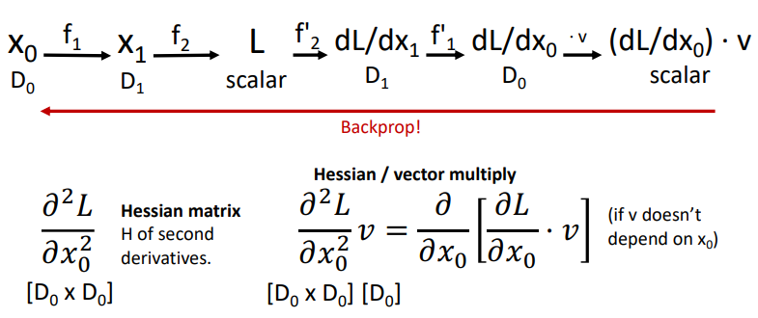Backpropagation also provides a convenient method for computing higher-order derivatives. For a given model, simply define a forward pass through some new model in a clever manner such that performing backpropagation on this new model will yield the higher-order derivative of interest. For example, calculating a Hessian / vector multiply:

# Lecture 7 – Convolutional Networks

Both the linear classifier and fully connected layer neural network that we have looked at so far do not respect the spatial structure of the input images. They require stretching the pixels into a single vector, effectively destroying the spatial information.

## Convolution Layer

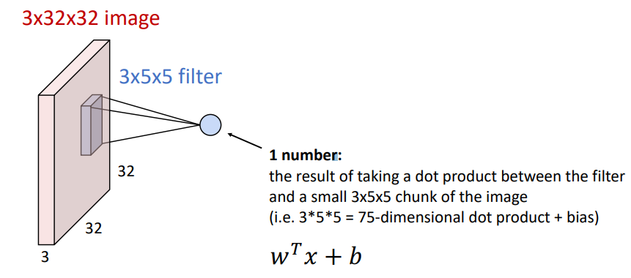Convolution layers preserve the spatial structure of input images by acting on the image in its original dimensions. Whilst each output of a fully connected layer is determined by every pixel in the input image (i.e. “fully connected”), a convolution layer slides a filter/kernel over the image spatially, computing a local dot product such that the output at that location is only dependent on the pixels covered by the filter. For example, a CIFAR10 3x32x32 image and a 3x5x5 convolution filter:

Sliding the filter over the entire image produces an “activation map”. This can be repeated for $n$ different filters to produce a collection of activation maps. There are two handy ways to think of this collection of activation maps:

1. As $n$ individual activation maps, where each map corresponds to the degree to which the entire input image responded to that map’s filter.
2. As a grid of $n$ dimensional vectors, where each vector encodes information from all $n$ filters at that grid location.

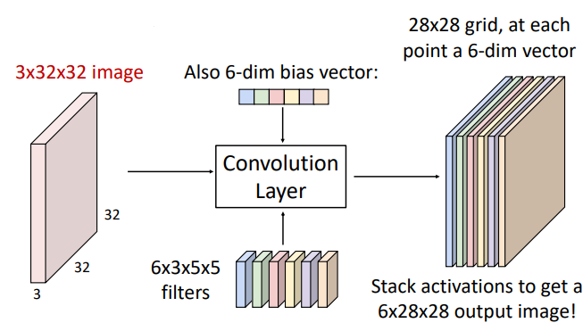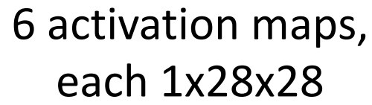

OR

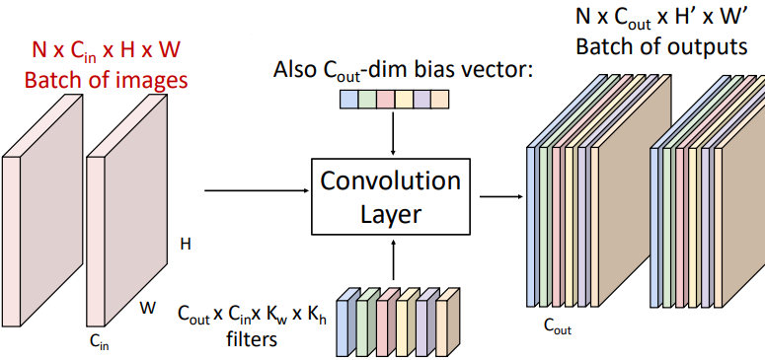The general form for a convolution layer is given below. Noting that for each channel in the output, there is a single scalar **bias** value that is added to each element in that channel’s output map.

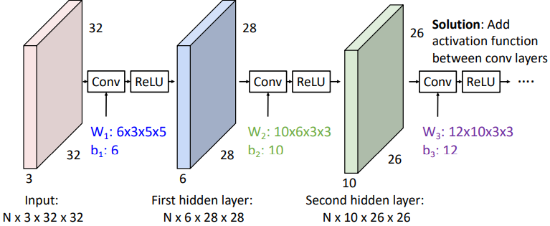Similar to how stacking multiple fully connected layers together without activation functions is equivalent to one fully connected layer, stacking convolutional layers must be done with activation functions between each layer.

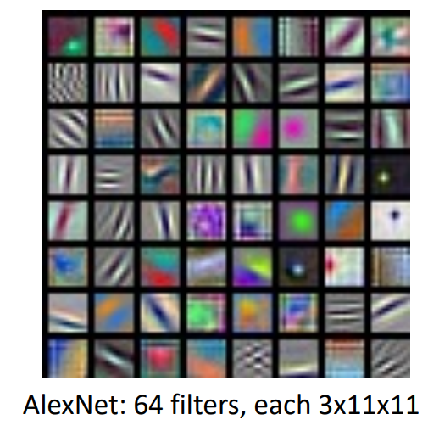Whilst fully connected layer neural networks learn a bank of whole-image templates, first-layer convolution filters learn local image templates (i.e. filters to extract things like orientated edges, opposing colours, etc.). Below are the 64 learned filters in the first layer of AlexNet, each 3x11x11:

### Receptive Fields

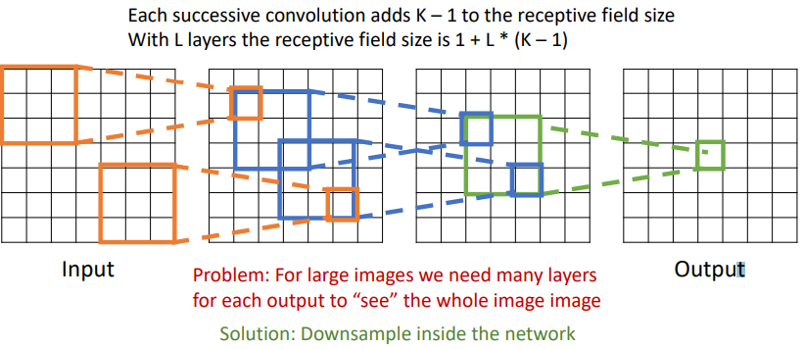For a convolution layer with kernel size K, each element in the output depends on a KxK receptive field in the layer’s input. This can be repeated back through multiple layers:

The above mentioned problem of requiring many layers to allow the receptive field of the model’s output to depend on the whole input image (especially for high resolution inputs) can be solved by downsampling using a **stride**. The stride of the convolution is how many places the kernel is moved along the input before evaluating each output.

### Convolution Output Size

For an input of dimension $\left(N, C_{in},H_{in},W_{in}\right)$, $C_{out}$ number of kernels of size $K$, padding $P$, and stride $S$, the output will have dimension $\left(N,C_{out},H_{out},W_{out}\right)$, where:

$$H_{out}=\frac{H_{in}-K+2P}{S}+1, W_{out}=\frac{W_{in}-K+2P}{S}+1$$

### 1x1 Convolution – Pointwise Convolution

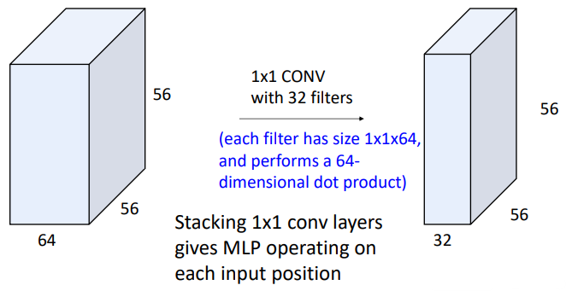Applying a convolution of $C_{out}$ number of kernels of size 1x1 on an image effectively performs a fully connected layer (MLP) operation on each input position. Using many pointwise convolutions in a network is sometimes referred to as a “Network in Network”.

### 1D and 3D convolution

2D convolution is the most common in computer vision applications, but 1D and higher dimension convolution operations exist.

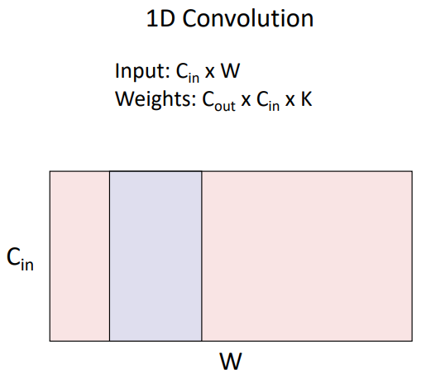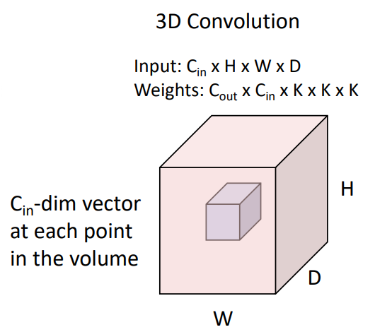

### Convolution Layer Summary

## Pooling Layers

Another component of convolutional networks is the **pooling layer**. Pooling layers serve as another way to downsample an input. They achieve this by sliding a kernel of size $1×K×K$ over the input image with stride $S$ and performing a pooling function on the inputs within the kernel (this kernel acts independently on each channel in the input, so $C_{out}=C_{in}$). This is typically either **max pooling**, where the maximum value in the kernel becomes the output, or **average pooling**, where the average value in the kernel becomes the output. Max pooling is 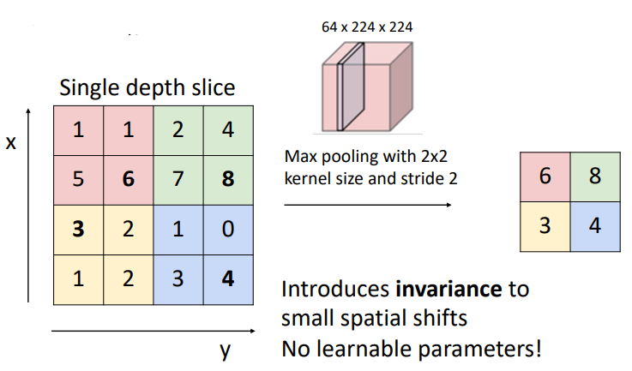demonstrated below:

Max pooling introduces invariance to small spatial shifts (e.g. as long as the maximum values are still within the same colours above, the output is the same). Pooling in general acts to reduce overall model complexity, shortens training time, and improves generalisation.

### Pooling Summary

## Example Conv. Network – LeNet-5

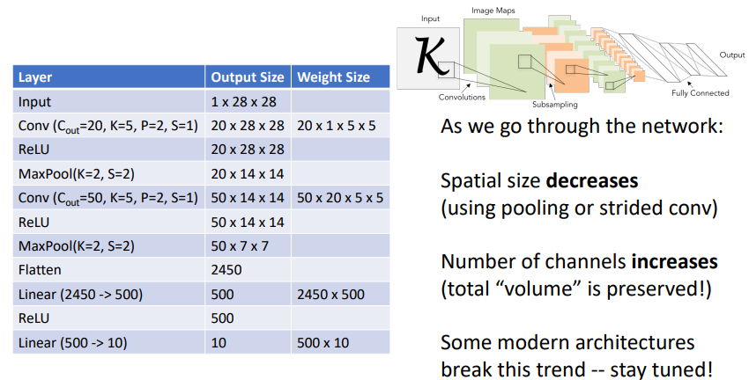Convolutional networks almost always also contain some fully connected layers. The output from the previous convolution layer is first flattened (for the same reason images need to be) before being processed by the fully connected layer.

## Normalisation

The final typical component of a basic convolutional network is **normalisation**. Normalisation solves the problem of “internal covariate shift”, where the distribution of the inputs to a given layer changes during training as the parameters of the previous layers change. As the training progresses, the layers keep receiving different input distributions, which makes it harder for the model to learn efficiently. Each layer has to constantly adjust to these shifting distributions, slowing down training.

By normalizing, the layer inputs maintain a stable distribution throughout training, which reduces the internal covariate shift. This means each layer gets more consistent and predictable inputs, making it easier for the network to learn. The model parameters are less likely to experience large shifts in scale, and the gradients during backpropagation don’t explode or vanish, leading to faster convergence.

We can normalise a batch of activations like by subtracting the mean and dividing by the standard deviation:

$$\hat{x}=\frac{x-E\left[x\right]}{\sqrt{Var\left[x\right]}}$$

Note: This is a differentiable function, so we can backpropagate through it!

### Batch Normalisation – Fully Connected Networks

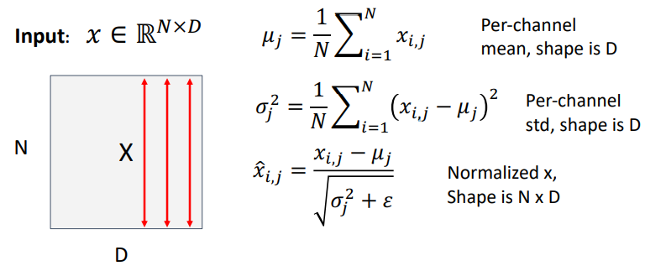If we have a batch of $N$ inputs, each of size $D$, for each channel $j$ along the input dimension $D$ we will calculate an empirical mean $μ_{j}$ along the batch dimension $N$. This mean $μ_{j}$ will then have size $D$ (i.e. the average of every input location across the $N$ batches). We can then do the same thing to calculate the per-channel standard deviation $σ_{j}$. Every element in the $N×D$ input can then be normalised to **zero mean**, **unit variance** (see below for why this isn’t typically done) by subtracting the mean and dividing by the standard deviation. This is illustrated below:

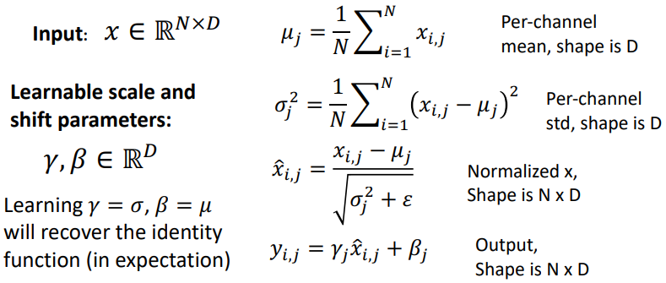Forcing the input to be normalised to zero mean, unit variance is probably too hard of a constraint to place on the model. Instead, we can learn some scale and shift parameters $γ, β$ of size $D$ to allow the model to decide what means and variances it wants to see for each channel in the input. This is shown below:

#### Batch Dependence and Use at Test-time

Whilst the previous operations we have explored (fully connected layers, convolutions, pooling, etc.) operate independently on each input in the batch, batch normalisation obviously depends on what other inputs are present in the batch. **This is a very bad property** at test-time, we do not want the performance of the model to be dependent on what other inputs are also being evaluated at the same time. Therefore, batch normalisation **acts differently during training than at test-time**.

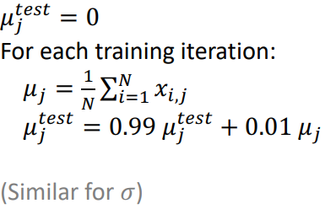During training we continue to calculate the mean and standard deviation across the batch and use them to normalise, however we also keep track of a running exponential average of the mean and standard deviation which will then be constants $μ_{j}^{test}, σ_{j}^{test}$ to be used at test-time. That is:

This then means that the result for each input at test-time is again independent of the other inputs in the batch. Another benefit of this approach is that because $μ_{j}^{test}, σ_{j}^{test}$ are constants, batch normalisation becomes a linear operation at test-time. And as we know that a linear operator (fully connected or convolution layer) followed by another linear operator is equivalent to a single linear operator, we can fuse a batch normalisation layer with the previous fully connected or convolution layer at test-time, so that **batch normalisation has zero computational overhead at test-time**.

### Batch Normalisation – Convolutional Networks

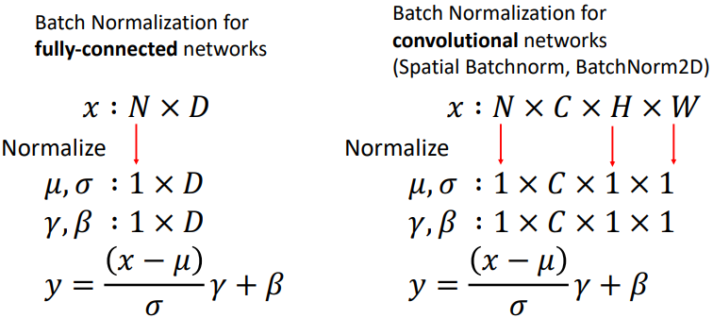Whilst for fully connected networks we compute the mean and standard deviation along the batch dimension, for convolutional networks we compute them along the batch dimension, and the image height and width dimensions. This leaves only the channel dimension, so the mean and standard deviation have size $C$.

### Batch Normalisation – Uses and Summary

Batch normalisation layers are usually inserted immediately after fully connected or convolutional layers, before the nonlinear activation function.

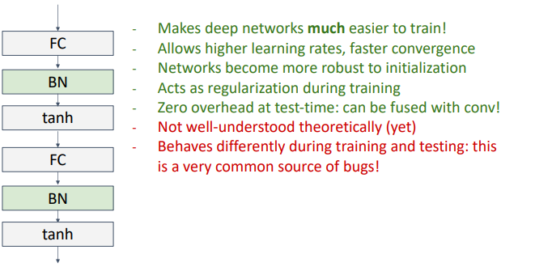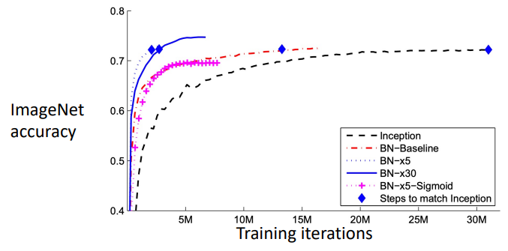

### Layer Normalisation + Instance and Group

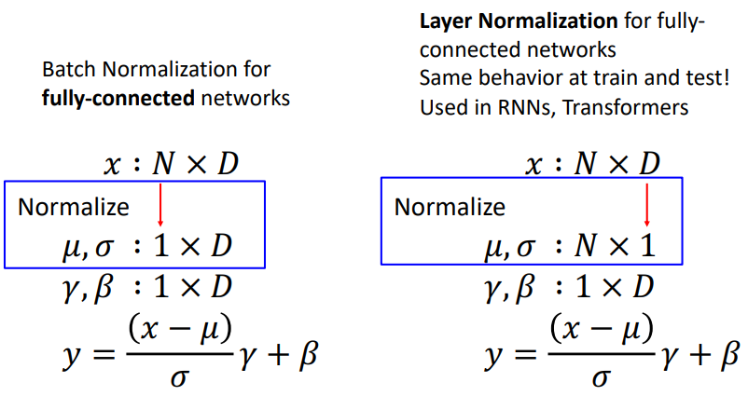Layer normalisation is the same as batch normalisation except instead of calculating the mean and standard deviation for each channel in the input along the length of the batch, we calculate the mean and standard deviation for each input in the batch along the length of the input. For fully connected networks, this looks like:

Now, because this does not rely on any information from the other inputs in the batch, layer normalisation gives the same behaviour at training as at test-time. Layer normalisation is commonly used in recurrent neural networks (RNNs) and transformer networks.

#### Instance Normalisation

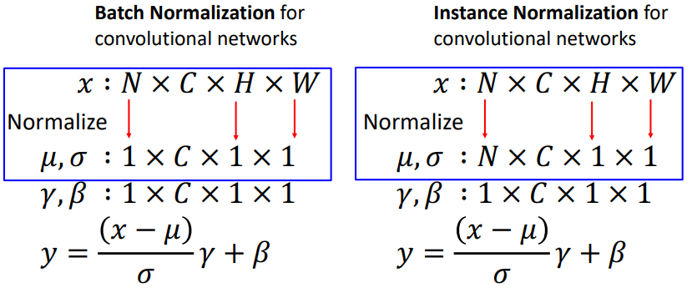A kind of equivalent operator of layer normalisation for fully connected networks but applied to image inputs (i.e. convolution layer outputs) is instance normalisation, where the mean and standard deviation is calculated along only the height and width dimensions. Again, this does not rely on information from other inputs in the batch, so instance normalisation gives the same behaviour at training as at test-time.

#### Group Normalisation

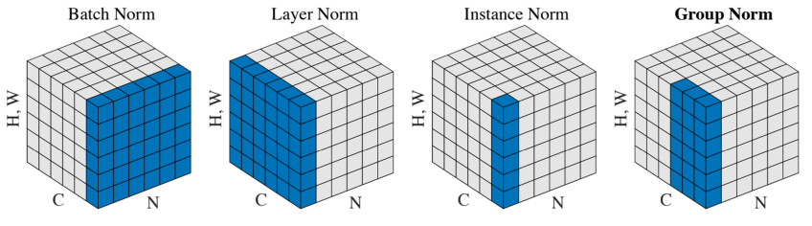Group normalisation has also been proposed and has been shown to work quiet well for object detection. The idea is that you split the channel dimension into some number of groups, and you then normalise over different subsets of the channel dimension. The below image compares the different types of normalisations that we’ve discussed.

# Lecture 8 – CNN Architectures I

Note: This is a two part lecture topic that is continued in Lecture 11.

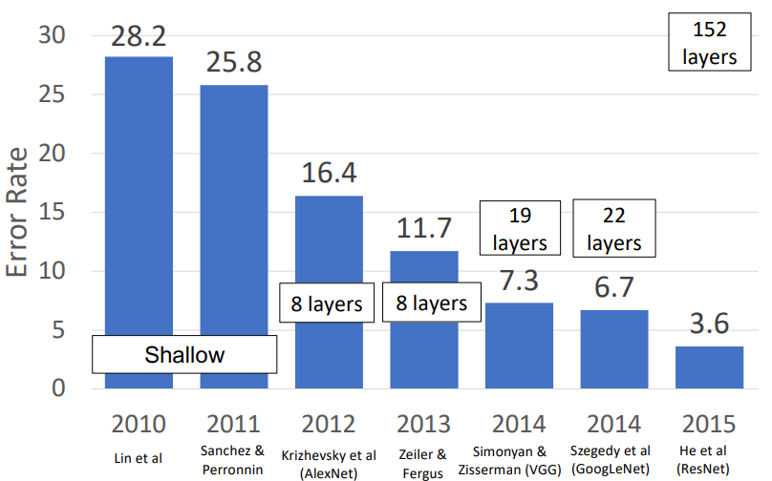We have investigated the typical components of a CNN in Lecture 7, now we will look at how these components have been arranged into CNNs in the past. In particular, we will focus on the top performing networks from the ImageNet Classification Challenge (~1.3M images, 1000 classes).

## AlexNet (Winner 2012)

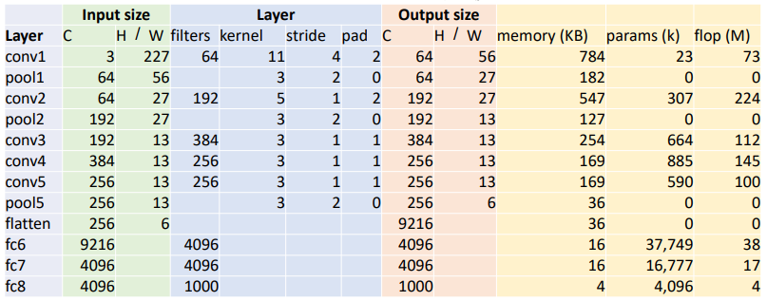AlexNet was the first “deep” (although 8 layers is no longer considered particularly deep) machine learning model to win ImageNet and was one of the very earliest models to kickstart deep learning as a field.

The model architecture, with ReLU activations omitted, is given in the below table:

The hyperparameters of the number of layers, kernel sizes, strides and padding, etc. were *chosen primarily through trial and error*.

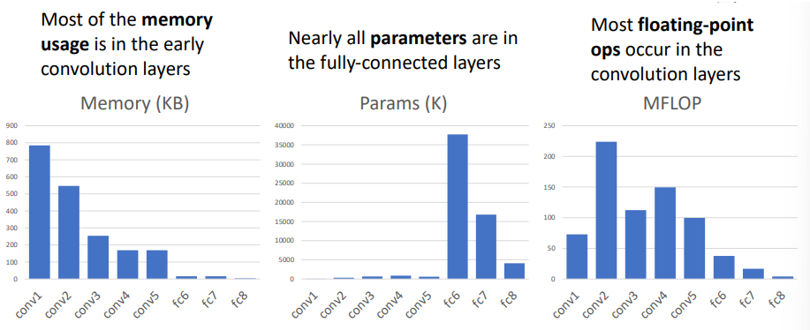Observing the trend of the memory usage, number of parameters, and floating point operations, through the different layers of the networks shows the following trends:

### Calculating Memory, Num. Parameters, and FLOPs

The **memory requirements** of a layer is typically just the memory required to store the layer’s output. Assuming 32-bit floating point numbers (i.e. 4 bytes), the number of output elements is.

$$N_{fp_{32}}=C_{out}×H_{out}×W_{out}$$

The memory requirements in KB are then:

$$KB=\frac{N_{fp_{32}}×4}{1024}$$

The **number of learnable parameters for a convolution layer** is:

$$Params=C_{out}×C_{in}×K×K+C_{out}$$

i.e. number of filters x filter size + bias terms

The **number of learnable parameters for a fully connected layer** is:

$$Params=C_{in}×C_{out}+C_{out}$$

i.e. weight matrix size + bias terms

The **number of floating point operations (FLOPs)** is generally considered as the number of combined multiply-adds (as modern computers have multiplier-accumulator [MAC] units which performs the product of two numbers and adds the product to an accumulator in a single step).

For a convolution layer:

$$FLOPS=number of output elements×OPs per output element$$

$$FLOPS=\left(C_{out}×H_{out}×W_{out}\right)×\left(C_{in}×K×K\right)$$

For a fully connected layer:

$$FLOPS=number of output elements×OPs per output element$$

$$FLOPS=C_{in}×C_{out}$$

## ZFNet (Winner 2013) – A Bigger AlexNet

ZFNet has the same structure as AlexNet but is larger. It has the following changes:

$$CONV1=Change from \left(11×11, stride 4\right) to \left(7×7, stride 2\right)$$

$$CONV3, 4, 5= Change from C=384, 384, 256 to C=512, 1024, 512$$

ZFNet demonstrated that increasing network size generally increases accuracy.

## VGG (Runner-up 2014) – Deeper Networks, with Regular Design

Instead of relying so much on trial and error for selecting the CNN’s architecture and scaling it’s size up or down, VGG attempted to define a standard recipe for their models with certain design rules. These rules are:

* All convolutions are 3x3 with stride=1 and padding=1
  + Reasoning: Two 3x3 convolutions have the same receptive field as a single 5x5 convolution and higher non-linearity due to the two activation functions (increase non-linearity can mean better capacity to model complex functions), but have fewer parameters and takes less computation!
* All max pooling layers are 2x2 with stride=2
* After each pooling layer, double the number of channels
  + Reasoning: If we half the spatial resolution with the max pooling layer but then double the number of channels, the convolutions at each spatial resolution then take the same amount of computation.

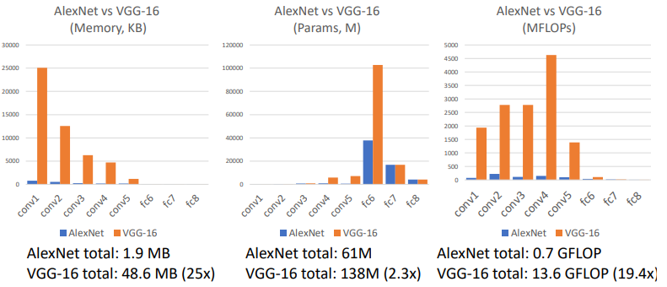The two most popular VGG models are VGG-16 and VGG-19. Both are much bigger than AlexNet:

## GoogLeNet (Winner 2014): Focus on Efficiency

Google were motivated to develop more cost effective models, leading to many innovations for efficiency (i.e. reduced parameter count, lower memory usage, and lower computation).

### Stem Network

The first innovation is the use of a **stem network** at the start of the network to aggressively downsample the input (recall compute is typically stacked towards the start of the network. This stem network downsampled from 224x224 to 28x28 in significantly less memory, parameters, 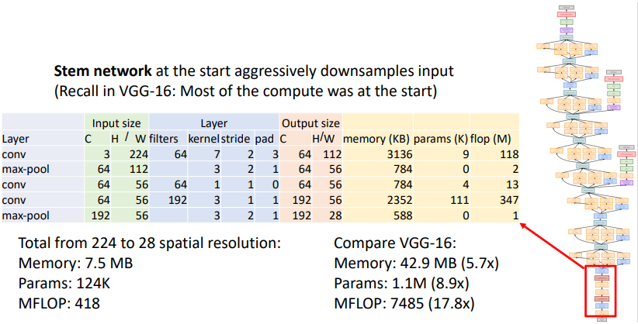and FLOPS than VGG-16.

### Inception Modules

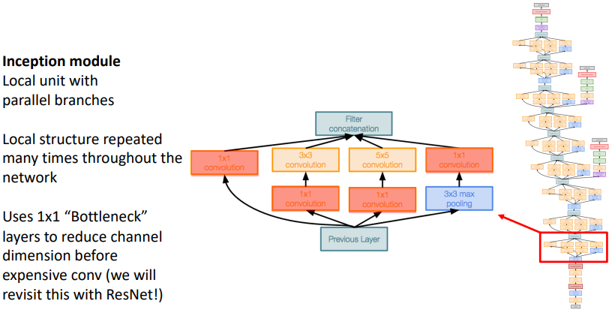The next innovation is the **inception module**, a local unit with parallel branches. Rather than trying to decide which size convolution filter is best, the inception module performed 1x1, 3x3, 5x5, and 3x3 max pooling all in parallel before concatenating the results. The module contained 1x1 bottleneck layers to reduce the number of channels before performing the expensive convolution (these are discussed more in the ResNet section).

### Global Average Pooling

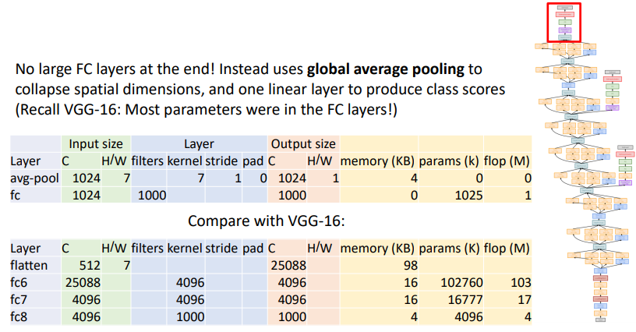Instead of flattening the output and using large and expensive fully connected layers to collapse the spatial dimensions at the end of the model (recalled most of VGG-16’s parameters were in the FC layers), GoogLeNet used global average pooling to collapse the spatial dimensions along with a single fully connected layer to produce class scores.

Global average pooling is done with an average pool layer that has the kernel size set to the input size.

### Auxiliary Classifiers

Due to the depth of GoogLeNet, training using the loss calculated from the end of the network didn’t work well, the gradients did not propagate cleanly. As a hack, they attached “auxiliary classifiers” at several intermediate points in the network that then also attempted to classify the image, from which the loss was also calculated and injected into the network at that location during backpropagation. *This is no longer necessary due to batch normalisation*.

## Residual Networks (Winner 2015)

### Motivation and Residual Blocks

Batch normalisation was discovered in early 2015, meaning much deeper models could now be trained. It was soon discovered that deeper models were performing worse than shallow models on both test and training sets, suggesting that the models were underfitting.

The hypothesis was that this was an optimisation problem with deeper models, in particular that they weren’t able to learn identity functions that would allow them to at least emulate the performance of shallow models (if you take a shallow model and add a bunch of layers that are just identity, this deep model will still have the same performance as the shallow model, i.e. deep models should be at least as good as shallow models).

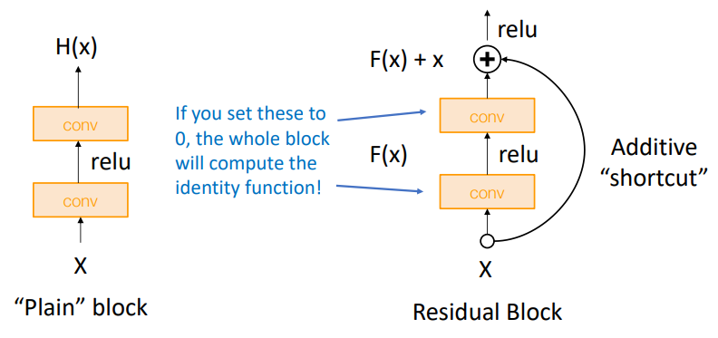A residual network (ResNet) adds a modification to make it easier for the network layers to learn the identity function. This modification is the **additive “shortcut”**, and a conv->ReLU->conv block with an additive block is called a residual block:

### Residual Networks – ResNet-18 and ResNet-34

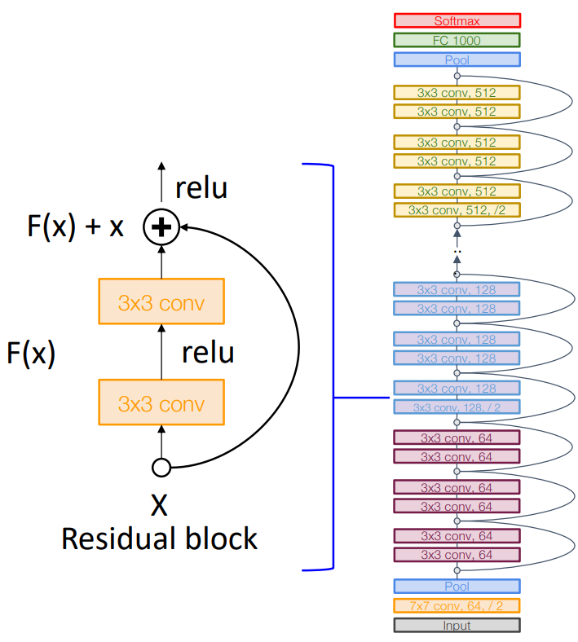A ResNet is then a stack of many residual blocks. ResNets are regular in their design, like VGG, each residual block has two 3x3 convolutions. The overall network is divided into stages, where the first residual block in each stages halves the resolution (with a stride=2 convolution) and doubles the number of channels.

ResNets use the same aggressive stem network as GoogLeNet to downsample the input 4x before the first residual block. Also like GoogLeNet, ResNets have no big fully connected layers and instead use global average pooling with a single fully connected layer at the end of the network.

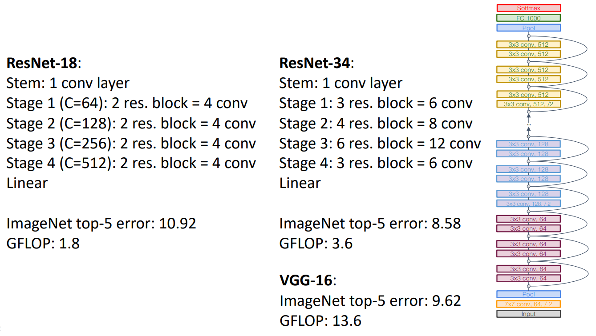ResNet-18 and ResNet-34 both have 4 stages but with a different number of residual blocks within them:

### Bottleneck Blocks – ResNet-50, ResNet-101, and ResNet-152

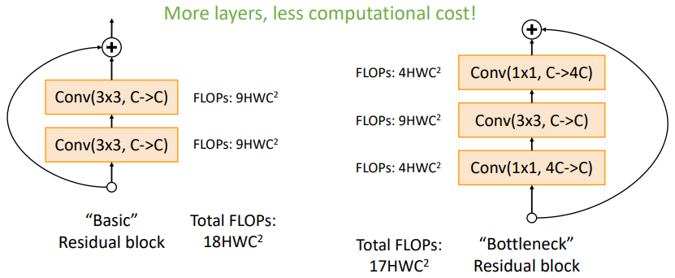A modified residual block that uses a single 3x3 convolution in the middle of two bottlenecking 1x1 convolutions is called a bottleneck residual block. Bottleneck blocks increase depth (and therefore non-linearity) for slightly less computational cost:

Bottleneck blocks also act as a form of regulariser, reducing the number of parameters that the model is using to counter overfitting (effectively forcing the model to “throw away” irrelevant data/features).

Replacing the basic residual blocks in ResNet-34 with bottleneck blocks led to ResNet-50 (increased number of layers due to 3 layers per block instead of 2). ResNet-50 remains a great baseline architecture for many tasks even today.

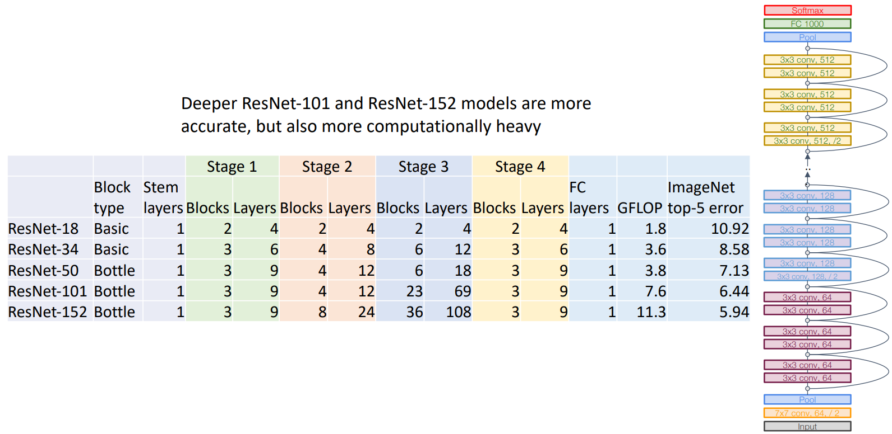The deeper ResNet-101 and ResNet-152 models are more accurate, but also more computationally heavy:

### Improving ResNet Block Design

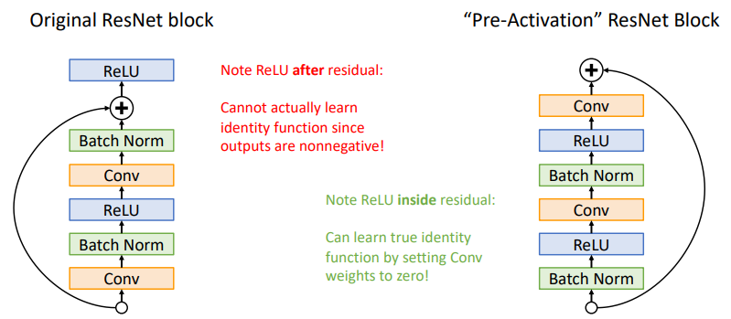The original ResNet block has the ReLU after the additive “shortcut”, so that the combined output is always non-negative after the ReLU, meaning that the overall block can’t actually learn the identity function. The “pre-activation” ResNet block resolves this:

This leads to a slight improvement in accuracy (20.7 vs 21.8 ImageNet top-1 error for ResNet-200) but is not actually used that much in practice.

## A graph with different colored circles AI-generated content may be incorrect.Summary

CNN architectures have continued to evolve past the architectures discussed so far. **Lecture 11** **will show more recent networks.**

The below plot compares some of the discussed architectures by their accuracy on ImageNet, their computer requirements, and their number of parameters:

* Inception-V4 is a high accuracy combination of ResNet and inception modules
* VGG has the highest memory and compute requirements
* GoogLeNet is very efficient
* AlexNet is low accuracy, requires low compute but uses lots of parameters

# Lecture 9 – Training Neural Networks I

There are quite a few topics of which an understanding of is required to be good at training neural networks. These can be thought of as occurring:

* before training, in the “one-time setup”
  + activation functions
  + data preprocessing
  + weight initialisation
  + regularisation
* during training, “training dynamics”
  + learning rate scheduling
  + large-batch training
  + hyperparameter optimisation
* and “after training”
  + model ensembles
  + transfer learning

This lecture covers the “one-time setup” topics, lecture 10 covers the remaining topics.

## One-time Setup

The one-time setup occurs once before the training process begins.

### Activation Functions

Recall that activation functions are critical in the design of neural networks; without them, multiple layers of linear functions are simply equivalent to a single linear function.

#### Sigmoid

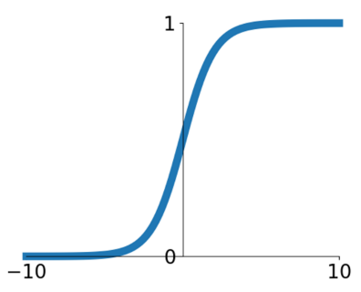The sigmoid activation function takes the form:

$$σ\left(x\right)=\frac{1}{1+e^{-x}}$$

* Squashes number to the output range $\left(0, 1\right)$
  + Can therefore be used to represent the probability of a Boolean variable being False=0 or True=1
* Has been historically popular due to its nice interpretation as a saturating “firing rate” of a neuron (saturation refers to the tail ends of the sigmoid, where changing the input no longer changes the output much, i.e. it is “saturated”)

Sigmoid has three main problems:

1. **Saturated neurons “kill” the gradients:**

Remembering that the downstream gradients $\frac{∂L}{∂x}$ are the product of the upstream gradients $\frac{∂L}{∂σ}$ with the local gradients $\frac{∂σ}{∂x}=\frac{∂}{∂x}\left(\frac{1}{1+e^{-x}}\right)$. If the input into the sigmoid function is too low or too high (i.e. at the tail ends), the local gradient is approximately zero, causing the downstream gradients to go to zero.

Therefore, this slows down training due to very small gradients giving very small weight updates. Also, for deep networks, a saturated sigmoid can lead to learning in the upstream layers and no learning in the downstream layers.

1. **Sigmoid outputs are not zero-centered**

Sigmoid gives outputs in the range $(0, 1)$, so the outputs are always positive and therefore not “zero-centered”. In the case where all activation functions in the network are sigmoids, the inputs to some $n^{th}$ layer is guaranteed to be positive. If the layer is described by:

$$h_{i}^{n}=\sum_{j}{w_{i,j}^{n}σ\left(h_{j}^{n-1}\right)+b_{i}^{n}}$$

Where:

* + is the $i^{th}$ element of the hidden layer at layer $n$ (before activation)
  + $w^{n}$, $b^{n}$ are the weights and bias of layer $n$

The loss with respect to the weights $w$ is:

$$\frac{dL}{dw_{i,j}^{n}}=\frac{dh_{i}^{n}}{dw_{i,j}^{n}}×\frac{dL}{dh_{i}^{n}}$$

$$=σ\left(h_{j}^{n-1}\right)×\frac{dL}{dh_{i}^{n}}$$

Where:

* + The local gradient is $\frac{dh_{i}^{n}}{dw_{i,j}^{n}}=σ\left(h_{j}^{n-1}\right)$, **which is always guaranteed to be positive**

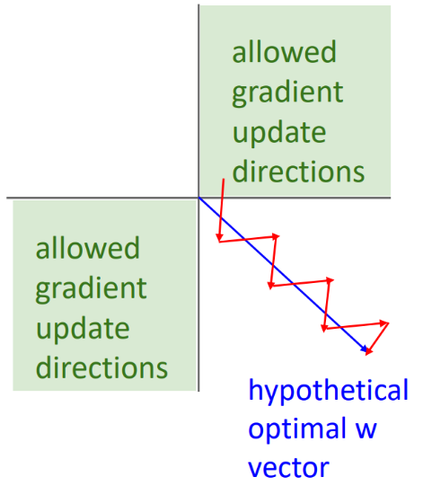Therefore, all gradients of $w$ (i.e. $\frac{dL}{dw_{i,j}^{n}}$) have the same sign as the upstream gradient $\frac{dL}{dh_{i}^{n}}$. This means we are constrained in which directions we can move during learning. Using the 2D example, moving only in the 1st and 3rd quadrant directions (much worse in higher dimensions):

In practice this is not that bad:

* + The above is only true for a single example. Using minibatches means the gradients are calculated and averaged across many examples.
  + Batch normalization acts to counter it

1. **exp() is compute expensive**

The exponential function is a complicated transcendental function that can take many clock cycles on a CPU to calculate. In comparison to a ReLU which involves just a simple threshold, sigmoid can be nearly 3 times slower.

This is only really a concern for mobile devices and CPU devices. For GPU devices, the cost of moving the data from the global memory to the compute elements of the GPU ends up taking much more time than computing the non-linearity itself, so most activation functions take about the same amount of time on GPU.

*Saturation killing the gradient is the most problematic aspect of sigmoid.*

#### Tanh

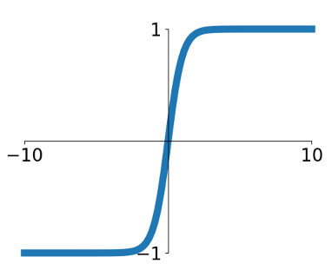The tanh activation function takes the form:

$$tanh\left(x\right)=\frac{e^{x}-e^{-x}}{e^{x}+e^{-x}}$$

* Is a shifted and rescaled sigmoid
* Squashes number to the output range $\left(-1, 1\right)$
* Unlike sigmoid, is **zero-centered**
* Like sigmoid, still kills gradients when saturated

#### ReLU – Rectified Linear Unit

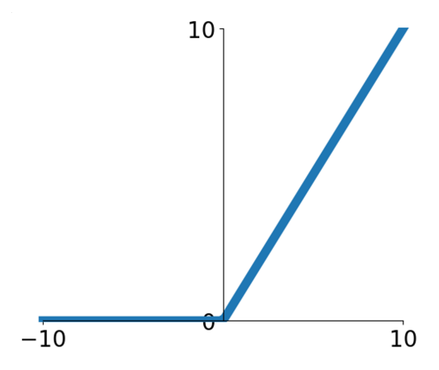ReLU is the function:

$$ReLU\left(x\right)=\max\left(0,x\right)$$

* Does not saturate (in the +ve region)
* Is very computationally efficient
* Converges much faster than sigmoid/tanh in practice (e.g. 6x as reported by AlexNet)
* Is not zero-centered, suffers from the same problem as the sigmoid

For negative inputs $x$, the gradient of ReLU is exactly zero (not just close to zero like sigmoid and tanh). This can lead to **dead ReLU**, where the weights in a layer are such that the output is negative for every single datapoint in the training set, so that the gradients for the weights of that layer will also be zero for all future updates.

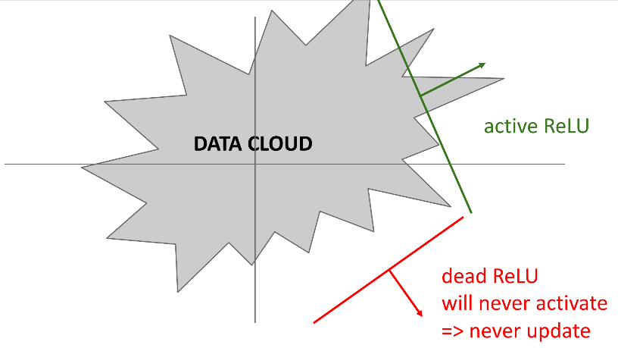A dead ReLU can be visualized as a decision plane lying outside of all of the possible input data (visualized below as the “data cloud”):

A trick that has been used in the past to make it harder for dead ReLU to occur, is to initialise the biases of the layers that use a ReLU activation to be slightly positive, e.g. $b=0.01$.

#### Leaky ReLU

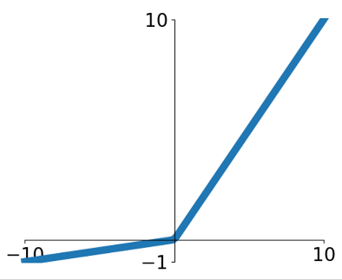The leaky ReLU activation function takes the form:

$$Leaky ReLU\left(x\right)=\max\left(αx, x\right)$$

Where $α$ is a hyperparameter that needs to be tuned, often $α=0.1$

* Does not saturate
* Is computationally efficient
* Converges much faster than sigmoid/tanh in practice (e.g. 6x as reported on AlexNet)
* **Will not “die”**

##### Parametric Rectifier – PReLU

Adding additional hyperparameters to search over increases the time required to tune your network. Instead we can attempt to learn hyperparameters where possible.

PReLU is just leaky ReLU except the negative domain slope parameter $α$ is learned via backpropagation rather than set as a hyperparameter.

#### Exponential Linear Unit – ELU

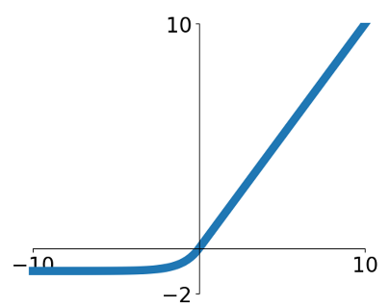The exponential linear unit activation function takes the form:

$$ELU\left(x\right)=\left\{ \begin{matrix}x & if x>0 \\ α\left(\exp\left(x\right)-1\right) & if x≤0\end{matrix}\right.$$

Where the hyperparameter $α=1$ by default

* Has most the benefits of ReLU whilst attempts to fix some of the problems
* Is smooth, i.e. differentiable at 0
* Requires exp(), which can be computationally expensive (see Sigmoid)

#### Scaled Exponential Linear Unit – SELU

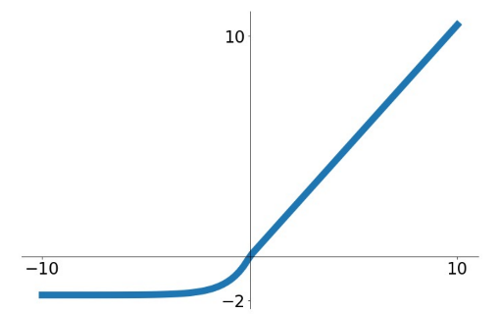The scaled exponential linear unit activation function takes the form:

$$SELU\left(x\right)=\left\{ \begin{matrix}λx & if x>0 \\ λα\left(\exp\left(x\right)-1\right) & if x≤0\end{matrix}\right.$$

Where the hyperparameter $α=1$ by default, and $α$ and $λ$ have very specific values:

$α=1.6732632423543772848170429916717$

$λ=1.0507009873554804934193349852946$

* Is simply a scaled version of ELU that works better for deep networks
* Has a “self-normalising” property; as the layer depth goes to infinity, the statistics of the layer activations becomes well behaved. Can train deep SELU networks without batch normalization.

#### Gaussian Error Linear Unit – GELU

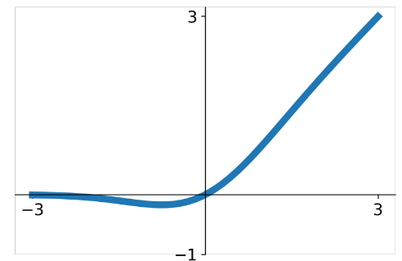The Gaussian error linear unit activation function takes the form:

$$GELU\left(x\right)=xP\left(X≤x\right)=\frac{x}{2}\left(1+\operatorname{erf}\left(\frac{x}{\sqrt{2}}\right)\right)$$

Where:

* + is the pre-activation input value
  + $P\left(X≤x\right)$ is the probability that some normally distributed random variable $X$ (with $μ=0, σ=1$) is less than $x$. This is the *cumulative distribution function (CDF) $Φ\left(x\right)$* of the normal distribution. $Φ\left(x\right)$ can be given in terms of the error function $\operatorname{erf}\left(x\right)$ (this is done because $\operatorname{erf}\left(x\right)$ is a commonly implemented function):
 $$Φ\left(x\right)=\frac{1}{2}\left(1+\operatorname{erf}\left(\frac{x}{\sqrt{2}}\right)\right)$$

 + We then multiply the pre-activation value with the CDF
  + GELU is approximately equal to $≈xσ\left(1.702x\right)$ where $σ$ is the sigmoid
* GELU is very common in transformer models (BERT, GPT, ViT)

#### Activation Function Performance Comparison

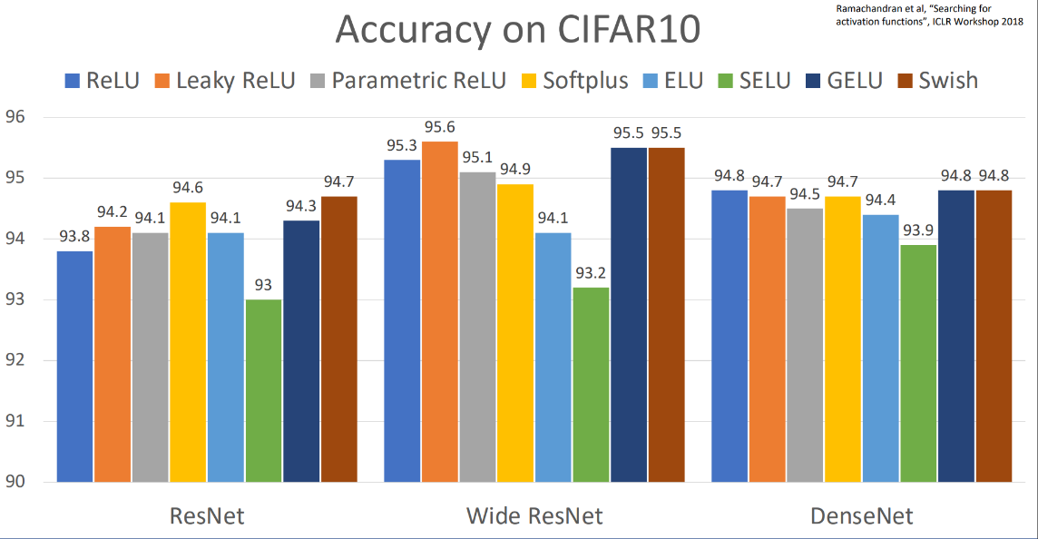The below plot compares the accuracy on CIFAR10 of eight different activation functions when used in three different neural networks:

Whilst there is some difference in the accuracy between different activation functions, **the difference is marginal, and the trends are not consistent**.

#### Summary

When picking an activation function:

* Don’t think too hard. **Just use ReLU**
* Try out Leaky ReLU / ELU / SELU / GELU if you need to squeeze out that last 0.1%
* **Do not use sigmoid or tanh**

### Data Preprocessing

Data preprocessing is the act of making your dataset more amenable to efficient training.

#### Mean Subtraction and Normalisation

One of the most common forms of preprocessing is **mean subtraction**, which involves subtracting the mean across every individual feature in the data (i.e. shifting the cloud of data to be centered around the origin in every single dimension), giving “zero-centered data”.

Then it is also common to **normalise** each input feature (i.e. data dimension) so that they are approximately the same scale. There are two common ways of achieving this:

1. Divide each data dimension through by its standard deviation after it is zero-centered, so that each feature has the same variance
2. Normalise such that the min and max of each dimension is -1 and 1 respectively.

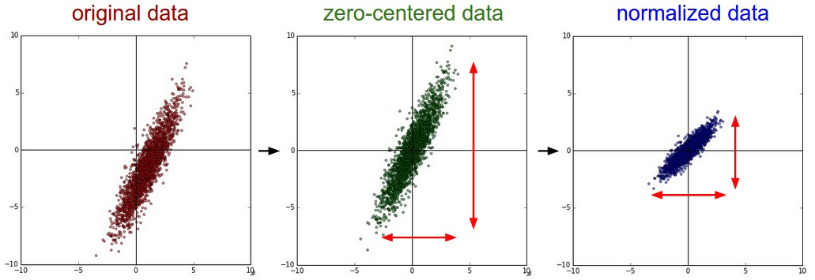Normalisation ensures that no individual feature dominates the learning process due to its larger magnitude. It only makes sense to do this if you believe that different input features have different scales (or units), but they should be of approximately equal importance to the learning algorithm. In case of images, the relative scales of pixels are already approximately equal (and in range from 0 to 255), so it is not strictly necessary to perform this preprocessing step.

**Why do we want to zero-center our data?**

In the same way that sigmoid outputs always being positive causes a constraint on the allowable gradient update directions (see Sigmoid), is our training data is always positive we get the same problem.

#### Principal Component Analysis (PCA) and Whitening

Whilst centering and normalising are common for image data, you may also see PCA and whitening used to preprocess other forms of training data.

**In the process of** **PCA (decorrelation)**:

We essentially move our data to the origin and then rotate it in such a way that it is decorrelated (i.e. the covariance matrix is diagonal). This is done by:

1. the data is first centered using mean subtraction,
2. then the covariance matrix is found. The covariance matrix contains elements at indices $\left(i,j\right)$, where the element is the covariance between the $i^{th}$ and $j^{th}$ dimension of the data (and therefore the diagonal elements are simply the variances).
3. the eigenvectors and eigenvalues of the covariance matrix are found. The eigenvectors are the directions of maximum variance in the data (i.e. the “principal components”), and the eigenvalues measure the amount of variance captured by each eigenvector
4. the eigenvectors are sorted in descending order based on their eigenvalues
5. you choose how many principal components to retain by looking at the cumulative explained variance. For example, you might select enough components to explain 95% of the total variance in the data.
6. the original data is projected onto the selected eigenvectors, giving and new dataset where the features are the principal components

**In the process of whitening (normalisation)**:

After the data has been decorrelated using PCA as above, we can then ensure each data dimension has zero mean and unit variance, in a process called whitening:

1. Divide each data dimension after PCA by the eigenvalues of the correlation matrix found during PCA. The data covariance matrix should now be the identity matrix
   1. In practice, we must add a small constant to the eigenvalues to prevent dividing by zero.
   2. 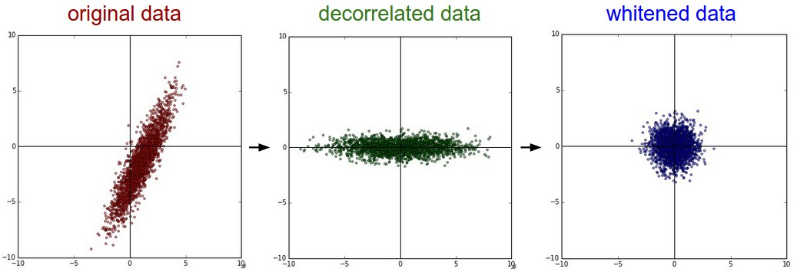One weakness of whitening is that it can greatly exaggerate the noise in the data, since it stretches all dimensions (including the irrelevant dimensions of tiny variance that are mostly noise) to be of equal size in the input. This can in practice be mitigated by stronger smoothing (i.e. increasing the small constant to some larger value).

#### Visualising the Effect of Data Preprocessing

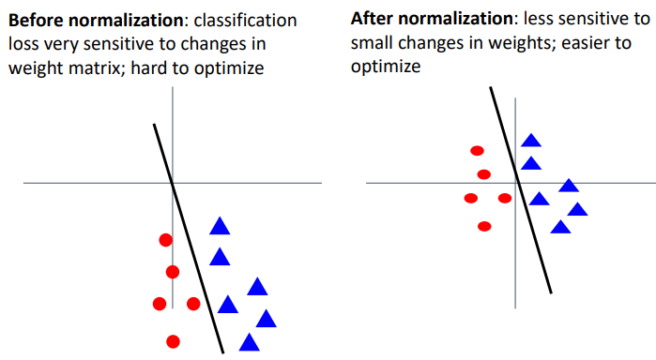For an example 2D dataset before normalisation, it may appear very far away from the origin, so we can imagine that a linear decision boundary may be very sensitive to changing the weight matrix as it effectively pivots around the origin, and the counterexample for the same dataset after normalisation.

#### Data Preprocessing for Images

Some common preprocessing techniques that are used for images are:

* Subtracting the mean image (e.g. AlexNet)
  + Calculate the mean image from all the training samples
  + Subtract that from each training sample
* Subtracting the per-channel mean (e.g. VGGNet)
  + Compute the mean RGB colour (i.e. a 3 number vector)
  + Subtract that from each pixel
* Subtracting the per-channel mean and divide by the per-channel standard deviation (e.g. ResNet)
  + Same steps as above for the per-channel mean
  + Compute and divide by the per-channel standard deviation in a similar manner

Note: The preprocessing statistics (e.g. mean and standard deviation) are calculated only on the training set and then applied consistently across the training, validation, and test sets.

### Weight Initialisation

Before training can start, the weights must be initialised to some values.

#### Zero or Constants

Weights should not be initialised to zero or any other constant common across all weights, as this will cause the output of every neuron (or every convolutional filter) in a given layer to compute the same output, and therefore the same gradient during backpropagation, and then update in the exact same way, preventing the network from learning diverse features (i.e. there is no “symmetry breaking” capability in the network).

Additionally, initialising to zero will cause some activation functions (e.g. ReLU) to only every output zero, preventing learning altogether.

#### Small Random Numbers

We may instead try to initialise the weights as small random numbers, e.g.:

$$W=0.01×np.random.randn\left(D_{in},D_{out}\right)$$

Note: multiplying random values from the normal distribution $N\left(0,1\right)$ by a scalar (e.g. 0.01) is equivalent to getting random values from the distribution $N\left({0,0.01}^{2}\right)$ (i.e. standard deviation of 0.01). The standard deviation is scaled by the scalar.

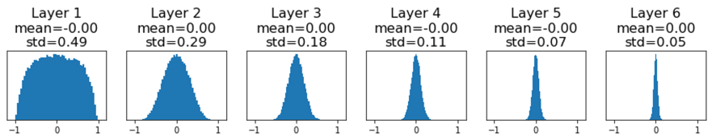This works okay for small networks but has problems with deeper networks. To see why this technique has issues we can imagine a 6-layer network with consistent hidden size of 4096, and tanh activation functions. Initialising the weights randomly with standard deviation of 0.01, and then plotting a histogram of the activation values from each of the layers after a single forward pass:

All activations tend to zero for deeper network layers. The gradients $dL/dW$ also then tend to zero, so no learning occurs.

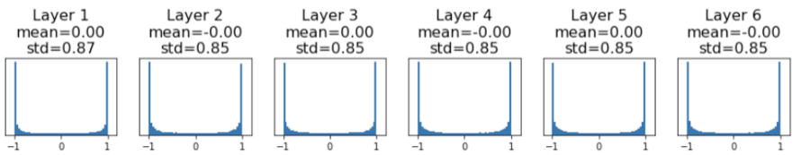If we then repeat the same exercise with an increased standard deviation of 0.05 with initialising the random weights:

All of the activations saturate, so the local gradients are zero and no learning occurs.

This suggests that there may be an optimal standard deviation value to use that is in between these two extremes.

#### Xavier Initialisation

One definition of the optimal value to use to solve the above problem is given by the Xavier Initialisation. The standard deviation is set to $1/\sqrt{D_{in}}$, i.e.:

$$W=np.random.randn\left(D_{in},D_{out}\right) / np.sqrt\left(D_{in}\right)$$

Note: For convolution layers, $D_{in}=k^{2}×C_{in}$

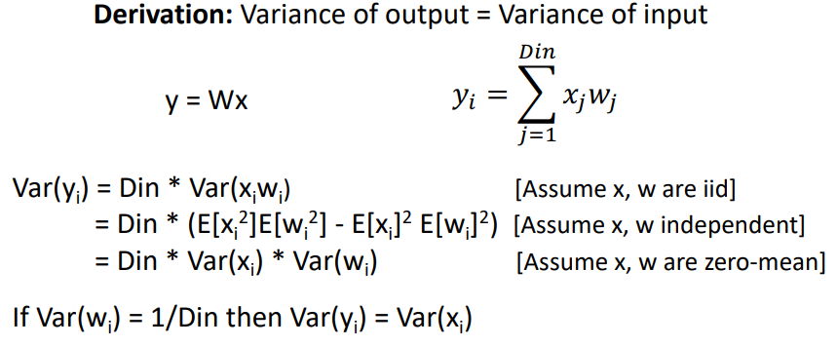This is derived from setting the variance of the output equal to the variance of the input.

**The above derivation only works because the tanh activation function is symmetric, it does not work for ReLU.**

#### Kaiming / MSRA Initialisation

To account for the fact that half of the zero-mean outputs are killed by ReLU (anything below zero), we simply double the variance of our initialised weights to account for this. Kaiming / MSRA initialisation therefore has standard deviation of $\sqrt{2/D_{in}}$, i.e.:

$$W=np.random.randn\left(D_{in},D_{out}\right) / np.sqrt\left({2/D}_{in}\right)$$

Kaiming / MSRA initialisation is able to make VGGNet trainable from scratch, without batch normalisation or any hacks.

**However, it is not suitable for residual networks (ResNets)**, due to adding on the residual which would cause the variance to grow between each block.For use with ResNets, we must make the modification of initialising the first convolution in the residual block with Kaiming / MSRA, and initialise the second convolution to zero, such that at initialisation the residual block 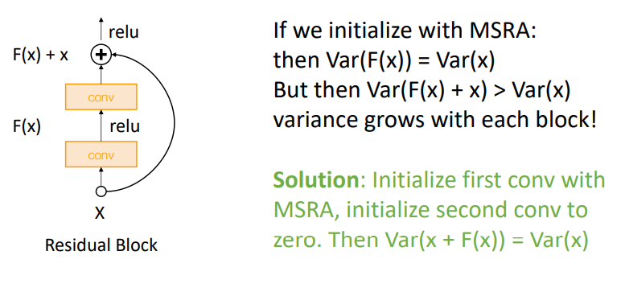only computes the identity function and variance is preserved.

#### Bias Initialisation

It is common to initialize the biases to zero, since the symmetry breaking is provided by the small random numbers in the weights.

### Regularisation

Now that our neural network is initialised and training, if we’ve done a good job of optimising it, we may see it perform much better on the training set compared to the validation set, i.e. it is **overfitting**.

We have already seen a simple method of regularisation, which is to add another term to the loss function:

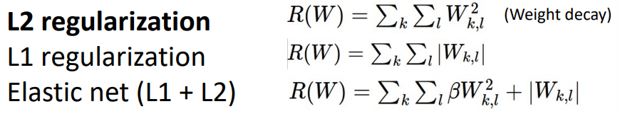Common terms used are L2 regularisation (aka. weight decay), L1 regularisation, and elastic net (L1 + L2).

Below are some additional regularisation techniques.

#### Dropout

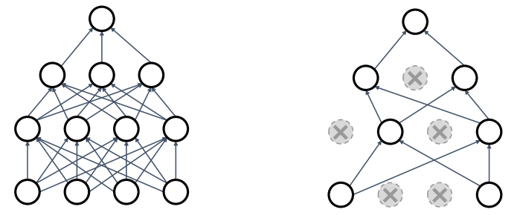In each forward pass, randomly set some neurons to zero. The probability of dropping is a hyperparameter, commonly set to 50%.

Dropout can be interpreted in multiple ways:

1. 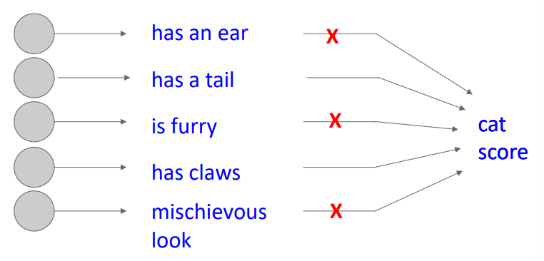Dropout forces the network to have a redundant representation, it prevents “co-adaptation” of features. Essentially, it encourages the network to be able to achieve its goals in multiple ways, using different combinations of the input information.
2. During each forward pass we are training a separate subnetwork contained within the full network. There are an incredibly large number of possible subnetworks. After training, the full network can then be seen as a large **ensemble** of these subnetworks.

At test-time we want dropout to be deterministic, we don’t want our output to be influenced by the random dropping of weights. We can attempt to “average out” the randomness at test-time. It turns out that the expected output value of a single neuron for all possible combinations of dropped inputs (e.g. neuron with two inputs: both dropped, neither dropped, one dropped or the other), is equal to the normal output scaled by the dropout percentage (e.g. 50%). Therefore, at test-time all neurons are active always, but we must scale their activations such that:

$$output at test time=expected output at training time$$

To avoid rescaling the activations at test-time, **inverted dropout** changes the implementation so that the scaling is done during training [e.g. we drop 50% of the neurons and then multiply each neuron by two (i.e. divide by the dropout rate)], and test-time occurs without any influence from dropout.

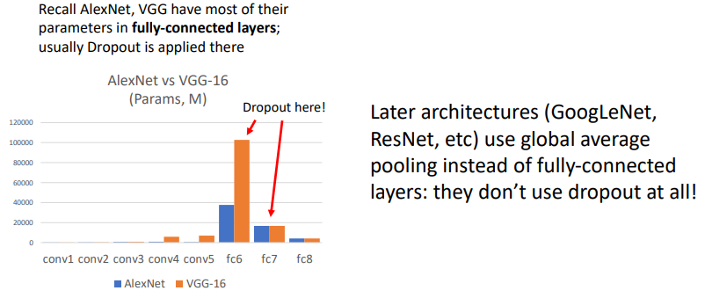Note about where/if to implement dropout:

#### Batch Normalisation

A common pattern observed when regularising is to:

1. Add some kind of randomness during training
2. Averaging out the randomness at test-time (sometimes approximately)

Batch normalisation fits this description and is indeed a form a regularisation. We normalise our training samples using statistics calculated on the *randomly generated batch*, then used *fixed statistics* at test-time to normalise.

We saw in dropout above that later architectures stopped relying on dropout. **For ResNet and later, it is often only L2 regularisation and batch normalisation which are used to regularise.**

#### Data Augmentation

Data augmentation is another method of adding randomness during the training process. For image data, this is often done by taking an existing training sample and then randomly applying some processing (e.g. flips, rotations, translations, crops, scales, brightness adjustments, etc.). This effectively multiplies the training set for free, whilst adding randomness during training.

**Data augmentation is a place where you can inject some of your own human expert knowledge into the training of the system about what the model should and shouldn’t be invariant to**.

#### DropConnect

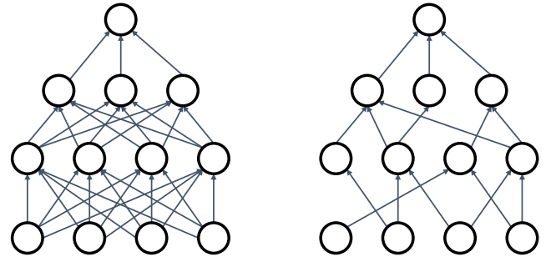Similar to dropout but instead of dropping random activations (i.e. neurons), we randomly drop weights (i.e. connections between neurons).

#### Fractional Pooling

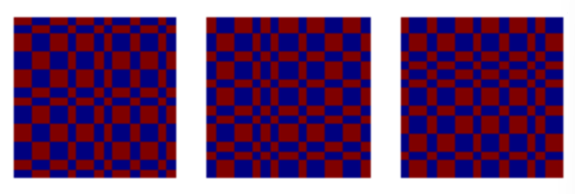Randomise the size of the pooling function kernel in each pooling layer for each forward pass. Called “fractional pooling” because although the pooling kernel has integer sizes, the expectation of its size for a bunch of different random sizes can be fractional.

#### Stochastic Depth

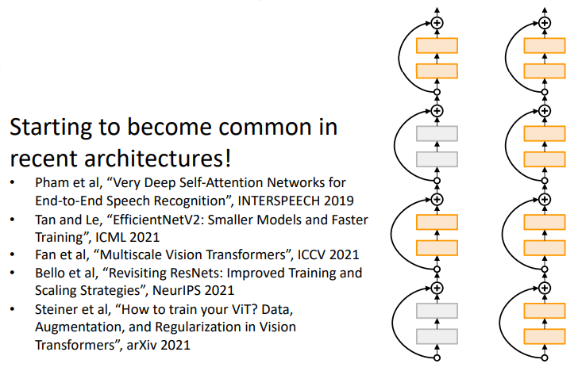Similar to dropout and DropConnect, except dropping random blocks in a ResNet. E.g. we can build a hundred residual block ResNet and then only use a subset of those blocks at training time, and all of them at test-time.

#### CutOut

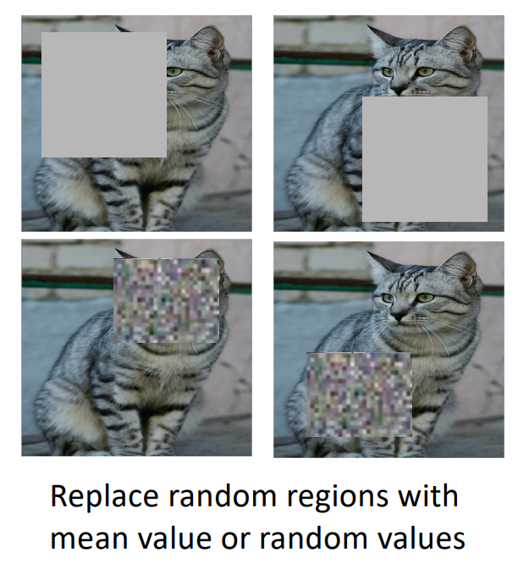Set random regions of training samples to zero, the mean value, or random values. Use the whole image at test-time.

#### MixUp

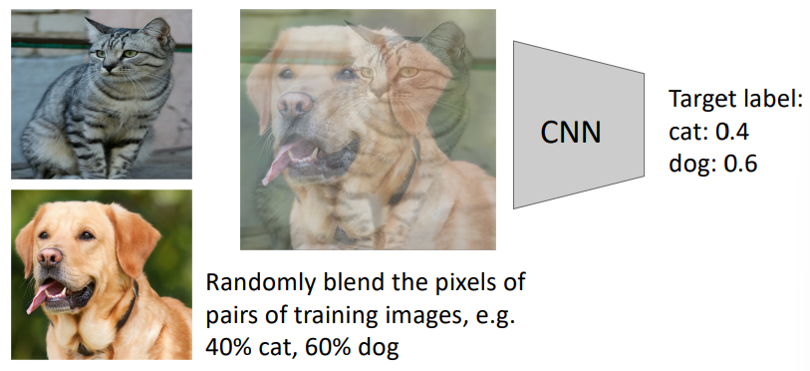Train of weighted blends of the training sample (where the weights are drawn from a beta distribution $β\left(a=0,b=0\right)$, so the blend weights are close to 0&1). Use the original images at test-time. Below example has exaggerated blend weights:

#### CutMix

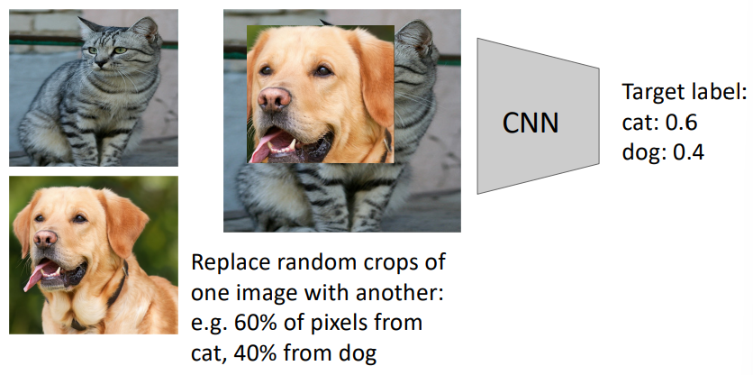Same as MixUp except random crops of one image are placed on another images.

#### Label Smoothing

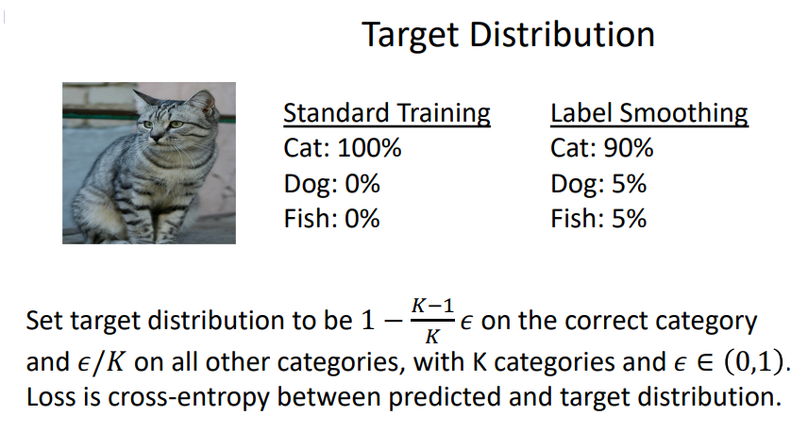Label smoothing “softens” one-hot encoded labels, encouraging the model to be less certain in its predictions. Instead of using one-hot encoded labels, we distribute some of the probability mass to the other classes:

#### Regularisation Summary

* Use DropOut for large fully connected layers
* Data augmentation is always a good idea
* Use BatchNorm for CNNs (but not ViTs)
* Try CutOut, MixUp, CutMix, Stochastic Depth, Label Smoothing to squeeze out a bit of extra performance

# Lecture 10 – Training Neural Networks II

In the previous lecture 9 we discussed some topics related to training neural networks in practice, specifically around the “one time setup” topics. This lecture will cover the “training dynamics” and “after training” topics.

## Training Dynamics (i.e. during training)

### Learning Rate Schedules

The different optimisation algorithms that we’ve explored (e.g. SGD, SGD+Momentum, Adagrad, RMSProp, Adam) all have learning rate as a hyperparameter. For most deep learning models, the learning rate is the most consequential hyperparameter.

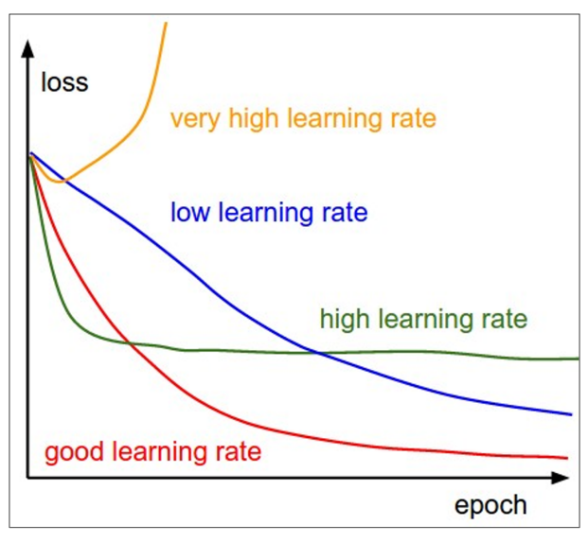Very high learning rates will diverge, high learning rates will make quick progress but usually struggle to achieve the best final loss, whilst low learning rates make slow progress but achieve better final loss values.

Rather than decided on a constant learning rate, we can schedule the learning rate as training progresses. Typically, the learning rate is decayed over time. There are different methods for implementing this reduction, described below.

#### Step

Involves reducing the learning rate at a few fixed points. For example, ResNets step their learning rate down by 10% after epochs 30, 60, and 90.

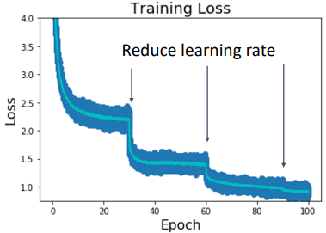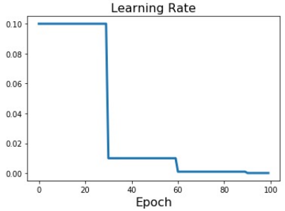

The above training loss plot is very characteristic of a stepped learning rate schedule.

One problem with stepped learning rate scheduling is that it introduces a lot more hyperparameters: which learning rates to use and at what epochs to step. This makes properly tuning a stepped learning rate schedule difficult, requiring a lot of trial and error. People typically train on a high learning rate and observe the training loss plot to see where the training loss or validation accuracy tends to plateau, then they decay the learning rate.

#### Functional Decay: Cosine, Linear

To counteract the tuning issue of stepped learning rate schedules, a cosine learning rate schedule decays the learning rate according to a half-wave cosine function:

$$α_{t}=\frac{1}{2}α_{0}\left(1+\cos\left(tπ/T\right)\right)$$

Where $α_{0}$ is the initial learning rate, and $T$ is the number of total epochs to train.

This is many fewer hyperparameters than the step decay schedule. In fact, it doesn’t introduce any new hyperparameters; we always need to choose some learning rate and some number of epochs to train for.

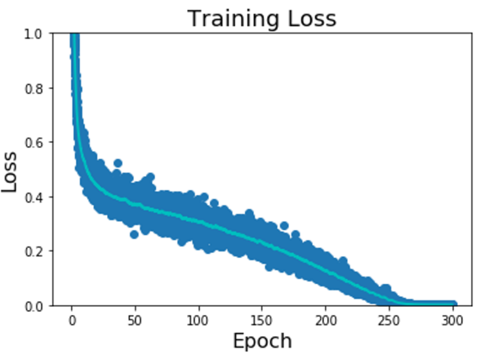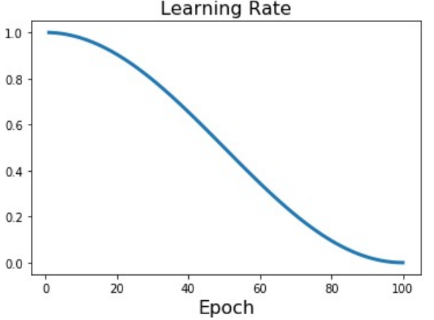

Rather than using a cosine as the function describing the decay, we can use a linear function:

$$α_{t}=α_{0}(1-t/T)$$

Or, less popularly, an inverse square root function:

$$α_{t}=α_{0}/\sqrt{t}$$

A potential pitfall of the inverse square root decay is that the model spends comparably less time at the high learning rates at the start of training.

#### Constant

**Using a constant learning rate works surprisingly well for most cases and should usually be tried first**. Changing learning rate schedules should not be done too early in the development process, it usually comes much later to squeeze out a couple of percent extra accuracy.

Caveat: If using SGD+Momentum, a decaying learning rate schedule is actually quite important to begin with. This is not the case of RMSProp and Adam.

#### Early Stopping: How long to train?

When training it is helpful to look at three different plots:

1. Loss vs iteration (where iteration is whenever the model weights are updated, i.e. after each minibatch). It’s useful to scatter plot each loss value to get an idea of the variance and also plot a moving average of the past 100 or 1000 iterations to get an idea of the trend.
2. Training accuracy vs epoch
3. 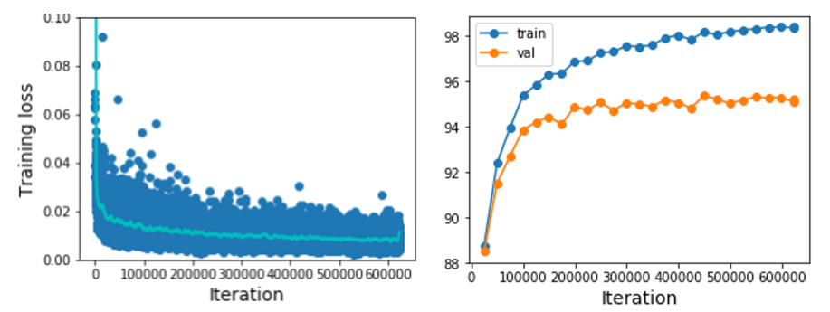Validation accuracy vs epoch

When deciding how long to train for:

1. Set a maximum number of epochs to train for
2. Always keep track of the model which gives us the best validation accuracy
   1. This is the model to use at test-time
3. 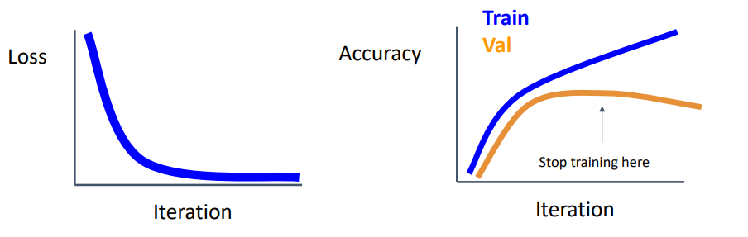Optionally, stop training early if training hasn’t yielded any improvement on the validation set in some minimum number of epochs.

### Choosing Hyperparameters

#### Grid Search

The grid search technique for choosing hyperparameters involves choosing several values for each hyperparameter [often spaced log-linearly (e.g. learning rates) or linearly (e.g. width) depending on the hyperparameter] and then training the model for all possible choices on this hyperparameter grid. For example:

$$weight decay:\left[1×{10}^{-4}, 1×{10}^{-3}, 1×{10}^{-2}, 1×{10}^{-1}\right]$$

$$learning rate: \left[1×{10}^{-4}, 1×{10}^{-3}, 1×{10}^{-2}, 1×{10}^{-1}\right]$$

We would try all 16 possible combinations, on as many GPUs as possible.

This technique gets infeasible very quickly as the grid grows larger and to higher dimensions; many GPUs are required.

#### Random Search

A technique that people try instead is a random search. Instead of defining discrete values for the hyperparameters that we want to test, we define ranges. Then many trials are run with randomly selected hyperparameter values from these ranges. For example,

$$weight decay:log\text{-}uniform on \left[1×{10}^{-4}, 1×{10}^{-1}\right]$$

$$learning rate: log\text{-}uniform on \left[1×{10}^{-4}, 1×{10}^{-1}\right]$$

We would try as many combinations as we can afford.

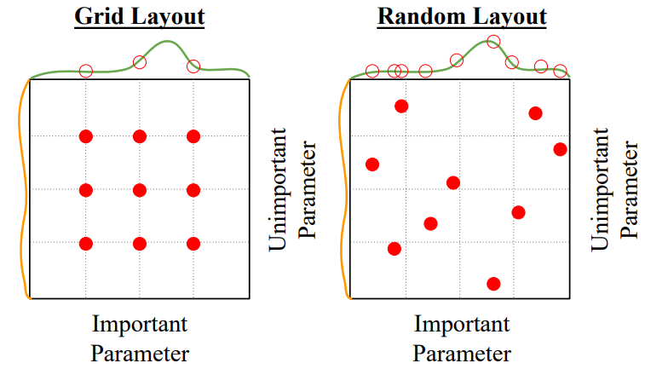Research suggests that **random search provides better results than a grid search**. To see why, see the plot below that shows that the x-axis hyperparameter influences model accuracy a lot whilst the y-axis hyperparameter does not. If we grid search, we spend a lot of time trying different values of the unimportant hyperparameter using a constant important parameter, such that only three different important parameter values are investigated in total. In contrast, the random search tries many more different values for the important hyperparameter.

Random search can also require a large number of GPUs.

#### In Practice

In the case where you don’t have access to many GPUs to try random search with, the following steps can be used to choose hyperparameters:

1. Check initial loss
   1. Turn off weight decay and run a single iteration
   2. Sanity check the initial loss

The expected value depends on the loss function and dataset.

E.g. $L_{0}≈\log{C}$ for softmax loss with $C$ classes

1. Overfit a small sample
   1. Turn off regularisation
   2. Take a small sample of the training data (~5-10 minibatches)
   3. Fiddle with the model architecture, learning rate, weight initialisation, etc. until you can achieve 100% training accuracy in less than 5 minutes of training.
      1. If loss isn’t going down: learning rate is too low and/or bad initialisation
      2. If loss explodes to Inf or NaN: learning rate is too high and/or bad initialisation
2. Find a learning rate that makes loss go down
   1. Use the same architecture from the previous step
   2. Use the full training set
   3. Turn on a small amount of weight decay
   4. Find a learning rate that makes the loss drop significantly within 100 iterations (only change the learning rate, no other parameters)
      1. Good learning rates to try: 1e-1, 1e-2, 1e-3, 1e-4
3. Conduct a coarse grid search, training for ~1-10 epochs
   1. Choose a few values of learning rate and weight decay around what worked from step 3
      1. Good weight decay to try: 1e-4, 1e-5, 0
   2. Train the model on the full training set for each hyperparameter combination, for ~1-10 epochs
   3. Record the model’s accuracy on the validation set
4. Iterate with finer grid, longer training (~10-20 epochs)
   1. Pick the best models from step 4
   2. Setup a finer grid around these hyperparameter values
   3. Train the model on the full training set for each hyperparameter combination, this time for ~10-20 epochs (without learning rate decay)
5. Look at learning curves
   1. As mentioned above, it’s useful to monitor multiple plots to gauge training performance:
      1. Training loss vs iteration: scatter plot showing each iteration and a moving average of the past 100 or 1000
      2. Training/validation accuracy vs epoch (not every iteration)
   2. 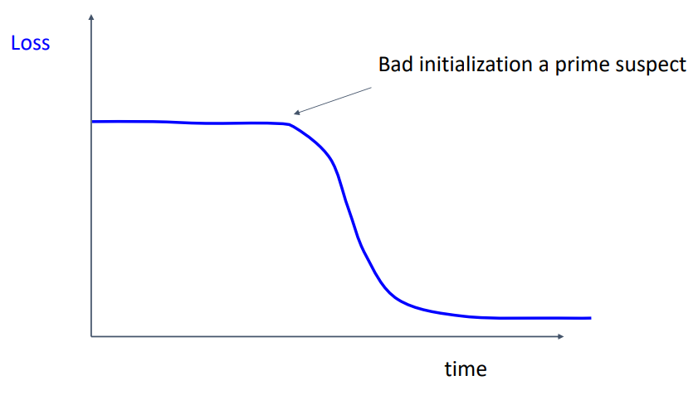Look out for the following learning curves:
      1. Poor initial learning; adjust initialisation and try again
      2. 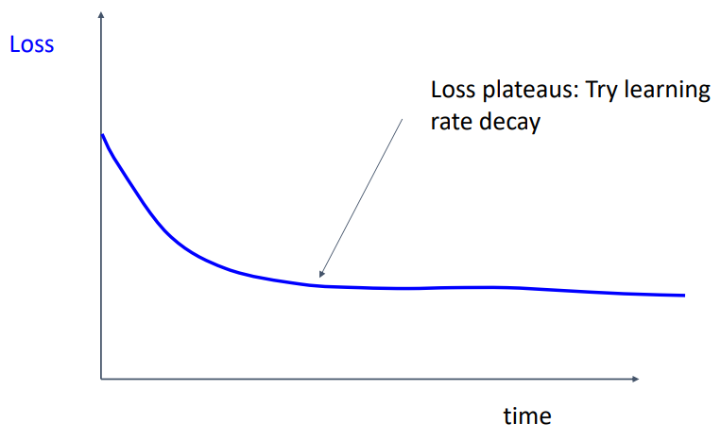Loss plateaus; try learning rate decay
      3. 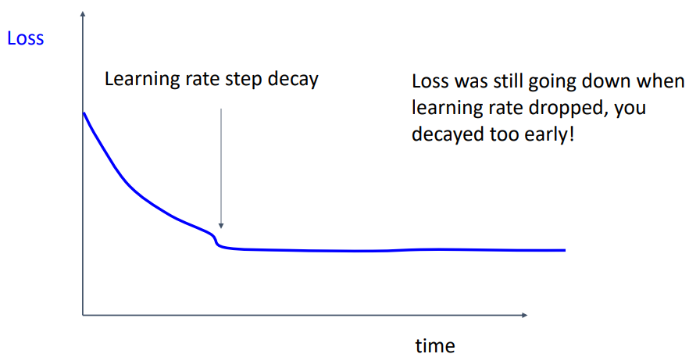Sudden loss drop and then plateaus; decayed learning rate too early whilst the model was still learning
      4. 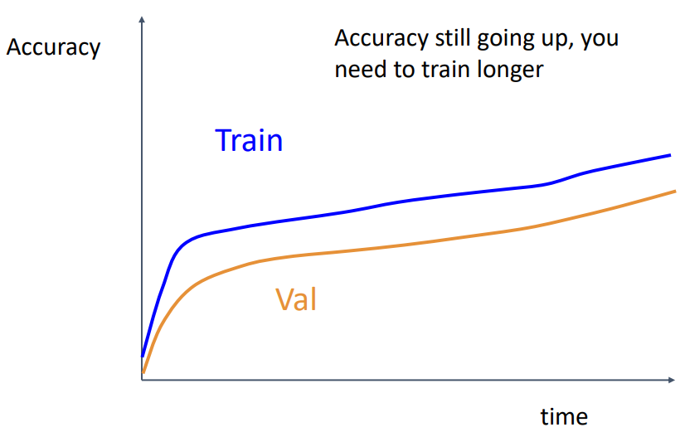Accuracy is still going up, healthy gap between train and val; you need to train longer
      5. 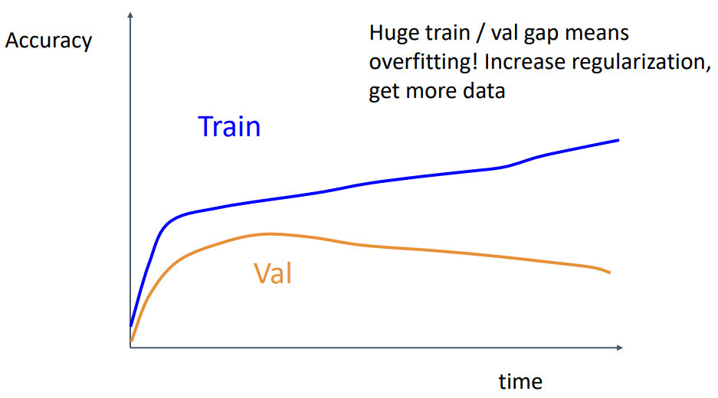Huge gap between train and val means overfitting; increase regularisation, or get more data (or in rare cases, decrease the size/capacity of the model)
      6. 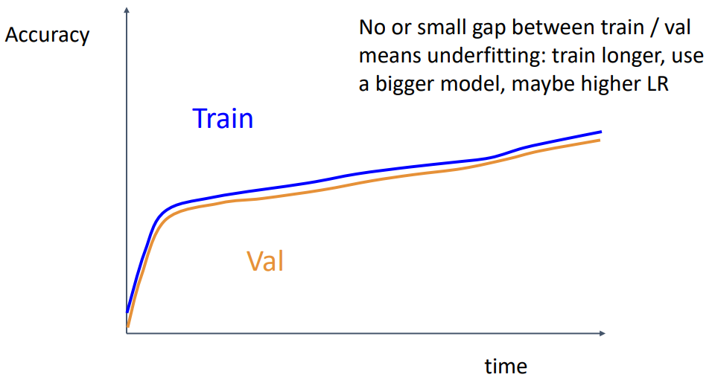No/small gap between train and val means underfitting; decrease regularisation, increase model capacity, maybe higher learning rate (note: although fixing underfitting will increase the gap between train and val, it should increase the overall magnitude of both)
6. GOTO step 5
   1. Based on the insights given by the loss curves of the previous iteration, refine the grid search and iterate again
   2. Stop when your paper submission deadline gets too close

#### NOTE: Learning Hyperparameters with Gradient Descent

It is possible to wrap your machine learning code in another optimisation loop such that backpropagation is used to optimise the hyperparameters. This can be done in PyTorch.

Additionally, researchers have been able to use this process to actually *learn the training data which would give the best performance on the validation set*.

### NOTE: Ratio of Weight Update to Weight Magnitude

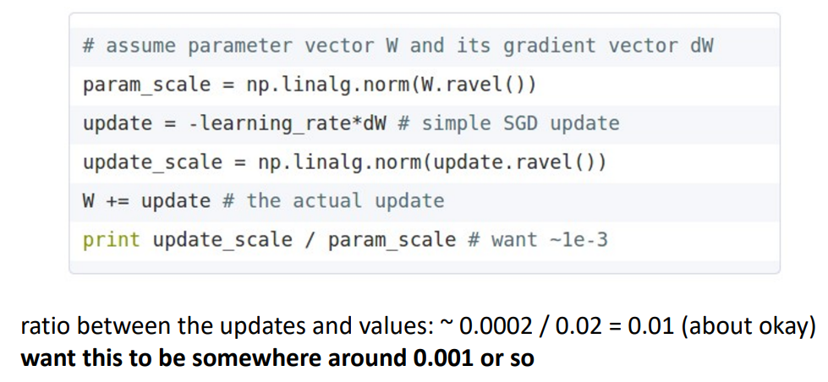Another heuristic we can use to see if training is progressing well is to check the ratio between the absolute value of the weight update and the absolute value of the weights. We want this to be somewhere around 1e-3 (0.001).

## After Training

### Model Ensembles

A very simple method that is able to achieve slightly better performance on basically any problem is the use of model ensembles.

1. Train $n$ independent models, as many as you can afford to train
   1. Alternatively, use multiple snapshots of a single model during training (note: cyclic learning rate schedules have been shown to make this work even better)
2. At test-time, average their results (averaging process depends on the problem)
   1. E.g. for a classification problem:
      1. Take the average of the predicted probability distributions
      2. Then choose argmax
3. Enjoy ~1-2% extra performance

#### Polyak Averaging

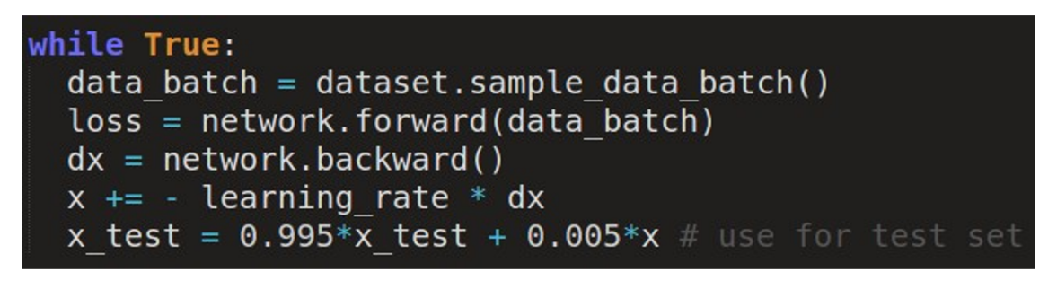Instead of using the actual weights matrix at test-time, we can keep a moving average of the weights matrix throughout training (similar to batch normalisation) and then use that at test-time:

This can help to smooth out some of the iteration-to-iteration variation seen during training.

### Transfer Learning

Transfer learning is a very powerful tool that allows us to make use of models which were trained for one task to do useful work on another new task.

It is a common misconception that “you need a lot of data if you want to train/use CNNs”. This is not the case if you make use of transfer learning. Many problems can be tackled using deep learning with relatively small amounts of training data.

#### Transfer Learning with CNNs

It is very common to use a CNN that has been pretrained on ImageNet as a base for a new application. Recall that neural networks can be thought of as feature extractors and classifiers all-in-one. By removing the classifier part of the pretrained CNN, which is problem specific (e.g. outputs 1000 class scores for ImageNet), we are left with essentially a CNN feature extractor.

With this feature extractor we can do a couple things:

* 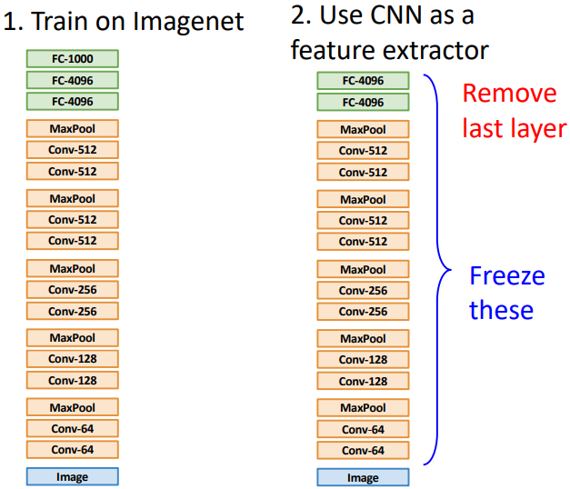**Freeze the CNN, then add new classifier (i.e. Feature Extraction)**: freeze the weights of the feature extractor and add on a new classifier (e.g. a fully connected layer) suited for our new task. Example shown below:
* **Finetuning**: add on a new classifier but continue training the entire network for the new task. Some tricks for doing this:
  + It is often beneficial to freeze the CNN and train the new classifier for a bit first, and then unfreeze in order to finetune the whole network
  + Lower the learning rate; use ~1/10 the learning rate used in the original training
  + Sometimes freezing the lower layers to save computation
  + Train with BatchNorm in “test” mode (i.e. maintain the pretrained statistics)
    - The fine-tuning dataset may have small batch sizes, leading to noisy mean/variance estimates and degrading stability

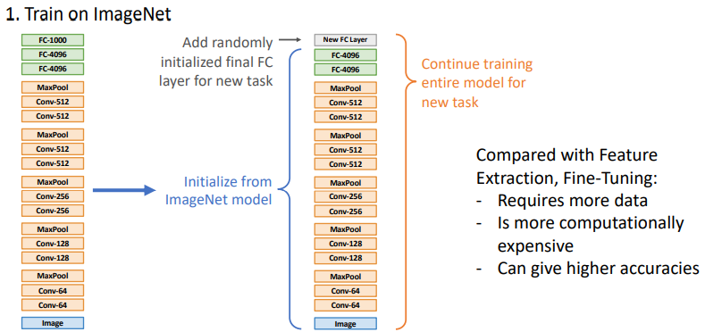The process of fine-tuning is shown below:

The relative performance of CNN architectures on ImageNet tends to correspond closely to their relative performance on other computer vision problems when used via transfer learning (e.g. ResNets outperform VGG on ImageNet and will also outperform them when used as a pretrained model for other problems).

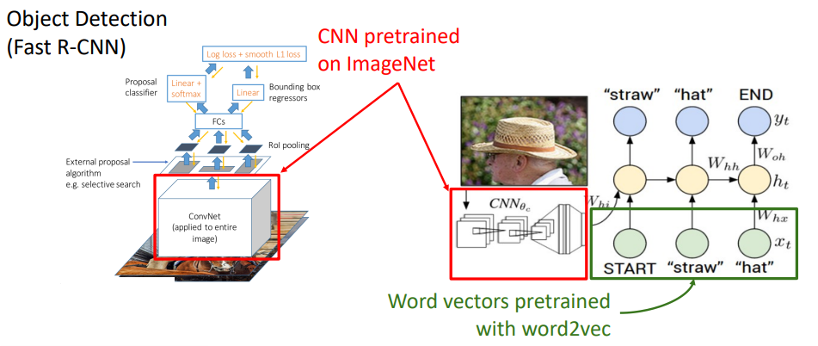Transfer learning is pervasive; it’s essentially the norm rather than being used in exception. For example, the same CNN trained on ImageNet can be used in object detection and generating image descriptions:

# Lecture 11 – CNN Architectures II

This lecture continues on from Lecture 8, providing an overview of more recent CNN architectures. We left off in 2015 when ResNet-152 won ImageNet.

## Model Ensemble (Winner 2016) – Inception, Inception-ResNet, ResNet, Wide ResNet

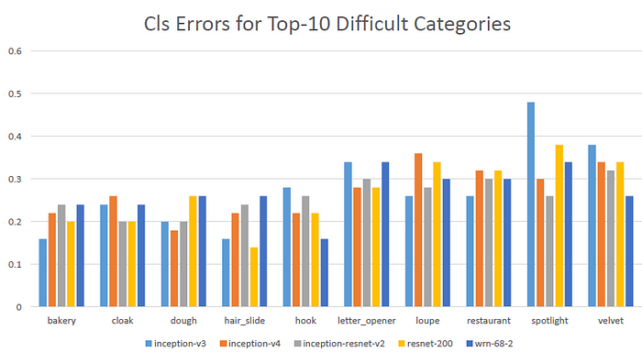The ImageNet 2016 winner was simply a model ensemble from Trimps-Soushen. The classification errors of the top-10 most difficult classes by five different models are given below:

There is no dominant model; each model is strong at classifying some categories whilst being weak at classifying others.

During training, they performed multi-scale augmentation & large mini batch size.

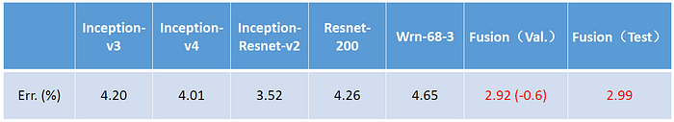The validation errors of each individual model is given below, along with the validation and test error of the ensemble (note: Inception-ResNet-v2 was weighted highest in the ensemble):

## ResNeXt (2017)

Recall that we were able to improve ResNets with the addition of “bottleneck” residual blocks. ResNeXts propose using $G$ number of “bottleneck” residual blocks in parallel as their basic building block. The inner number of channels within each “bottleneck” residual block is denoted $c$. Then, for a set channel dimension $C$ and $G$ number of parallel blocks, we can solve for the inner channel dimension $c$ which gives an equal number of FLOPs as the original “bottleneck” residual block design. Similarly, you could instead solve for the number of parallel 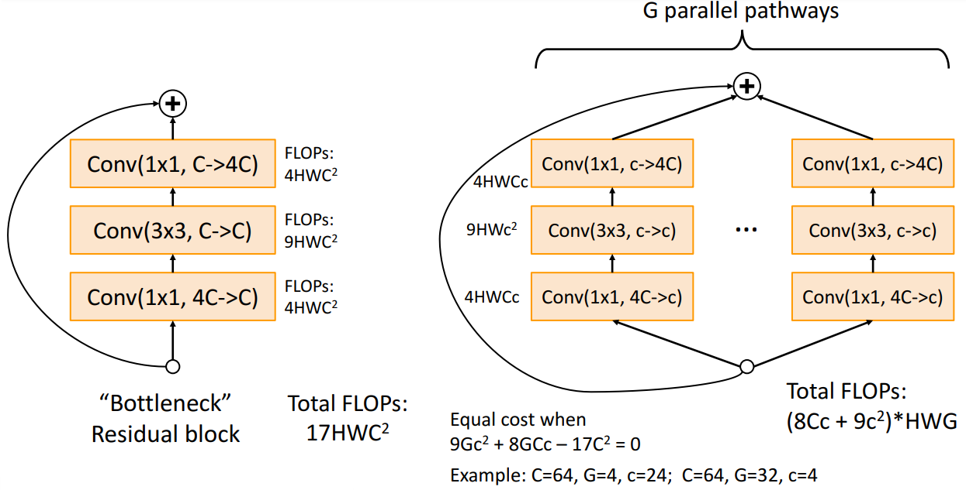pathways $G$.

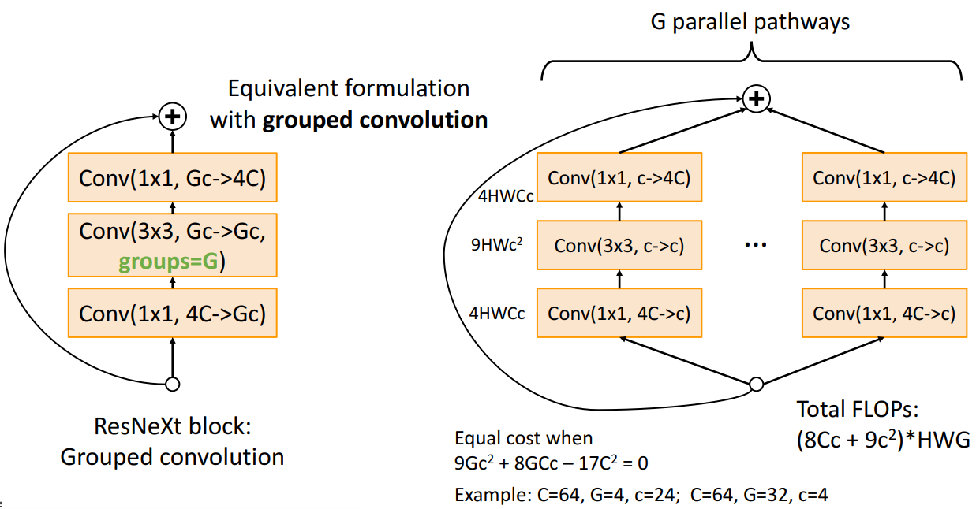The same formulation can be implemented using **grouped convolutions**, described further below.

### Grouped Convolution

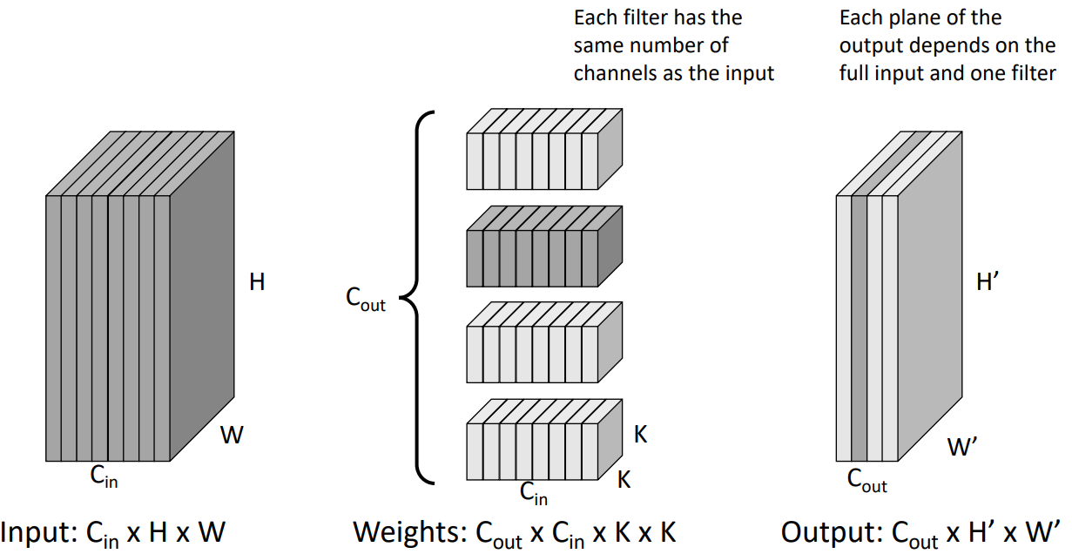Recall for a regular convolution, each of the filters has the same number of channels as the input, and each of those filters is responsible for a single channel in the output.

**Grouped convolution**, on the other hand, divides the channels of the input into $G$ groups, with $C_{in}/G$ channels in each. The filters are also divided into $G$ groups, where each group of filters acts only on the corresponding group of channels in the input. Therefore, each channel in the output depends on a single filter which acted on only a subset of the input channels.

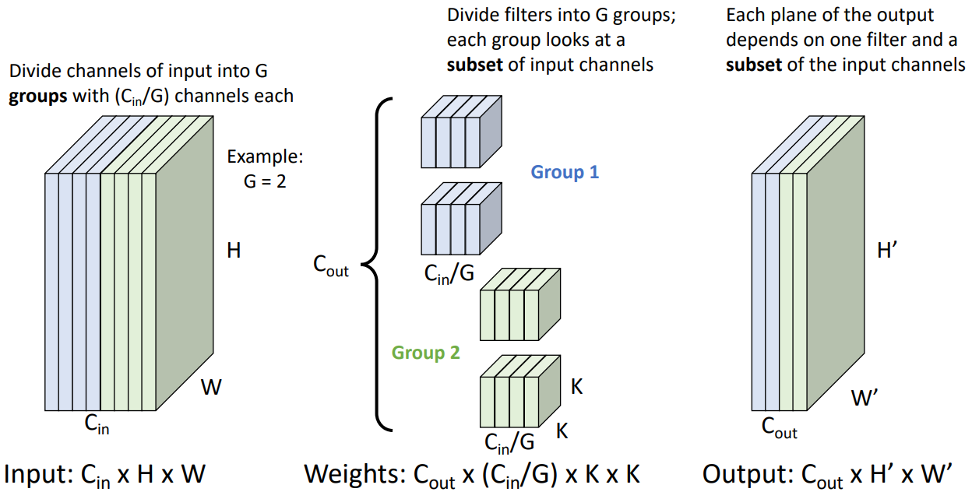An example with $G=2$ number of groups is given below:

#### Special Case: Depthwise Convolution

Depthwise convolution is a grouped convolution where the number of groups equals the number of input channels, i.e. each filter group acts only on a single input channel. It is also common to set the number of output channels (i.e. the number of filters) to the number of groups/input channels, however you can still have multiple filters per group.

*Depthwise convolution only mixes spatial information from the input; channel information is not mixed.*

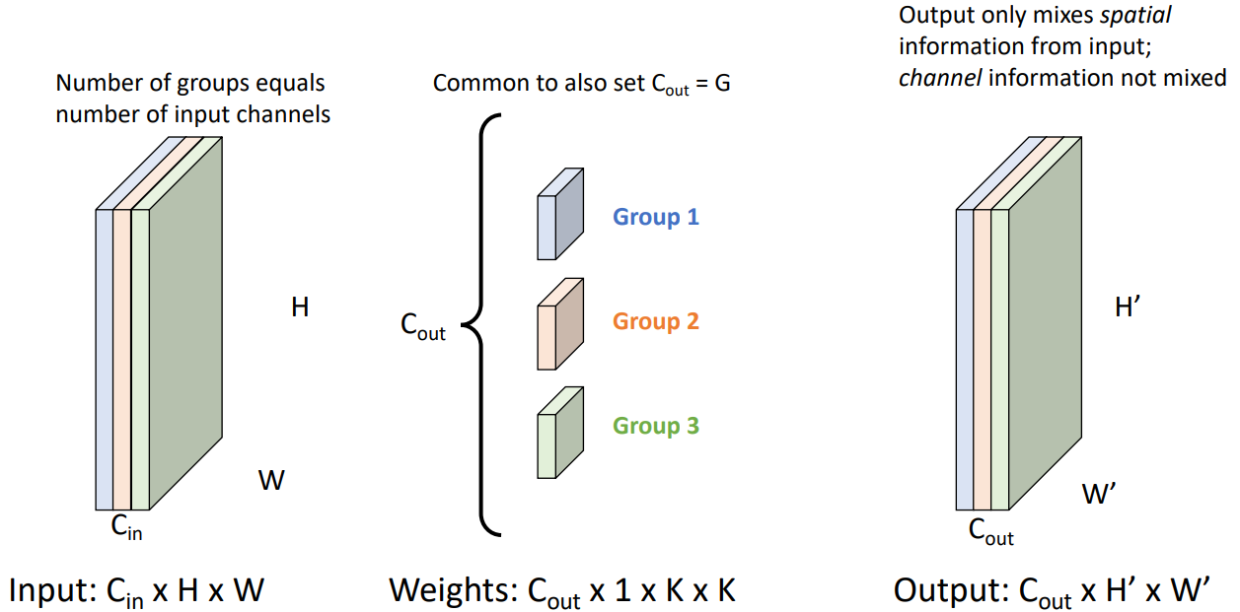An example of depthwise convolution for $C_{out}=G=C_{in}$ is given below:

#### Grouped vs Standard Convolution

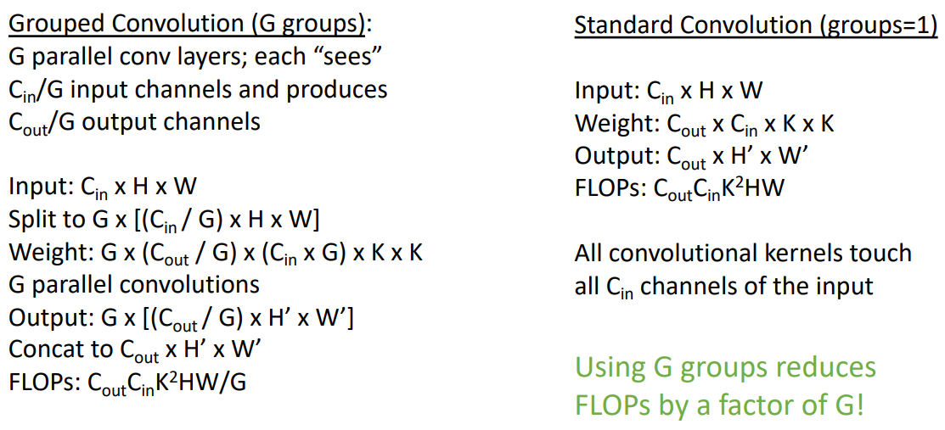For the same input of size $C_{in}×H×W$, a grouped convolution with $G$ groups will reduce the number of FLOPs required by a factor of $G$ compared to a standard convolution:

### ResNeXt Performance

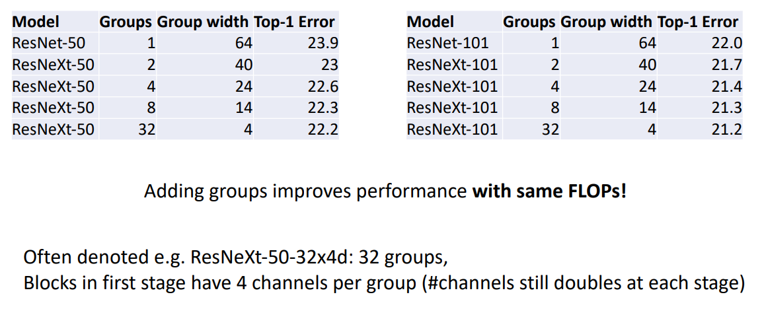Adding grouped convolutions to ResNets improves their performance **for the same FLOPs**.

## Squeeze-and-Excitation Networks (SENet) (Winner 2017)

In a typical ResNet block, the convolutions act on local patches of the image. SENets perform:

1. a “squeeze operation” (i.e. a global average pooling to get the average value for each channel), and then
2. an “excitation operation” (i.e. pass the channel averages through some fully connected layers followed by a sigmoid) to generate a set of scalar weights for each channel
3. The output of the residual block is then scaled by these weights, adjusting the importance of each channel

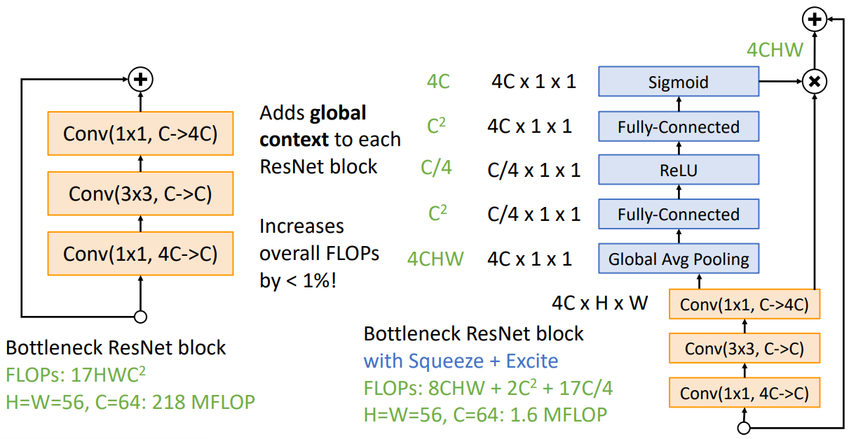This provides **global context** (i.e. some information about the input as a whole)to typical residual blocks. Adding squeeze and excitation to a bottleneck residual block increases the overall FLOPs by less than 1%.

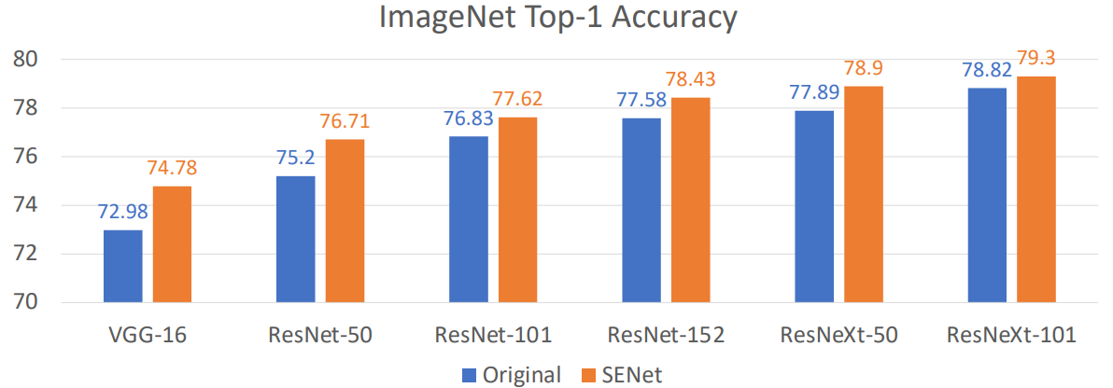Whilst providing a 1-2% boost in accuracy:

## Tiny Neural Networks for Mobile Devices

Instead of pushing for the largest network with the biggest accuracy, tiny networks aim for the best possible accuracy / complexity trade-off, for using on mobile and embedded devices. Model complexity can be measure in FLOPs, number of parameters, or runtime speed.

### MobileNets

MobileNets are a family of neural networks designed for mobile and embedded devices. Instead of standard convolution blocks, MobileNets use **depthwise separable convolution blocks** which break the standard convolution into two parts. These parts are a depthwise convolution followed by BatchNorm and ReLU, and then a pointwise convolution followed by BatchNorm and ReLU. The depthwise convolution mixes spatial involution, whilst the pointwise convolution 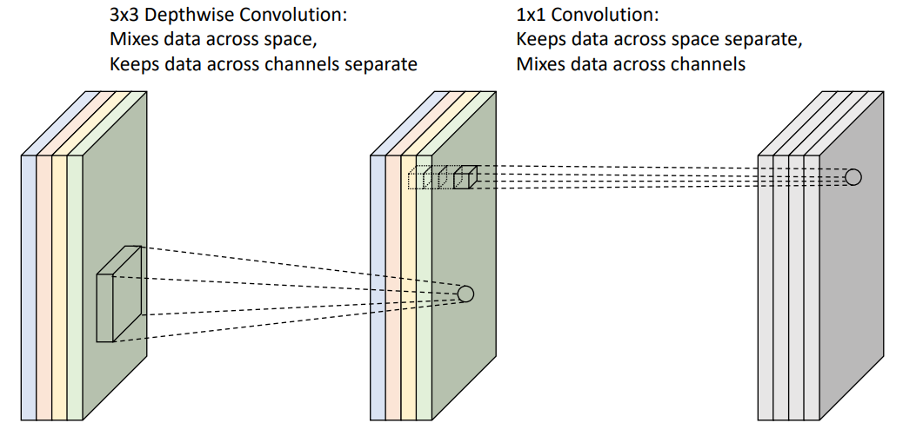combines the channels:

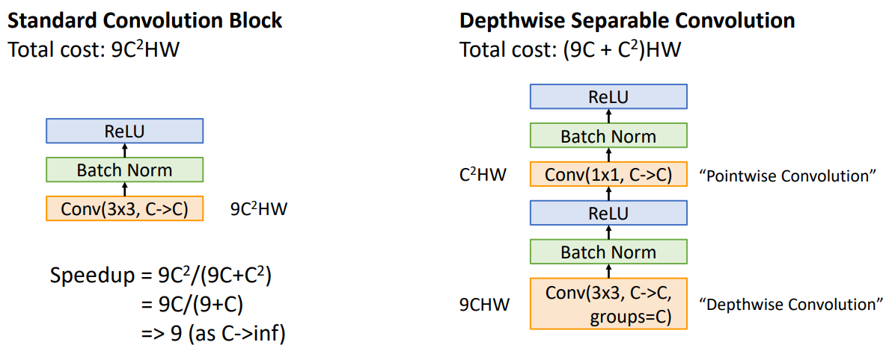Compared to standard convolution blocks, depthwise separable convolution blocks have fewer parameters and less computation, although may have slightly lower accuracy:

#### MobileNetV2: Inverted Bottleneck, Linear Residual

MobileNetV2 improved on the efficiency of MobileNet with the addition of **inverted bottleneck blocks** and the use of **linear residuals** (i.e. simply an identity function instead of ReLU).

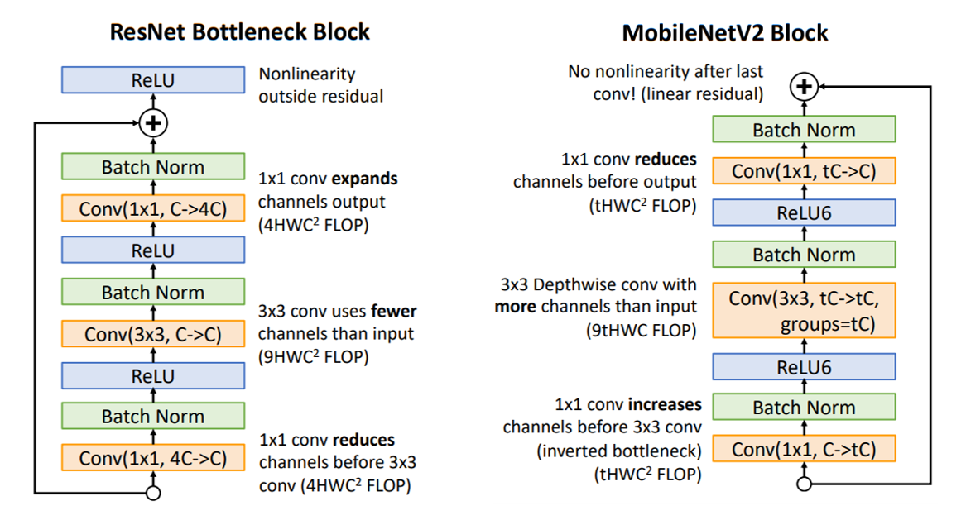

In comparison to standard bottleneck blocks which reduce the number of channels before expanding them later, inverted bottleneck blocks expand the number of channels using a pointwise convolution, then perform a depthwise convolution, followed by another pointwise convolution to contract back to fewer channels.

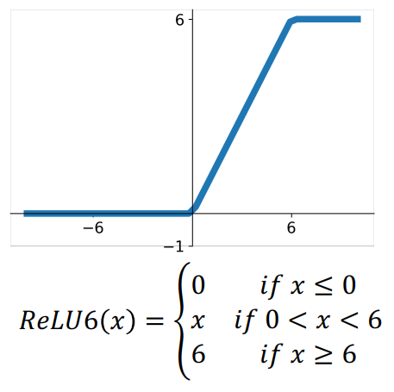Note the use of **ReLU6** in the MobileNetV2 block. This activation function is simply a ReLU function that is clipped at 6, to keep the activations in a reasonable range when the model is running inference in low precision.

### ShuffleNet

ShuffleNets are another family of efficient convolutional neural networks. They make use of the idea of the **channel shuffle** layer.

#### Channel Shuffle

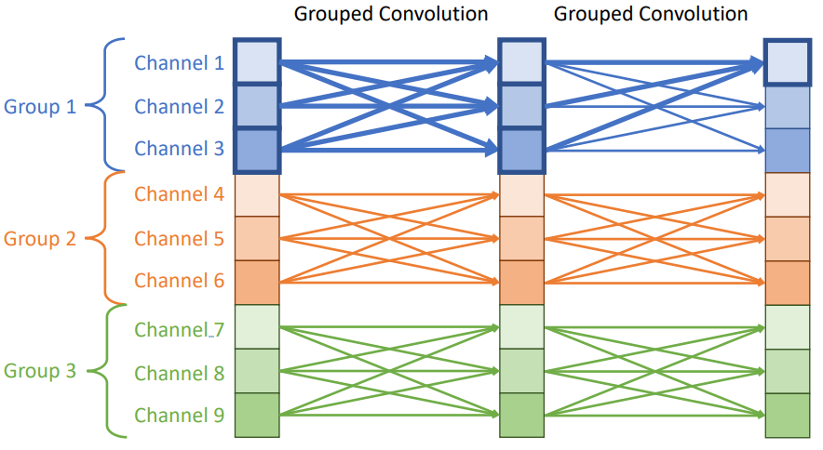A potential inefficiency with grouped convolutions is that when you stack multiple of them in a row, the information is never mixed across channels from the different groups, i.e.:

This could be resolved by performing an ungrouped convolution to mix the grouped channel information, at the cost of the efficiency provided by grouped convolutions.

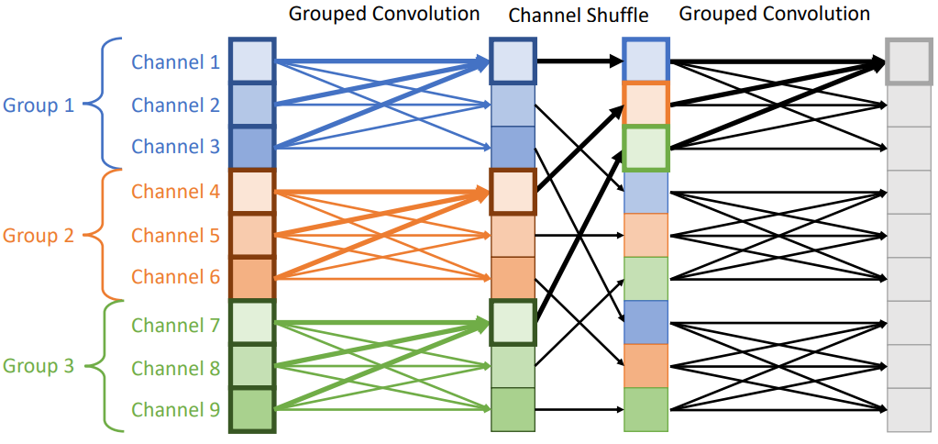Instead, “channel shuffling” permutes the channels in between grouped convolutions, mixing the grouped channel information without the need for any ungrouped convolutions:

#### A screenshot of a graph AI-generated content may be incorrect.ShuffleNet Block and Accuracy

## Neural Architecture Search (NAS)

Manual designing neural network architectures is difficult, NAS attempts to automate it. NAS follows these steps:

1. One network (**controller**) outputs network architectures
2. Sample **child networks** from the controller and train them
3. After training a batch of child networks, make a gradient step on the controller network using a **policy gradient**
4. Over time, the controller learns to output good architectures

**MobileNetV3** was found using NAS.

NAS is very expensive. In the original NAS paper, each update to the controller required training 800 child models for 50 epochs on CIFAR10. A total of 12,800 child models were trained. Later work has improved the efficiency, but the process is still expensive.

## Model Scaling

Starting from a given architecture, how should we scale it up to improve performance?

Some options include:

* Width: Increase the number of channels in all layers
* Depth: Increase the number of layers
* Resolution: Increase the resolution of the input image
* Compound: Use all of the above jointly.

### EfficientNets

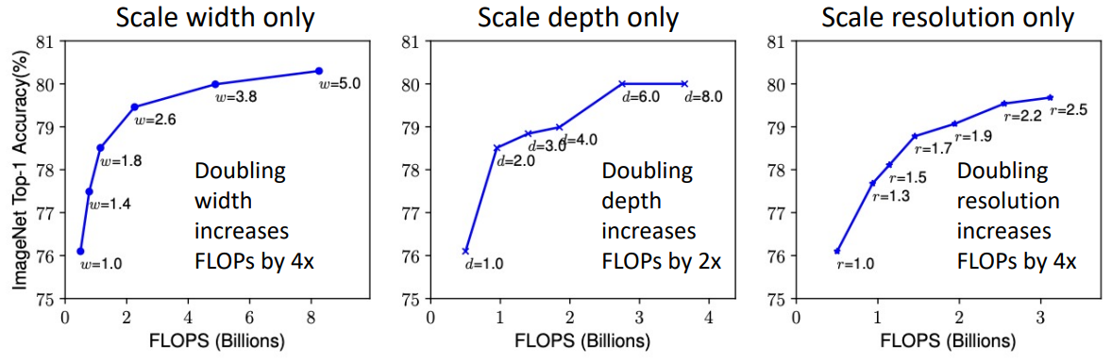Scaling any of width, depth, or resolution alone has diminishing returns. For optimal results, we need to scale them all jointly.

EfficientNet is a family of convolutional neural networks that utilise compound scaling; where all dimensions of width, depth, and resolution are scaled together.

The baseline network EfficientNet-B0 was found using NAS and uses depthwise convolutions, inverted bottlenecks (as in MobileNets), and [Squeeze-and-Excitation](#_Squeeze-and-Excitation_Networks_(SE).

The depth, width, and resolution are then scaled using the compound coefficient $ϕ$:

$$depth multiplier:d=α^{ϕ}$$

$$width multiplier:w=β^{ϕ}$$

$$resolution multiplier:r=γ^{ϕ}$$

Such that $α≥1,β≥1,γ≥1$ and $α∙β^{2}∙γ^{2}≈2$. This last condition is such that increasing $ϕ$ by a factor of $ϕ_{0}$ would increasing the total FLOPs by approximately $2^{ϕ_{0}}$.

The hyperparameters $α,β,γ$ are determined using a small grid search, the original paper suggests $α=1.2$, $β=1.1$, $γ=1.15$.

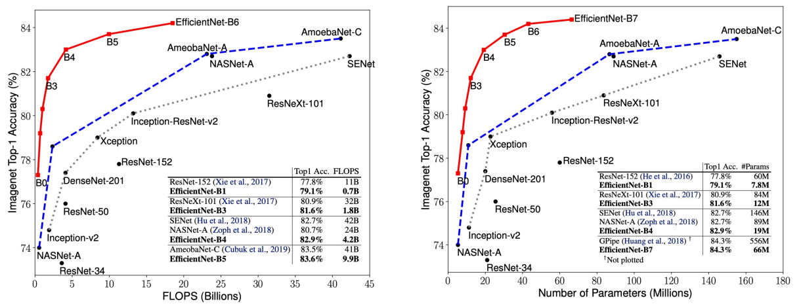This is how EfficientNets compare to other architectures in terms of FLOPs and number of parameters:

There is a **big problem** with this comparison however: *real-world runtime does not correlate well with FLOPs*.

* Runtime depends on the device (mobile CPU, server CPU, GPU, TPU); a model which is fast on one device may be slow on another
* Depthwise convolutions are efficient on mobile, but not on GPU / TPU (they become memory-bound)
* The “naïve” FLOP counting we have done for convolutions can be incorrect [there are alternate convolution algorithms that can reduce FLOPs in some settings (e.g. FFT for large kernels, Winograd for 3x3 conv)]

EfficientNet was designed to minimize FLOPs, not actual runtime – so it is surprisingly slow!

## NFNets – Normaliser-free ResNets

Batch normalisation has good properties:

* Makes it easy to train deep networks >= 10 layers
* Makes learning rate selection and weight initialisation less critical
* Acts as a form of regularisation
* Is “free” at test-time (can be merged into linear layers)

But it also has some undesirable properties:

* Doesn’t work with small minibatches
* Gives different behaviour at train and test-time
* Is slow during training

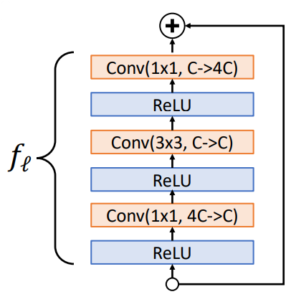NFNets are a family of ResNets that are trained without batch normalisation.

### Scaled Residual Blocks

NFNets make use of scaled residual blocks. Consider a pre-activation ResNet block (with no batch normalisation) with output $x_{l+1}=f_{l}\left(x_{l}\right)+x_{l}$ (shown right).

**Problem** – The variance grows with each of these blocks:

$$Var\left(x_{l+1}\right)=Var\left(x_{l}\right)+Var\left(f_{l}\left(x_{l}\right)\right)$$

**Solution** – Reparametrise the block:

$$x_{l+1}=x_{l}+αf_{l}(x_{l}/β_{l})$$

Where $α$ is a hyperparameter, $β_{l}=\sqrt{Var\left(x_{l}\right)}$ at initialisation; and both are constants during training.

Now, $Var\left(x_{l+1}\right)=Var\left(x_{l}\right)+α^{2}$. This resets to $1+α^{2}$ after each downsampling block.

### Weight Standardisation

Rather than normalisation activations during training, NFNets use weight standardisation to normalise weights instead.

We learn the weights $W$ but normalise it such that we are convolving using weights $\hat{W}$:

$${\hat{W}}_{i,j}=γ∙\frac{W_{i,j}-mean\left(W_{i}\right)}{std\left(W_{i}\right)\sqrt{N}}$$

Where $W_{i}$ is a single filter, $N=K^{2}C_{in}$ is the “fan-in” of the kernel, and $γ$ is a constant that depends on the activation function used [for ReLU: $γ=\sqrt{2/(1-\left(1/π\right))}$].

We compute $\hat{W}$ each iteration during training (and backpropagate through it). At test-time we use fixed $\hat{W}$ (giving zero overhead like in batch normalisation).

### NFNets: Other Tricks

NFNets also use some other tricks, including:

* **Adaptive Gradient Clipping**: Clip raw gradients during training if they get too large
* **Tweaked ResNet architecture**:
  + Start from SE-ResNeXt
  + Tweak the stem and downsampling blocks (ResNet-D)
  + Change ReLU to GeLU
  + Set group width to 128 for all layers
  + Change the stage widths from [256, 512, 1024, 1024] to [256, 512, 1536, 1536]
  + Change the stage depths from [3, 4, 6, 3] to [1, 2, 6, 3]
* **Stronger Regularisation**: Use MixUp, RandAugment, CutMix, DropOut, StochasticDepth

## ResNets: Revisited

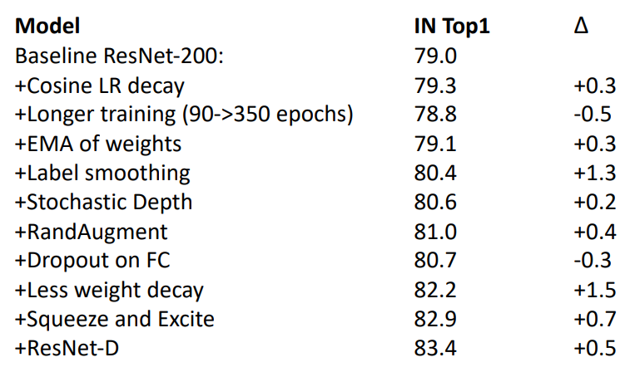Starting from the baseline ResNet-200 model, we can improve performance with the following small tweaks:

### ResNet-RS: Rescaled ResNets

To get scaled ResNets of different sizes, we can brute-search over:

* Initial network width: [0.25, 0.5, 1.0, 1.5, 2.0] times the baseline model
* Overall network depth: [26, 50, 101, 200, 300, 350, 400] layers
* Input image resolution: [128, 160, 224, 320, 448] pixels

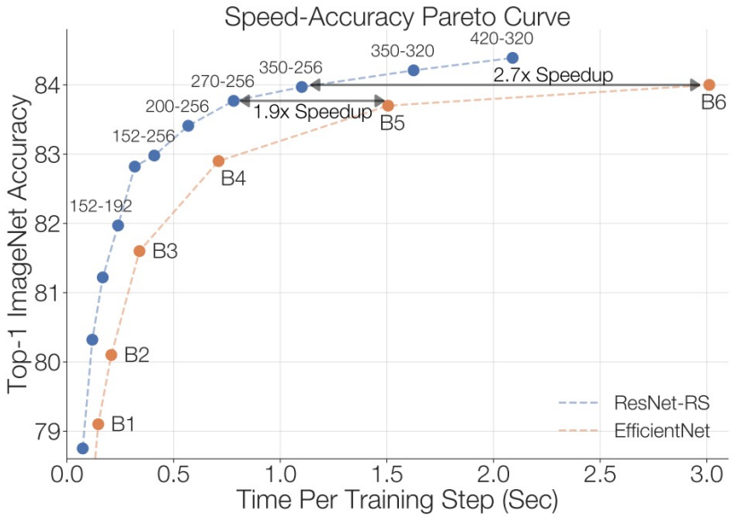This yielded the family of networks known as ResNet-RS, which are significantly faster than EfficientNets at the same accuracy (when timed on a TPU):

## RegNets

In an attempt to understand network design principles which successfully generalise, researchers focused on designing network design spaces that parameterise whole populations of networks. This resulted in the family of simple, regular networks known as RegNets.

The network design of RegNets is simple:

* Stem consisting of 3x3 convolutions
* Body made of 4 stages
  + Each stage has multiple blocks
    - The first block downsamples by 2x (i.e. S=2)
    - 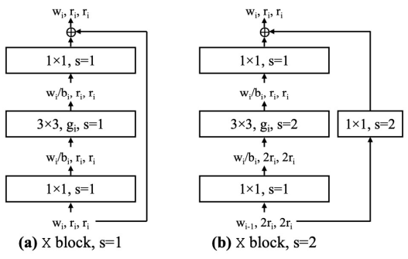Other blocks keep the resolution the same (S=1)
* 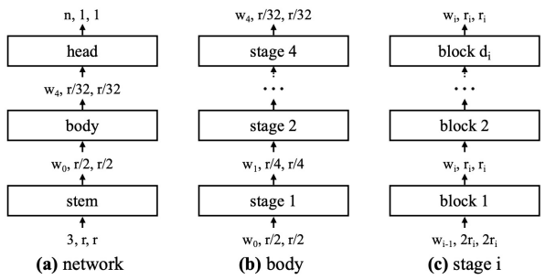And a head

The design space for the family of RegNets has 6 parameters:

* Overall depth $d$
* Bottleneck ratio $b$
* Group width $g$
* Initial width $w_{0}$
* Width grow rate $w_{a}$
* Blocks per stage $w_{m}$

Randomly searching over these parameters found good-performing models at varying FLOP budgets (e.g. RegNetX-8.0GF, RegNetX-12GF, etc. [12GF means 12 giga FLOPs]). RegNetY adds Squeeze-and-Excitation.

**At the same FLOPs, RegNet models get similar accuracy as EfficientNets but are up to 5x faster in training.**

## CNN Architectures Summary

* Early work (AlexNet -> VGG -> ResNet) showed that bigger networks work better
* More recent focus has been on efficiency: Improve performance whilst controlling for network complexity
* Grouped and depthwise convolution appear in many modern architectures
* Squeeze-and-Excitation adds accuracy boost to just about any architecture while only adding a tiny amount of FLOPs and runtime
* Tiny networks for mobile devices (e.g. MobileNet, ShuffleNet)
* Neural Architecture Search (NAS) promised to automate architecture design
* More recent work has moved towards careful improvements to ResNet-like architectures
* ResNet and ResNeXt are still surprisingly strong and popular architectures!
* RegNet appears to be a promising and efficient architecture to use

Recent work has moved away from CNNs entirely, instead focusing on vision transformers and MLP-like models.

# Lecture 12 – Deep Learning Hardware & Software

## GPU Hardware

Advancements in GPUs have enabled the field of deep learning. Below is an explanation of the architecture of NVIDIA GPUs.

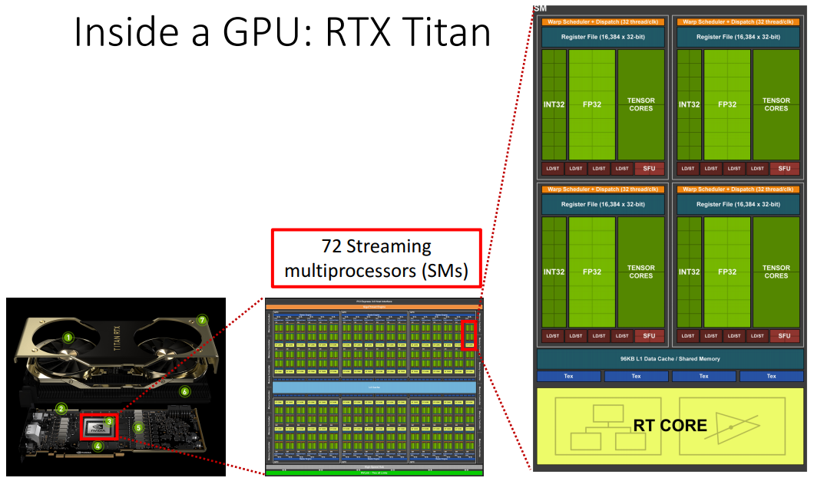The fundamental building block of an NVIDIA GPU are **streaming multiprocessors** (**SMs**), these are slightly akin to cores within a multicore CPU.

### CUDA Cores

Inside of each SM is some number of FP32 (i.e. single precision floating-point) cores (often referred to as **CUDA cores** by NVIDIA) which are the fundamental processing units of an NVIDIA GPU and are optimised for general purpose and graphics calculations. Each CUDA core can complete a 32-bit multiply-accumulate operation (2 FLOPs) per clock-cycle.

### Tensor Cores

Alongside CUDA cores inside each SM are **tensor cores**. Due to machine learning playing such a large role in NVIDIA’s use case, they have implemented specialised compute units specifically to perform matrix multiplication and addition. In a single clock-cycle, a tensor core calculates:

$$A×B+C$$

Where $A$ and $B$ are 4x4 FP16 matrices, and $C$ is a 4x4 FP16 or FP32 matrix.

This is 128 FLOPs in a single clock-cycle. Note that tensor cores use mixed precision; the multiplication is done in FP16 and the addition in FP32.

Deep learning operations heavily involve matrix multiplications plus some bias term, so they’re able to be split up into many 4x4 matrix multiplies and mapped to many parallel tensor cores. For this reason, it is usually most efficient to set the dimensions of your neural network to be powers of 2 (sometimes multiples of 64 or 256 are even recommended).

## CUDA Language

CUDA is a software language that extends C/C++ developed by NVIDIA to program GPUs. In practice, because NVIDIA provides APIs/libraries of already optimised machine learning code which frameworks such as PyTorch then use, most people working as deep learning practitioners don’t write CUDA code directly.

## Deep Learning Frameworks

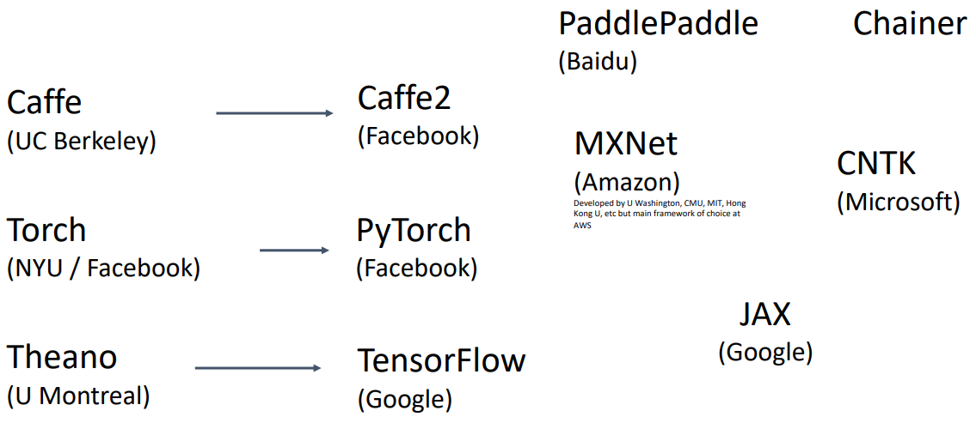Many different frameworks have been developed over the years, first from academia and then mostly from industry. Below is a figure of some of the notable frameworks:

The current state of these frameworks are:

* Caffe2: was merged into PyTorch in March 2018
* PaddlePaddle: still actively developed (March 2025). Popular in China
* MXNet: abandoned in September 2023, Amazon shifted its use to other frameworks such as PyTorch
* Chainer: abandoned in December 2019
* CNTK: abandoned, last stable release April 2019
* JAX: still actively developed (March 2025). Can be very fast
* TensorFlow: still actively developed (March 2025). Described below
* PyTorch: still actively developed (March 2025). Described below

Note, there are other actively developed deep learning frameworks which are not mentioned here.

### PyTorch

The fundamental concepts of PyTorch are:

* Tensors: Like a numpy array, but can run on GPU
* Autograd: A package for building computational graphs out of tensors, and automatically computing gradients
* Module: A neural network layer; may store state or learnable weights

In PyTorch, the computational graph – along which the forward pass is computed from start to finish, and the backward pass is computed from finish to start – is constructed on the fly during every forward pass. This is called **dynamic graphs** and has various advantages:

* Flexibility: You can modify the model on the fly, which is especially useful for tasks like dynamic architectures, variable input sizes, or conditional computation (e.g., using if-else statements inside the model).
* Debugging: Since the graph is built during execution, you can debug using standard Python tools, such as printing out intermediate values or using breakpoints.

PyTorch also has the capability to construct static graphs, which are defined below in TensorFlow.

### TensorFlow

TensorFlow is another deep learning framework. It first used **static graphs** before version 2.0 but now defaults to dynamic graphs like PyTorch. Static graphs have some advantages over dynamic graphs:

* Optimisation: Since the structure is predefined, the system can apply various optimisations (like memory management, fusion of operations) ahead of time.
* 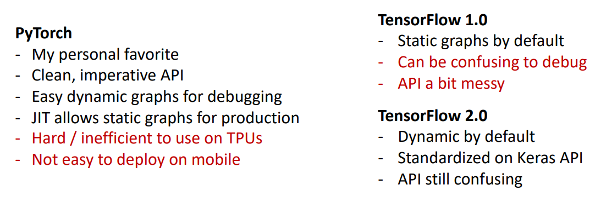Efficiency: The graph can be optimised for performance, especially in production environments.

Justin Johnson’s comparison between PyTorch and TensorFlow is given below:

# Lecture 13 – Object Detection

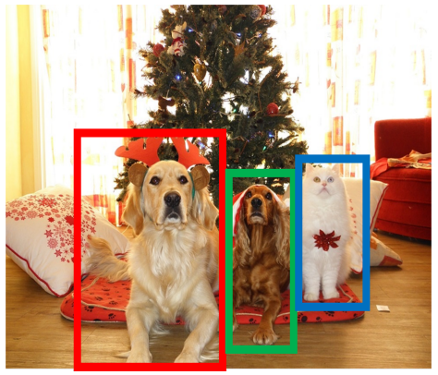Object detection is the following task:

* **Input:** A single image
* **Output:** A set of detected objects. For each object, predict:
  + Category label (from some known set of categories)
  + Bounding box (e.g. x, y, width, height)

This poses some new challenges in comparison to basic image classification:

* Variable output length: the number of detected objects can change per image
* Multiple output types: i.e. category label (“what”) and bounding box (“where”)
* Resolution: whilst classification works at lower resolutions (e.g. 224x224), object detection requires higher resolutions (often ~800x600).

## Bounding Boxes

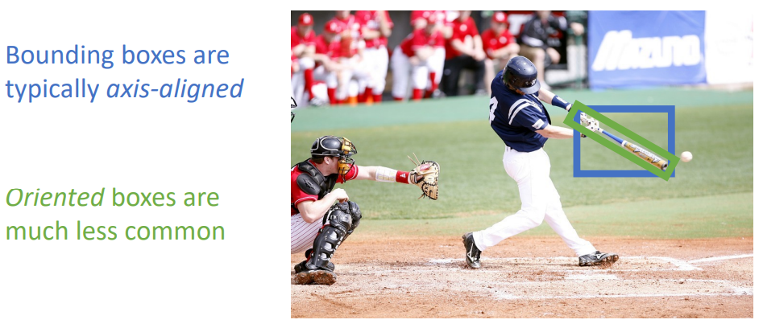Bounding boxes are almost always axis-aligned, however some object detection models are developed to output **oriented bounding boxes** which have an additional parameter to describe the bounding box’s rotation/orientation.

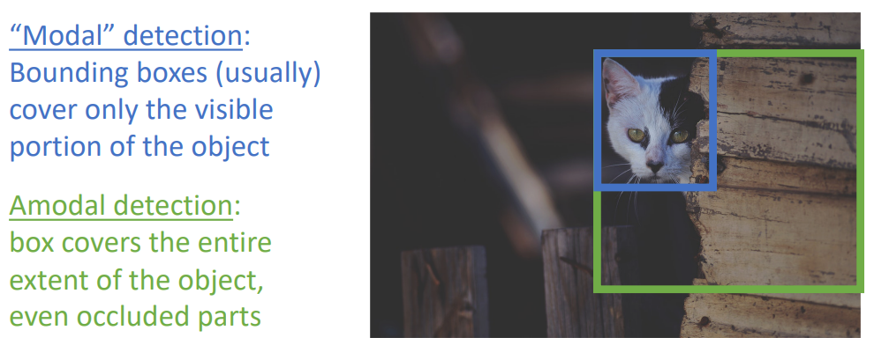Bounding boxes usually only cover the visible portion of the object (referred to as a **modal detection**), however some models perform **amodal detection** to predict the entire bounding box of the partly occluded object.

### Intersection over Union (IoU): Comparing Bounding Boxes

Intersection over Union (IoU, also called “Jaccard similarity” or “Jaccard index”), provides a measure for comparing an object detection model’s prediction to the ground-truth bounding box. An IoU > 0.5 is “decent”, IoU > 0.7 is “pretty good”, and IoU > 0.9 is “almost perfect”.

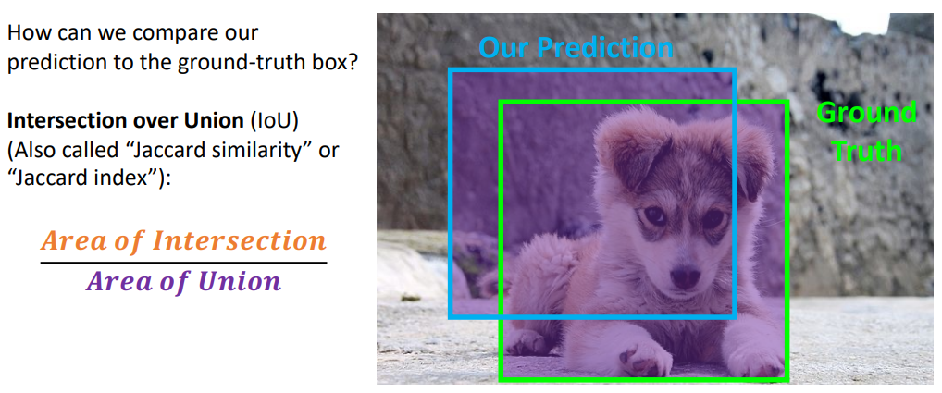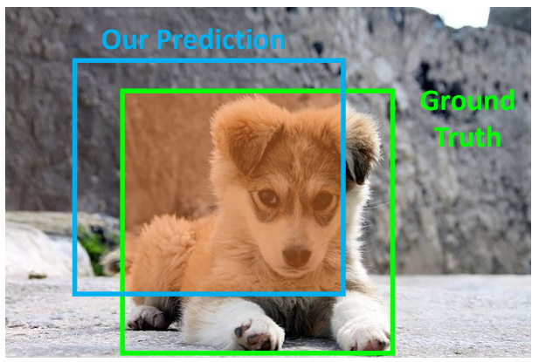

## Detecting a single object

A naïve approach to object detection which only works for detecting a single object is as follows:

1. Take a network pretrained on ImageNet (i.e. transfer learning)
2. Keep the original fully connected layer classifier which produces the class scores
3. Add an additional fully connected layer in parallel (i.e. uses the same feature vector as the classifier) to produce the bounding box coordinates
4. Combine their losses as a weighted sum into the **multitask loss**
   1. 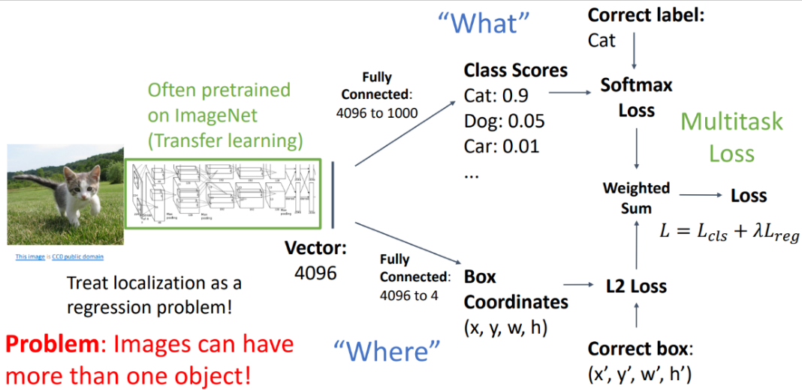Note: multitask loss more generally refers to the single loss value that you use for a network which performs multiple tasks. A weighted sum is only one method of constructing a multitask loss.

The AlexNet authors used this approach for performing object detection, so it is actually a reasonable approach (IF you know that there’s only a single object in the images).

## Detecting Multiple Objects

In reality, we nearly always want the ability to perform object detection on images which may contain many instances of the objects of interest.

### Sliding Window

A relatively simple approach to detecting multiple objects is the use of sliding windows, where we apply an image classifier to many different crops of the image and predict each crop as an object or background. This effectively breaks an object detection task back into many image classification tasks.

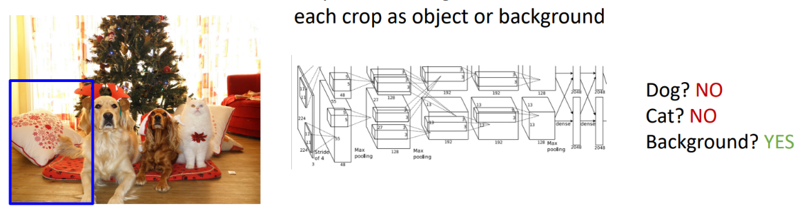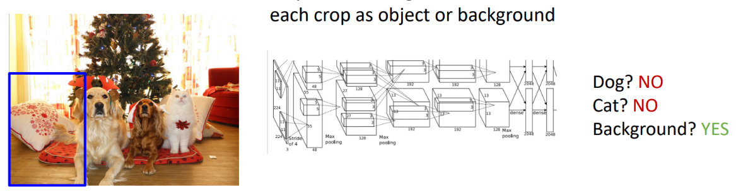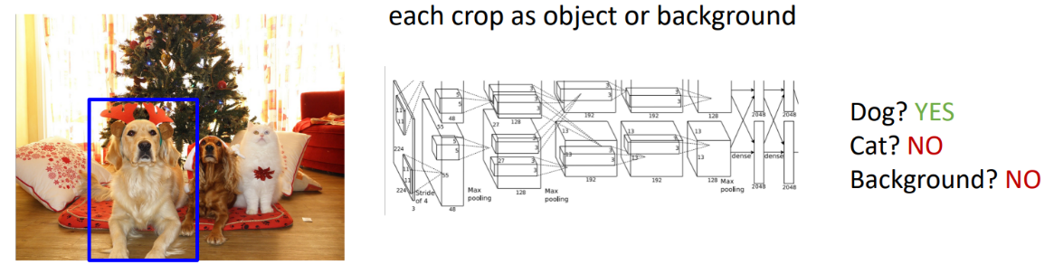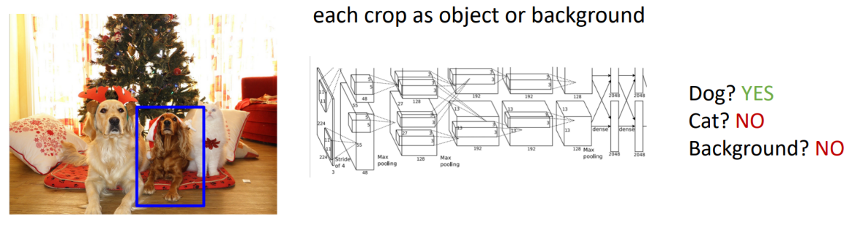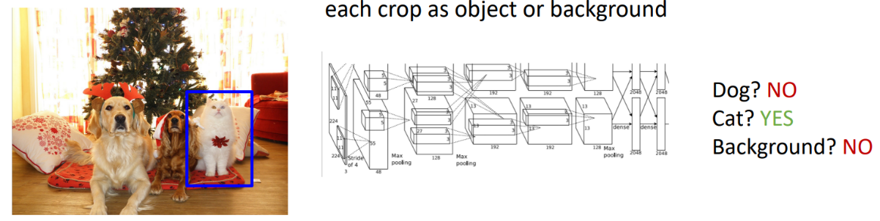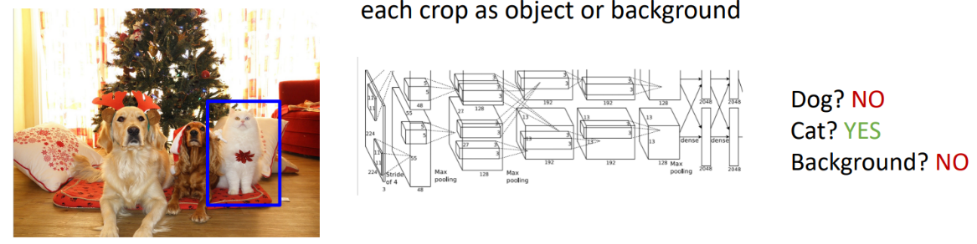

For an image of size $H×W$ and a box of size $h×w$, there are $\left(W-w+1\right)×\left(H-w+1\right)$ total possible boxes in the image. For all boxes from size $1×1$ up to $H×W$, there are then:

$$\sum_{h=1}^{H}{\sum_{w=1}^{W}{\left(W-w+1\right)×\left(H-w+1\right)}}=\frac{H\left(H+1\right)}{2}\frac{W\left(W+1\right)}{2}$$

total possible boxes.

An $800×600$ px image has $\sim 58$ M possible boxes, there is no way we can evaluate an image classifier on every single one of them.

### Region Proposals

A more targeted method rather than trying all possible boxes is to use some algorithm to propose a small set of boxes which are likely to cover all objects. This is often based on heuristics (e.g. look for “blob-like” image regions) and are “relatively” fast to run (e.g. the Selective Search algorithm gives 2000 region proposals in a few seconds on CPU).

#### R-CNN: Region-based CNN (2014)

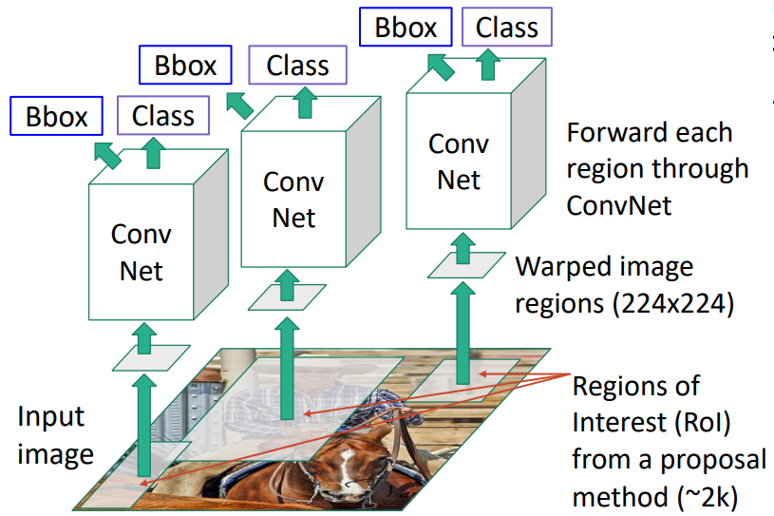The paper describing R-CNN is perhaps one of the most influential papers in deep learning. R-CNN follows the following steps:

1. Some number (e.g. 2000) of regions of interest (RoI) are proposed from some region proposal method (e.g. Selective Search)
2. These image regions can all be different sizes and aspect ratios; therefore, they are warped to all become the same size (e.g. 224x224) to match the CNN’s input dimension
3. Each warped image region is processed independently by a CNN to:
   1. Classify the image as either “background” or one of the classes of interest
   2. Predict a “transform” [i.e. four numbers $\left(t_{x},t_{y},t_{h},t_{w}\right)$] which corrects the non-exact proposed image regions into a more accurate bounding box. The most common way to do this is:
      1. For a region proposal with center $\left(p_{x},p_{y}\right)$, width $p_{w}$, and height $p_{h}$
      2. The model predicts a transform $\left(t_{x},t_{y},t_{h},t_{w}\right)$ to correct the proposed region
      3. The output box is then defined by:
 $$b_{x}=p_{x}+p_{w}t_{x}$$

 $$b_{y}=p_{y}+p_{h}t_{y}$$

 $$b_{w}=p_{w}\exp\left(t_{w}\right) \left(exp ensures scaling>0\right)$$

 $$b_{h}=p_{h}\exp\left(t_{h}\right)$$

  4. L2 regularisation encourages small transforms, i.e. leaving the proposal unchanged
      5. This has **scale and translation invariance** due to the transform encoding the *relative* difference between the proposal and the output (i.e. the CNN doesn’t know the actual region size or position after it has been cropped and warped)

This model is unfortunately very slow, needing to do one forward pass through the CNN per proposed region (e.g. 2000 forward passes). Faster methods are described in Lecture 14.

##### R-CNN Training

Training an R-CNN involves the following steps:

1. Prepare the ground truth boxes for each image
2. Use the region proposal method to suggest a set of proposed regions
3. Categorise each region as positive, negative, or neutral based on their overlap with the ground truth boxes:
   1. Positive: > 0.5 IoU with a ground truth box
   2. Negative < 0.3 IoU with a ground truth box
   3. Neutral: 0.3 < IoU < 0.5 with a ground truth box
4. Crop pixels from each positive and negative proposals, then resize the region to 224x224.
5. Run each region through the CNN:
   1. For positive regions: predict the class and bounding box transforms
   2. 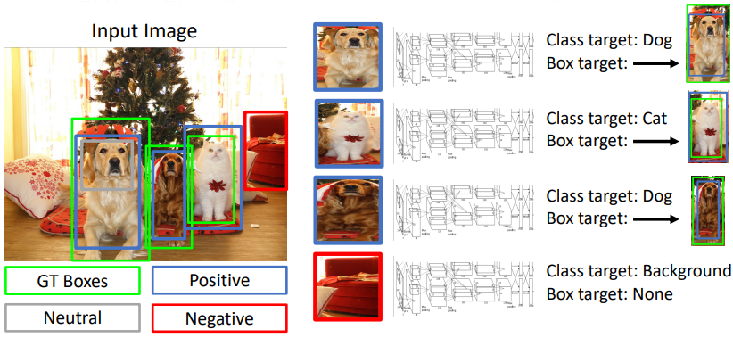For negative regions: just predict the class
6. Calculate loss and backpropagate

##### R-CNN Test-time

At test time:

1. Use the region proposal method to suggest a set of proposed regions
2. Run each region through the CNN to get class scores and bounding box transforms
3. Apply a threshold to the class scores to get a set of detections
   1. Also known as the confidence threshold, this value is tuned based on the desired confidence in the object detectors output

The CNN will often output overlapping boxes, how do we tell which boxes belong to the same object?

### Overlapping Boxes: Non-Maximum Suppression (NMS)

Non-maximum suppression (NMS) can be used to eliminate overlapping detections based on the following procedure:

1. Select the next highest-scoring (i.e. highest confidence) box
2. Eliminate any lower-scoring boxes with an IoU greater than some threshold (e.g. IoU > 0.7)

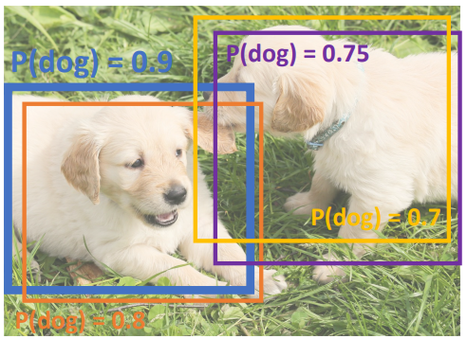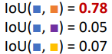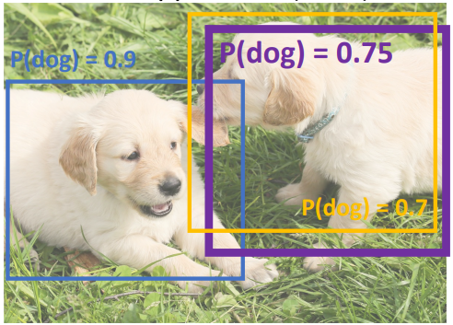

1. If any boxes remain, GOTO step 1

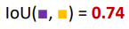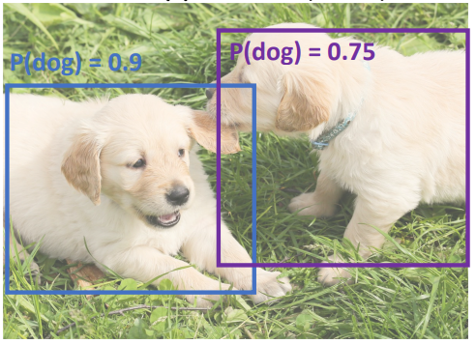

NOTE: NMS may eliminate “good” bounding boxes when objects are highly overlapping. There is currently no good solution for this.

### Evaluating Object Detectors: Mean Average Precision (mAP)

Calculating the mean average precision (mAP) is done as follows:

1. Run the object detector (with NMS) on all of the test images
2. For each class/category; compute the Average Precision (AP) = area under the Precision vs Recall curve:
   1. 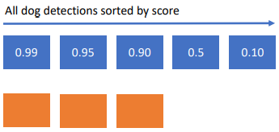Order all of the detections across the test set for this class/category (e.g. “dog”) in descending order of score/confidence
   2. For each of these detections, starting from highest score/confidence:
      1. If it matches a ground truth box with IoU greater than some threshold (e.g. IoU > 0.5), mark it as positive and eliminate the ground truth box
      2. Otherwise, mark it as negative and don’t modify the list of ground truth boxes
      3. 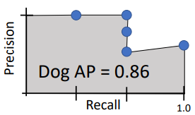Plot a point on the Precision vs Recall curve

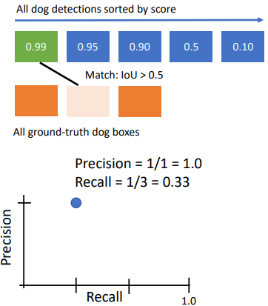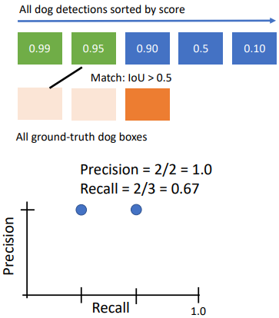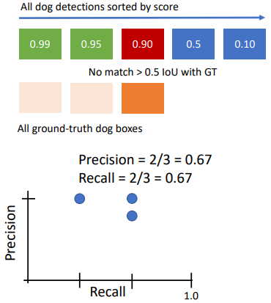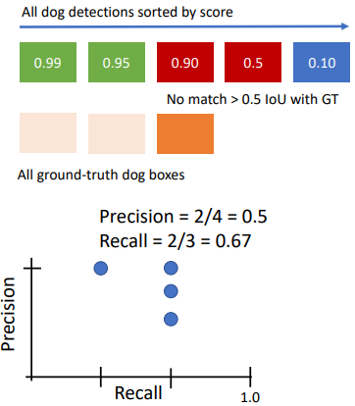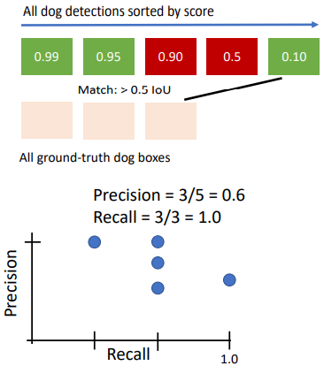

* 1. The average precision is the area under this curve. I.e.:

1. 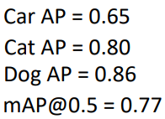Then, the **mean average precision (mAP)** is the average of the average precision for each category. It is specified for a particular IoU threshold. Using IoU > 0.5 for example:
2. 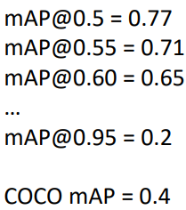Finally, mAP can be calculated over a range of IoU thresholds and then averaged (e.g. COCO mAP specifies performance as mAP@0.5-0.95):

# Lecture 14 – Object Detectors

## Fast R-CNN (2015)

The R-CNN described in Lecture 13 is now commonly referred to as “Slow” R-CNN due to requiring a forward pass of the CNN for every proposed image region.

One way that people have found to speed up R-CNN is to swap the warping process and the CNN process, i.e. the CNN runs *before* the warping occurs. This allows us to share some expensive computation across multiple image regions.

Fast R-CNN works as follows:

1. Run the entire high-resolution image through the CNN *without the fully-connected layers*. This is referred to as the “backbone” network (e.g. AlexNet, VGG, ResNet, etc.)
2. Same as R-CNN, use the region proposal method to suggest a set of proposed regions
3. Project these regions of interest (RoIs) onto the image features produced by the CNN
4. Crop and resize the image features for each RoI (see how this is done below)
5. 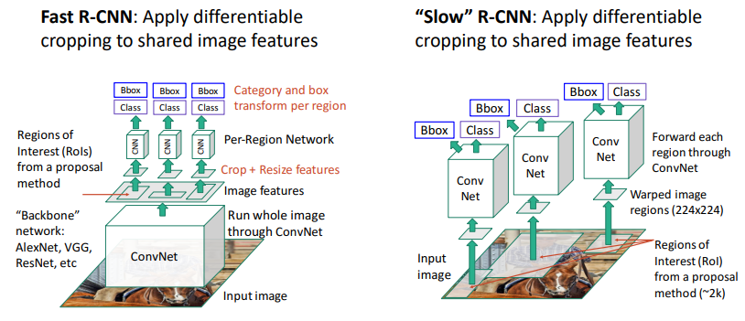Run each region through a small lightweight network which outputs the class/category and bounding box transform

This is much faster because most of the computation happens in the backbone network, and this computation is done once and the output shared for all regions.

How the backbone network is constructed from existing classification networks varies:

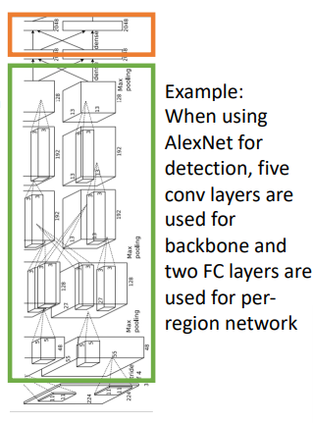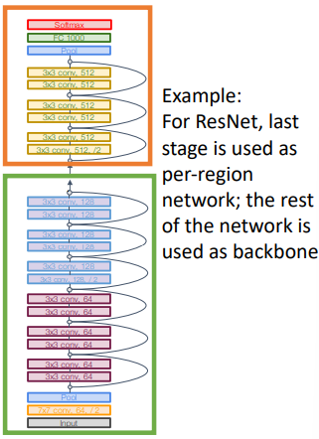

### Cropping Image Features

#### Recall: Receptive Fields

Extending on the earlier introduction of receptive fields (Lecture 7), we can also project arbitrary points from the coordinate system of the input to/from the coordinate system of the output.

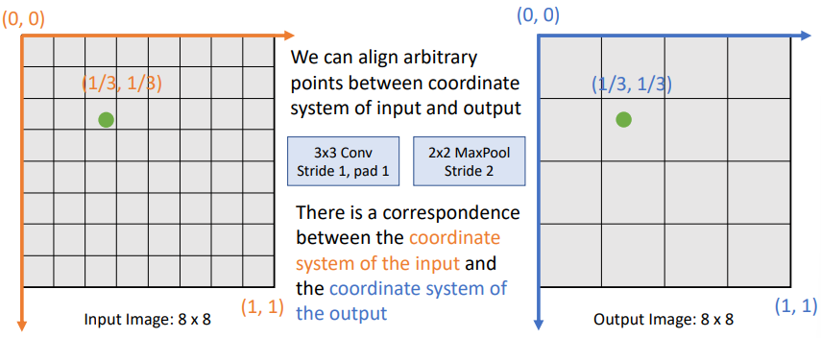For example, after a 3x3 convolution (s=1, p=1) and max pool (s=2), a point one-third across the x and y axis of the input coordinate system will project to a point of the same extent along the x and y axis in the output coordinate system:

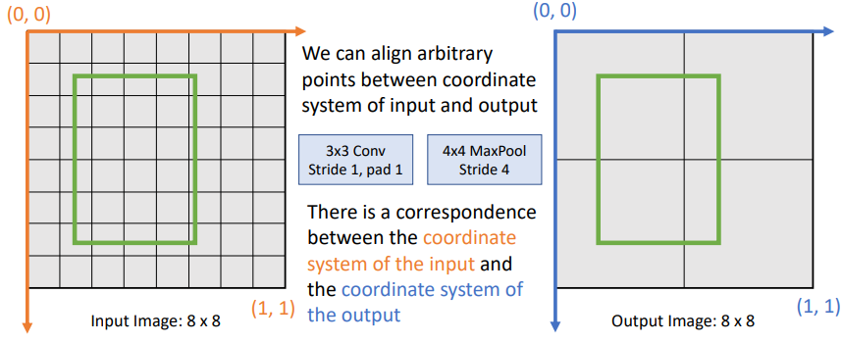We can use this idea to **project bounding boxes** (i.e. just projecting four different points) between an input image and a feature map:

#### Region of Interest (RoI) Pool

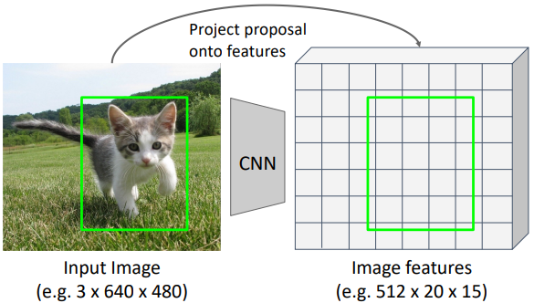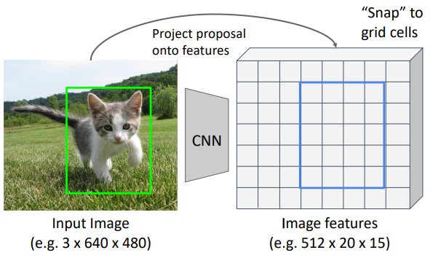

RoI Pooling provides a backprop-able method for cropping the image features in Fast R-CNN. It follows the following steps:

1. Project the RoI bounding box onto the image features (refer to the above receptive fields explanation)
2. The projection will not necessarily align with the image features’ grid, so “snap” to fit
3. Divide the image features RoI into a grid (typically 7x7 or 14x14, here we use 2x2 as an example)
4. Then max pool within each region to produce the “region features” (e.g. size 512x2x2)
   1. 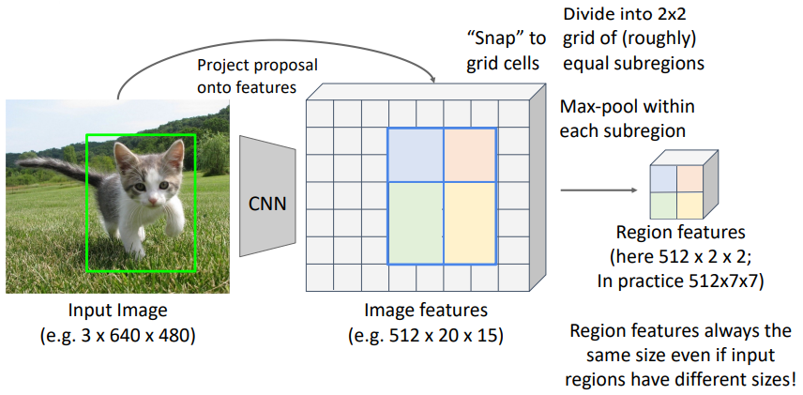This causes the region features to always be the same size – regardless of the input image RoI size – allowing them to be input into the Fast R-CNN’s later lightweight network.

Problem: The “snapping” to grid cells and potential for different size subregions (e.g. above, the blue and orange are 2x2 whilst green and yellow are 3x2) are a problem for RoI Pool. Additionally, whilst we can backpropagate from the region features to the image features, there is no way to backpropagate from the image features to the input image (as the bounding box coordinates are lost when snapping).

Solution: RoI Align is fully differentiable and solves the above problems, and is therefore used instead.

#### Region of Interest (RoI) Align

RoI Align is very similar to RoI Pool except it has better alignment of the input image features to the output region features, and allows backpropagating all the way to the input image bounding box coordinates. Instead of snapping the RoI to the image feature grid:

1. The RoI is place in its exact location without snapping
2. It is then divided into a grid (e.g. 2x2, however typically 7x7 or 14x14)
3. 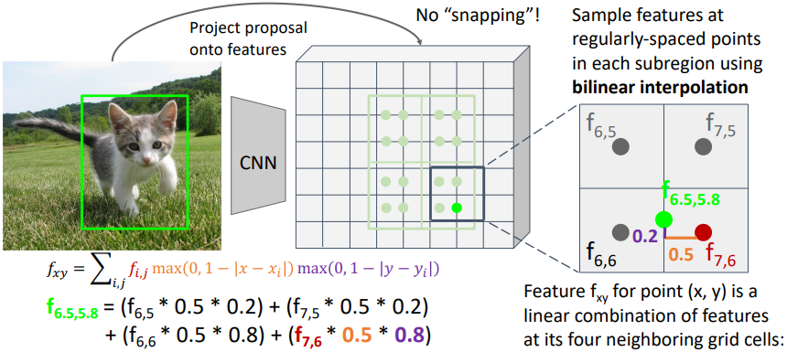Bilinear interpolation is used to sample features at regularly-spaced points in each subregion (e.g. 2x2 points within each subregion)
4. 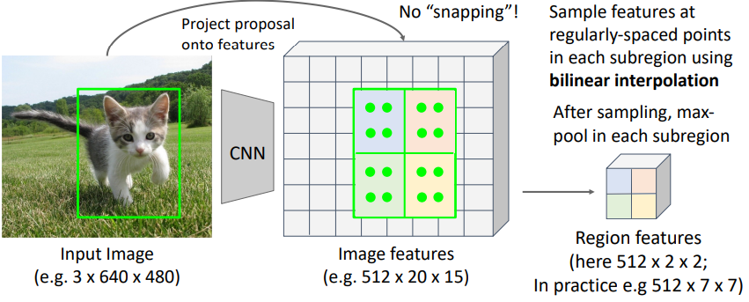Finally, max pool is performed as before to produce the region features

### Fast R-CNN vs “Slow” R-CNN

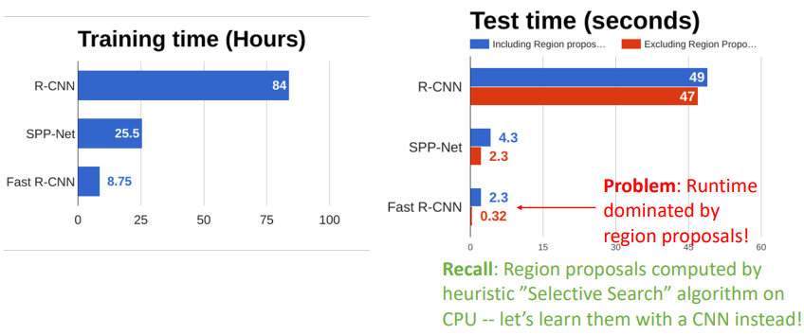The below graphs compare the training and test time performance of Fast R-CNN with “Slow” R-CNN (on 2014 GPUs…). Note that the test time of Fast R-CNN is dominated by the time taken to generate the region proposals. [Faster R-CNN](#_Faster_R-CNN_(2015):) uses a CNN to learn how to propose good regions rather than a heuristic algorithm like Selective Search.

## Faster R-CNN (2015): Learnable Region Proposals

Faster R-CNN abandons the heuristic Selective Search region proposal method and instead trains a CNN to predict good region proposals. Otherise the network is the same as [Fast R-CNN](#_Fast_R-CNN_(2015)).

The general process is:

1. Pass the input image into the backbone CNN to generate the image features
2. Pass the image features to a Region Proposal Network to get the region proposals
3. 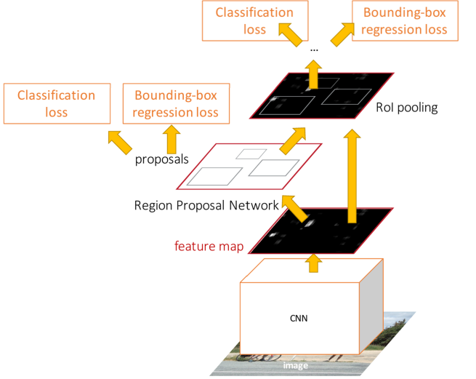Following the remaining steps as in Fast R-CNN

### Region Proposal Network (RPN)

Below summarises the architecture of the RPN:

1. The input image is passed through the backbone CNN to produce image features which are aligned to the input image
   1. Each point in the feature map corresponds to a point in the input image (see here).
2. We can then imagine an **anchor box** of fixed size placed at each point in the feature map
3. Train a convolution layer to classify each anchor as positive (object) or negative (no object)

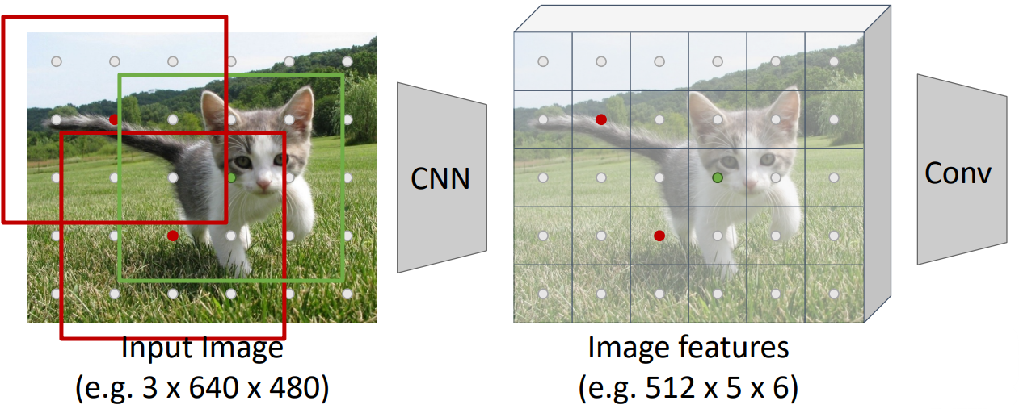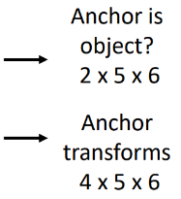

* 1. For positive anchors, also predict the transform that converts the anchor to a ground-truth box (like R-CNN)
  2. In the above example:
     1. The convolution filters are size 512x1x1
     2. There are two output filters (one for “object”, on for “no object”)
     3. The anchor transforms are size 4x5x6

1. 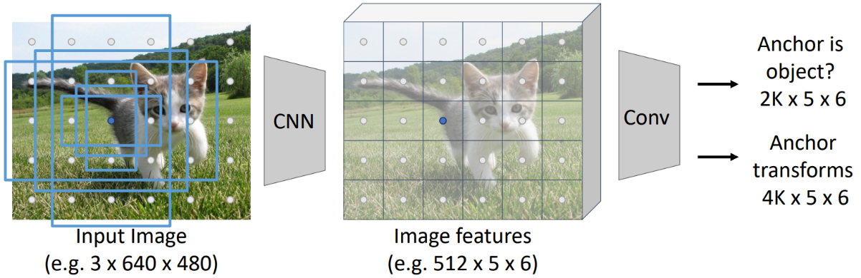In practice, rather than using on anchor per point, instead we consider $K$ different anchors with different sizes and scales (e.g. below $K=6$). $K$ is a hyperparameter than needs to be selected.
2. During training:
   1. Positive anchors have $IoU≥0.7$ with any ground truth box, OR they have the highest IoU for every ground truth box.
   2. Negative anchors have $IoU<0.3$ with all ground truth boxes.
      1. Box transforms are not supervised for negative anchors
   3. Neutral anchors have $0.3≤IoU<0.7$ with all ground truth boxes and are ignored during training
3. At test-time:
   1. Sort all $K×5×6$ anchors by their positive score
   2. Take the top 300 as our region proposals
   3. Jointly train with four losses:
      1. RPN classification: anchor box is/isn’t an object
      2. RPN regression: predict transform from anchor box to proposal box
      3. Object classification: classify proposals as background or object class
      4. Object regression: predict transform from proposal box to object box

### Faster R-CNN Performance

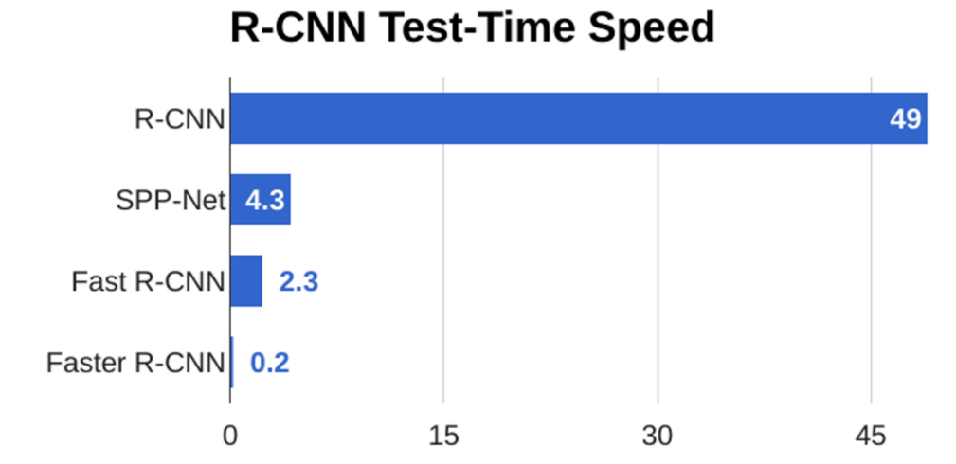Because region proposals are now computed on the GPU (instead of CPU) using a tiny RPN, Faster R-CNN is around 10x faster than Fast R-CNN and **can be run in real time**.

### Two-Stage Detectors

Faster R-CNN is what is referred to as a **two-stage object detector**.

1. First stage, run once per image
   1. Backbone network
   2. Region proposal network (RPN)
2. Second stage, run one per region
   1. Crop features: RoI pool / align
   2. Predict object class
   3. Predict bounding box transform

Single stage object detectors instead remove the second stage and get the RPN to make a full classification decision (i.e. exactly what category rather than object / no object).

## Dealing with Scale

Often, we need to detect objects of many different scales, i.e. we want an object detector with good *scale invariance*.

### Image Pyramid

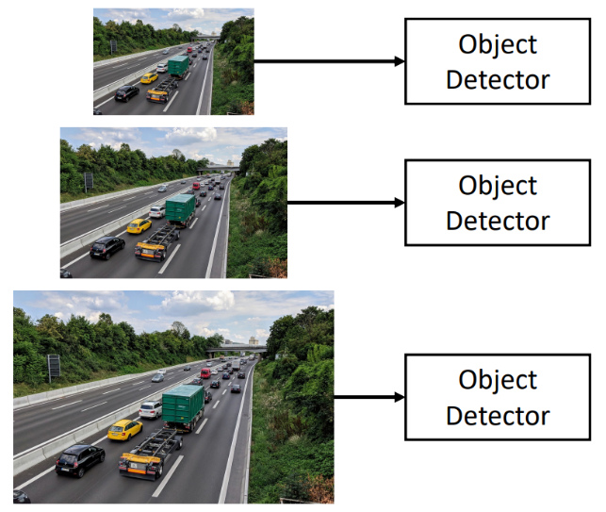One classical idea to achieve scale invariance in an object detector is to build an image pyramid by resizing the input image to multiple different scales, then processing each image scale independently.

Problem: This is very expensive. No computation is shared between the object detectors running at each scale.

### Multiscale Features

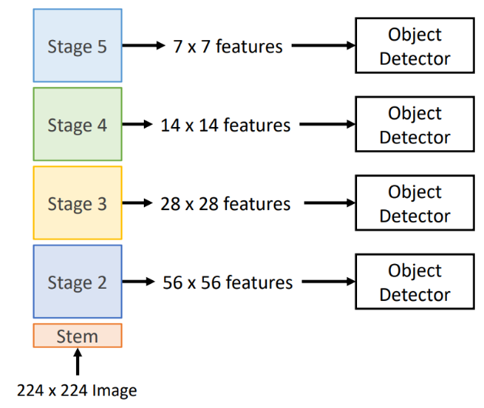CNNs are made up of multiple stages which operate at different resolutions (i.e. different feature map sizes). We can attach an independent detector to operate on the features at each stage.

Problem: The detectors of early stages don’t make use of the entire backbone; they don’t have access to the high-level features.

### Feature Pyramid Network (FPN)

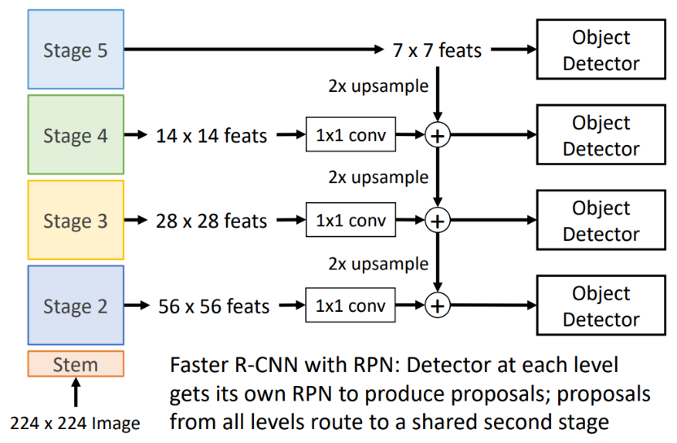If we take the previous multiscale features idea and add *top-down connections* that feed information from high level features back down to lower level features, we get the feature pyramid network.

This gives efficient multiscale features where all stages of the backbone benefit from the entire backbone. FPNs are widely used in practice.

## Single Stage Detectors

Single stage object detectors remove the second stage seen in two-stage detectors, and instead get the region proposal network (RPN) to make a full classification decision (i.e. exactly what category rather than object / no object).

### RetinaNet (2017)

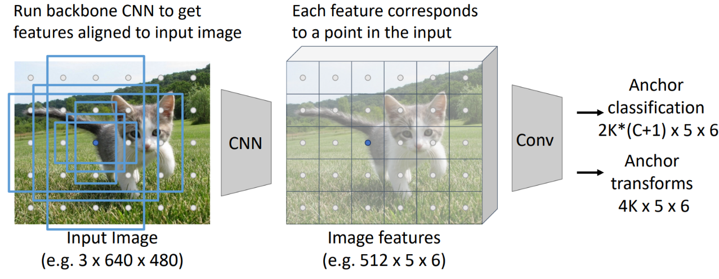RetinaNet’s architecture is essentially the same as that described in the RPN section, except the classification output is for $C$ categories/classes (or background).

Problem: Class imbalance; there are many more background anchors than non-background anchors.

Solution: Use a different loss function, **focal loss**.

Focal loss modifies cross entropy (CE) loss by providing greater weight to hard (i.e. false negative) samples while learning than easy (i.e. true negative) samples.

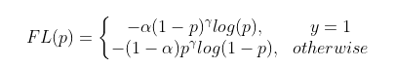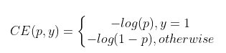

Where $α$ and $γ$ are hyperparameters.

#### RetinaNet: Use of Feature Pyramid Network / Performance

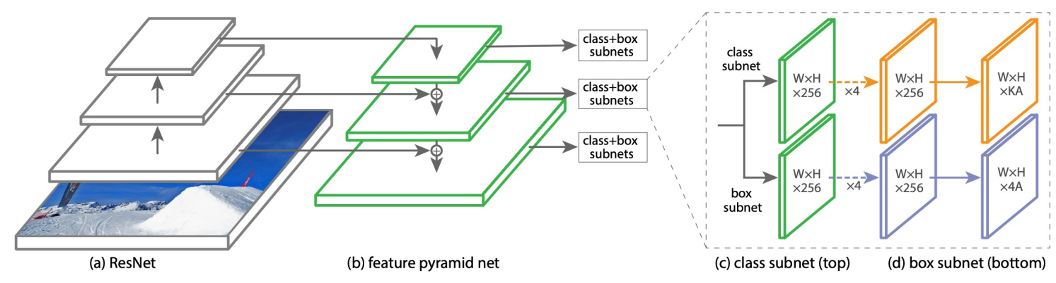In practice, RetinaNet also uses an FPN to handle multiscale object detection.

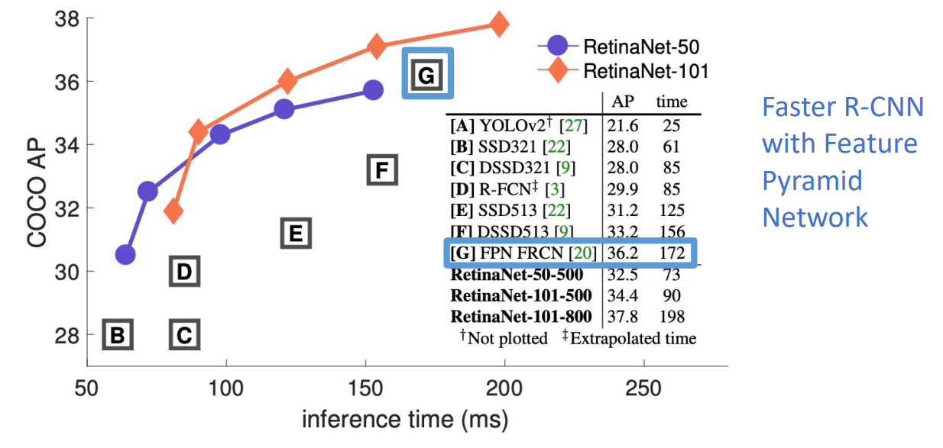Single stage detectors can be much faster than two-stage detectors. Below is a plot and table comparing the average precision and inference time of RetinaNet with some other object detectors.

### FCOS (2019): Fully Convolution One-Stage

The FCOS algorithm avoids computing anchor boxes (i.e. is “anchor free”) and instead detects objects in a per-pixel manner. The algorithm is as follows:

1. Same as step 1 of the region proposal network (RPN).
2. Each point in the output is then classified as positive (i.e. inside of a ground truth box) or negative (i.e. outside of a ground truth box), **per class**.
3. For positive points, also regress the distance from the point to the left/right/top/bottom edges of the ground truth box (with L2 loss).
4. Finally, predict the “centerness” for all positive points (using logistic regression loss), where centerness is defined as:

$$centerness=\sqrt{\frac{\min\left(L,R\right)}{\max\left(L,R\right)}∙\frac{\min\left(T,B\right)}{\max\left(T,B\right)}}$$

At test time, the final confidences (used for ranking the detected bounding boxes) is the product of centerness with the corresponding classification score.

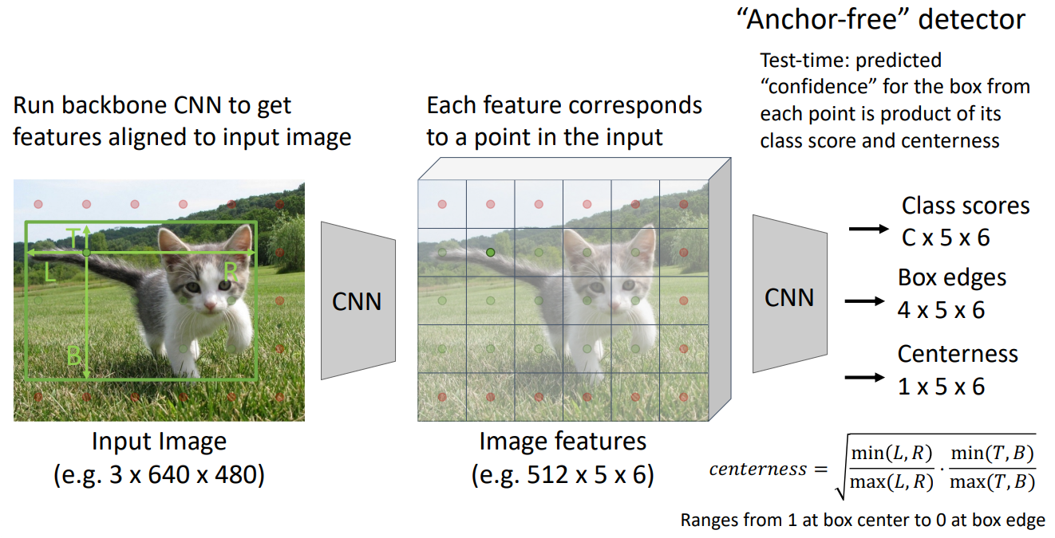Without centerness, FCOS predicts a lot of low quality bounding boxes produced by locations far away from the center of an object; centerness down-weights the scores of bounding boxes far from the centre of an object.

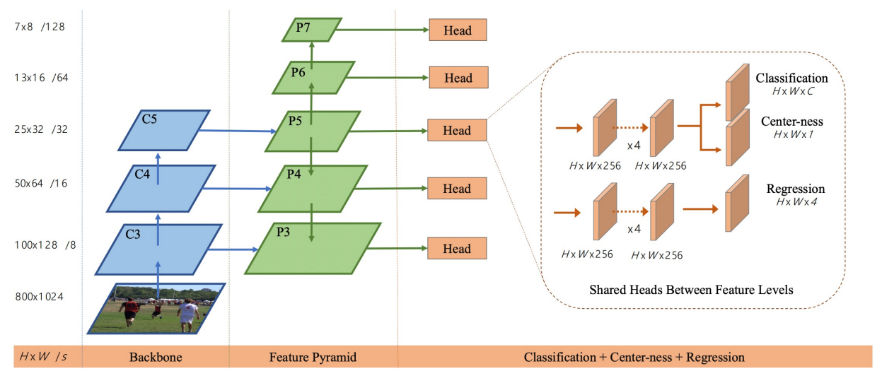FCOS also uses a feature pyramid network (FPN) with heads shared across the stages.

# Lecture 15 – Image Segmentation

Image segmentation is another computer vision task, alongside classification and object detection, that involves classify regions of pixels of an input image into discrete segments.

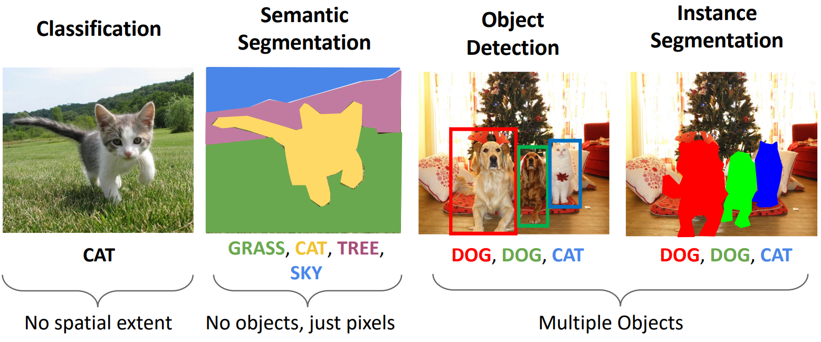We will discuss semantic segmentation and instance segmentation.

## Semantic Segmentation

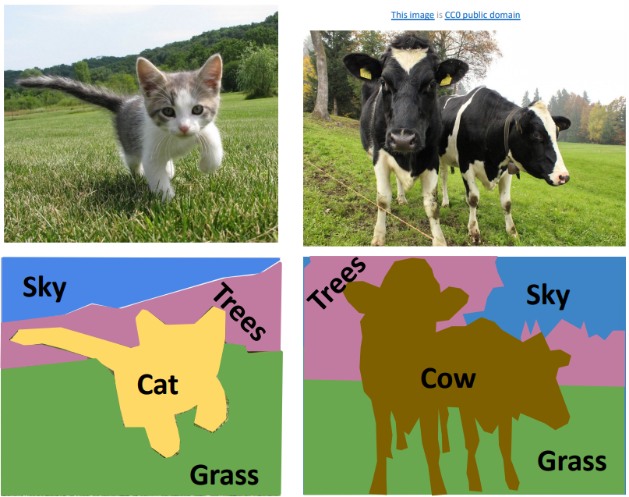Semantic segmentation is the task of labelling every pixel in the image with a category label, without caring about different distinct instances of each category (i.e. no “cat 1”, “cat 2”, etc. All labelled as “cat”).

### Sliding Window

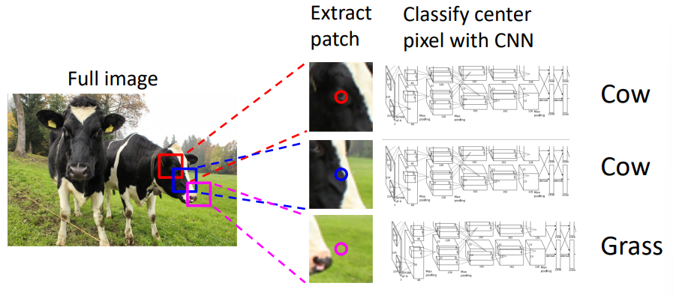A naïve approach that you may imagine using for semantic segmentation is again the idea of a sliding window, where a small region is extracted from around each pixel and then classified with a CNN.

Problem: As seen previously however, this would be very slow and very inefficient due to not reusing shared features between overlapping regions.

### Fully Convolutional Network

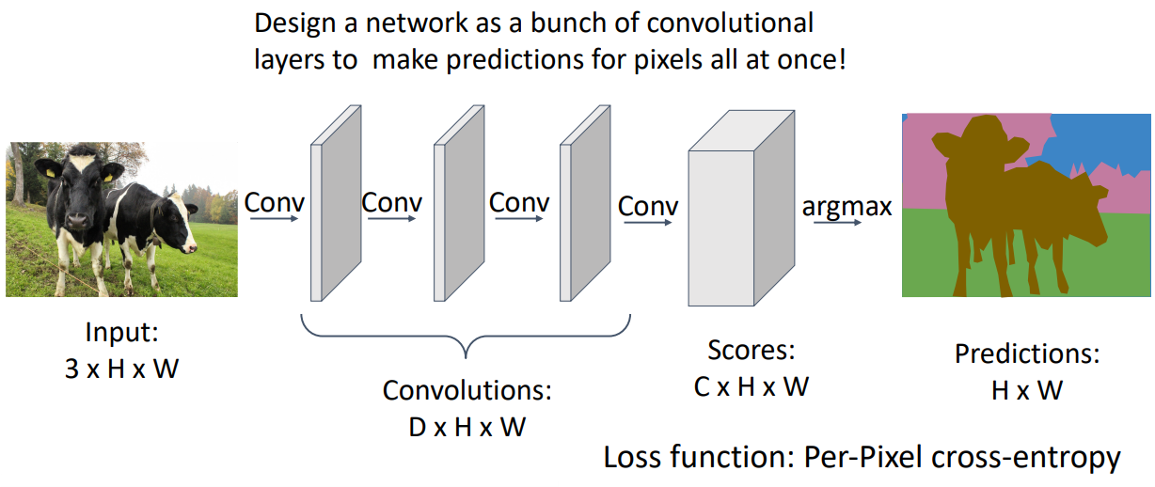A more approach to semantic segmentation is to use a CNN architecture referred to as a fully convolutional network. This is a convolutional network that does not have any fully connected layers or global pooling layers. The general architecture is illustrated below, noting that the output is the same size as the input image, with a class score (e.g. 0, 1, 2, etc.) for each pixel.

For example, this could be achieved by stacking a bunch of 3x3 stride 1, pad 1 convolutions in series to produce an output of the same size as the input (this is not done in practice due to the below problems).

Problem: The effective receptive field size grows linearly with number of convolution layers (e.g. with $L$ 3x3 layers, receptive field is $1+2L$). To make effective segmentation decisions per pixel we may want to look at relatively large regions around each pixel, therefore we need lots of layers.

Problem: Convolution on high resolution images is expensive. Like object detection, semantic segmentation benefits from high resolution images. Recall, this is why the ResNet stem aggressively downsamples the input image.

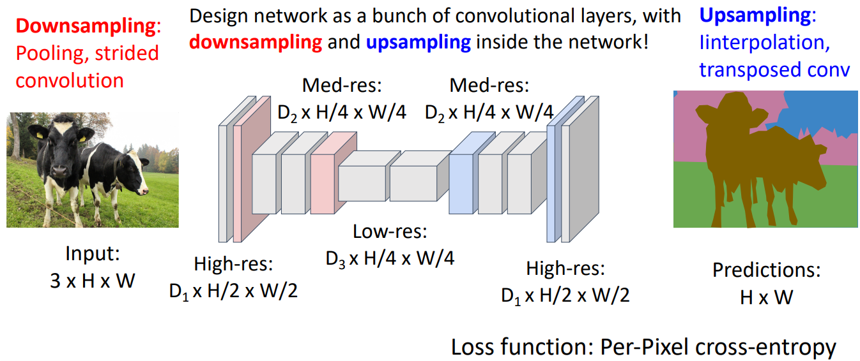Solution: Fully convolutional networks typically downsample the image at the start of the network and then upsample at the end, such that the output is still the same size as the input image. This addresses both of the above problems.

Downsampling is performed using pooling and strided convolutions. Upsampling is performed using the methods described below.

#### In-Network Upsampling

##### Unpooling

Unpooling is the opposite of pooling. For example, if we have some input with size $C×2×2$, we may want to upsample to an output of size $C×4×4$. There are a few ways to do this:

* **Bed of nails**:
  + 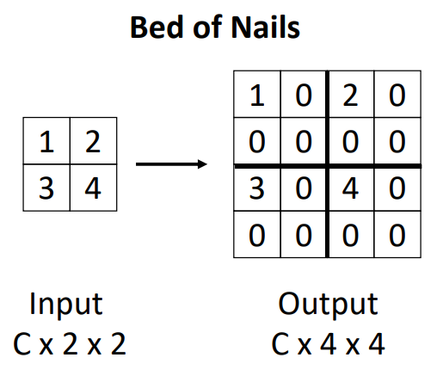Involves filling the output with all zeros, then placing the input values into the top left corner of the output. This can lead to bad aliasing problems so isn’t used much in practice.
* **Nearest neighbour**:
  + 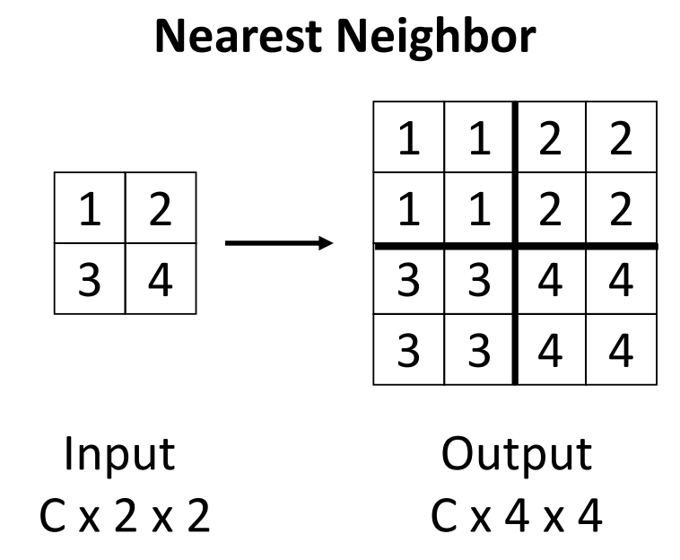Each input value is duplicated a fixed number of times to produce a larger output.
* **Max unpooling**:
  + 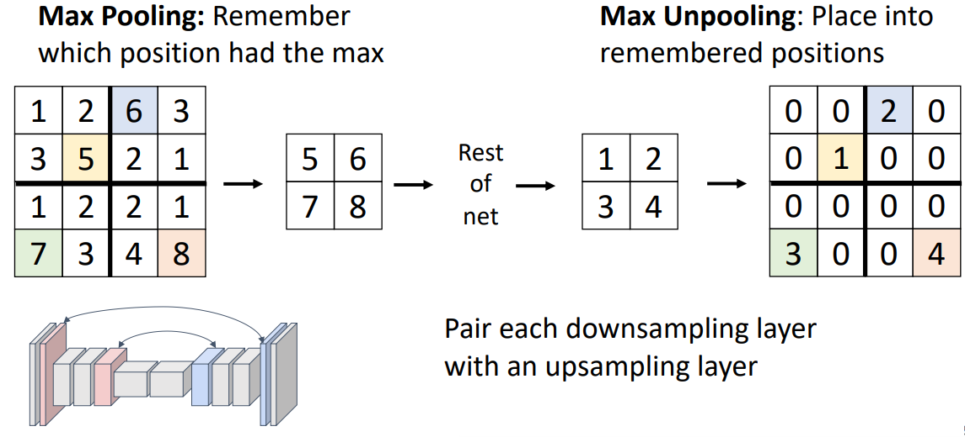Max unpooling is a slightly more complex unpooling operation, in that it is no longer an independent operation. Each max pooling layer in the downsampling portion of the network is paired to a max unpooling layer in the upsampling portion, so that the input values are placed into the locations from which the maximum values were found earlier, with the remaining values zero. I.e.:
  + This helps to maintain alignment between the feature vectors in the later layers to those in the earlier layers.
  + **Rule of thumb:** If you used average pooling in the downsampling portion of the network, use nearest neighbour / interpolation (below) to upsample. If you used max pooling to downsample, use max unpooling to upsample.

##### Bilinear Interpolation

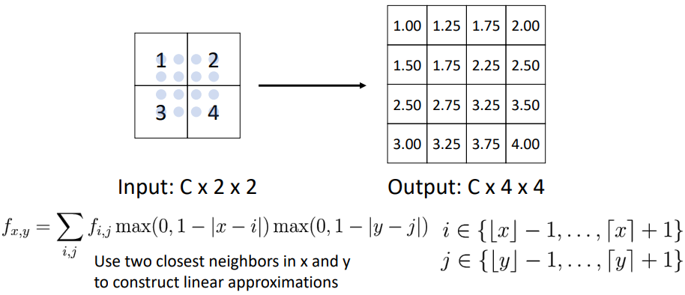Bilinear interpolation can be used to upsample by placing a finer “sampling grid” within the input and interpolating between the two closest neighbours.

This provides a smoother upsample than simple nearest neighbours.

##### Bicubic Interpolation

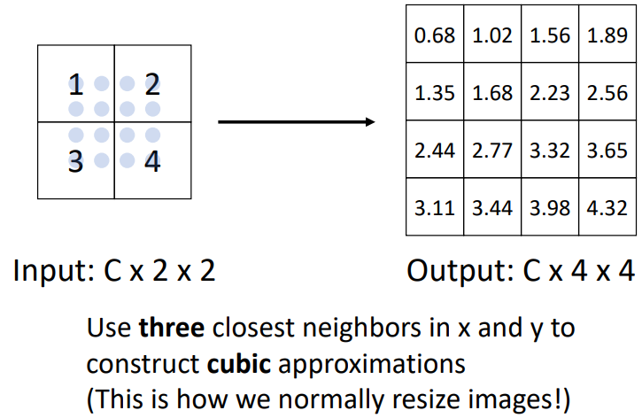Further to bilinear interpolation, we can instead use more neighbours to construct cubic approximations instead of linear.

This produces even sharper upsampled images than bilinear interpolation and is widely used in practice (e.g. Adobe Photoshop).

##### Learnable Upsampling: Transpose Convolution

The above upsampling do not contain any learnable parameters, they are simply fixed operations. On the contrast, transposed convolutions are sometimes used to upsample and is a learnable operation.

Recall, a normal convolution with stride $>1$ is effectively a learnable downsampling operation. Therefore, we can use stride $<1$ for learnable upsampling, i.e. transpose convolution. This works as follows:

1. We have some weight filter/kernel that is scaled by the values in the input and the result is copied to the output.
2. When the filter is applied to the next input value, we move the result by the stride amount along the output.
3. Any overlapping values are summed.
4. 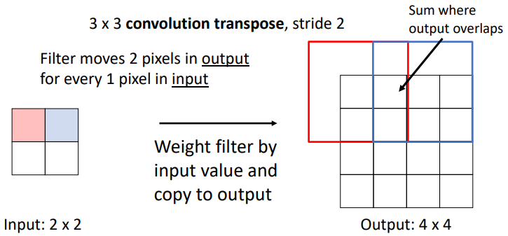Any excess output values are trimmed to give the correct dimensions (e.g. the top and left values in the below example).

## Instance Segmentation

In computer vision, object categories/classes can be thought of as either:

* **Things**: Objects that can be separated into individual instances (e.g. cats, cars, person)
* **Stuff**: Objects that cannot be separated into individual instances (e.g. sky, grass, water)

We have seen that object detection detects individual object instances, but only as a bounding box (i.e. only detects things), whilst semantic segmentation gives per-pixel labels, but merges individual instances (i.e. detects both things and stuff).

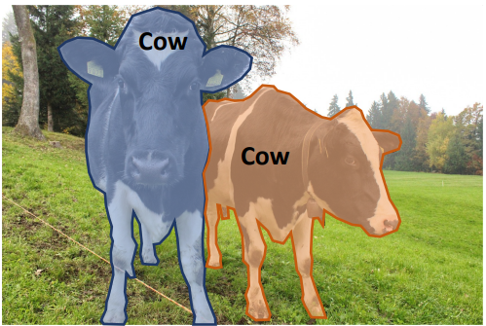**Instance segmentation** is then a hybrid of object detection and semantic segmentation, where we jointly detect all objects in the image whilst identifying the pixels which belong to each instance (i.e. only detects things).

The general approach for doing this is to first perform object detection, then use semantic segmentation to predict a segmentation mask for each object.

### Mask R-CNN (2017)

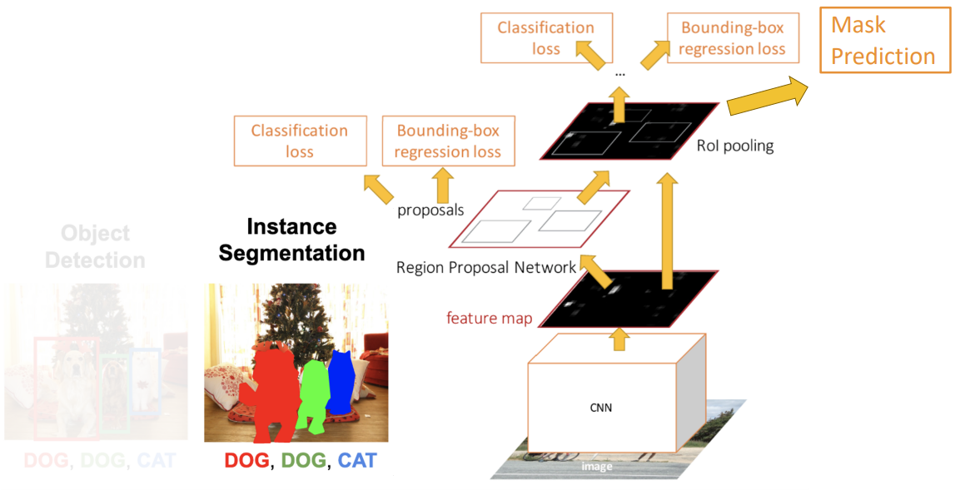Mask R-CNN is the [Faster R-CNN](#_Faster_R-CNN_(2015):) network with an additional head which asks on the features of each region to predict a foreground/background segmentation mask for each of the objects that we detect. The rest of the network is identical to Faster R-CNN.

The architecture of the mask prediction portion is as follows:

1. Run the input image through the backbone and RPN to get the image level features and the region proposals
2. Use RoI align to crop the image features for each region proposal
3. 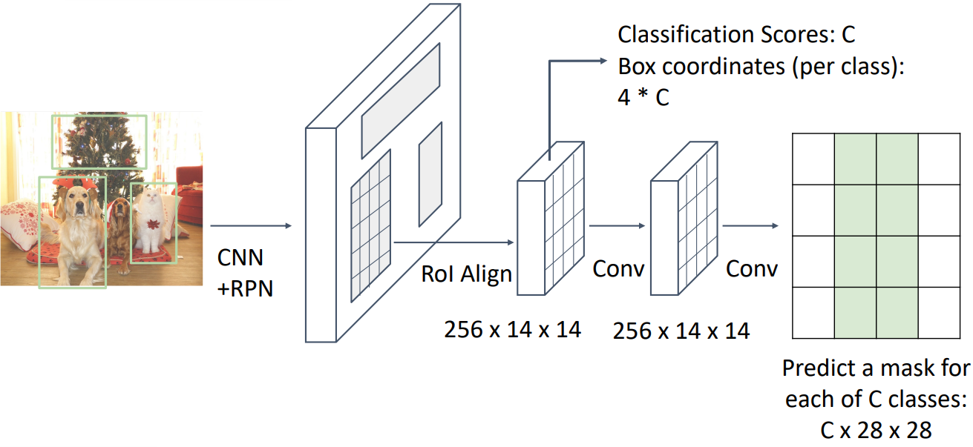For each region proposal, run a small semantic segmentation network to predict a segmentation mask

The idea is simple but gives very good results.

#### Mask R-CNN – Example Training Targets

Each object bounding box in the image has a corresponding mask of equal dimensions, showing which pixels in the bounding box belong to the object:

### Beyond Instant Segmentation: Panoptic Segmentation

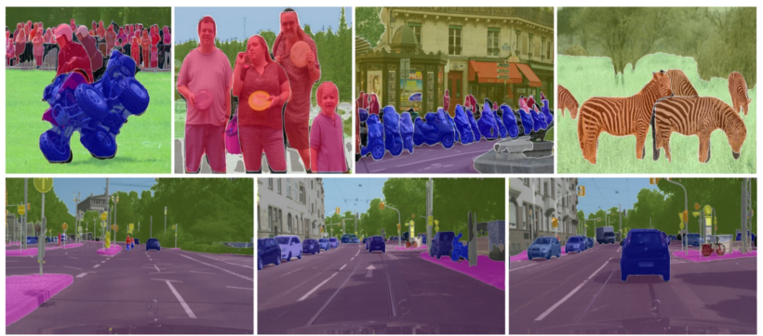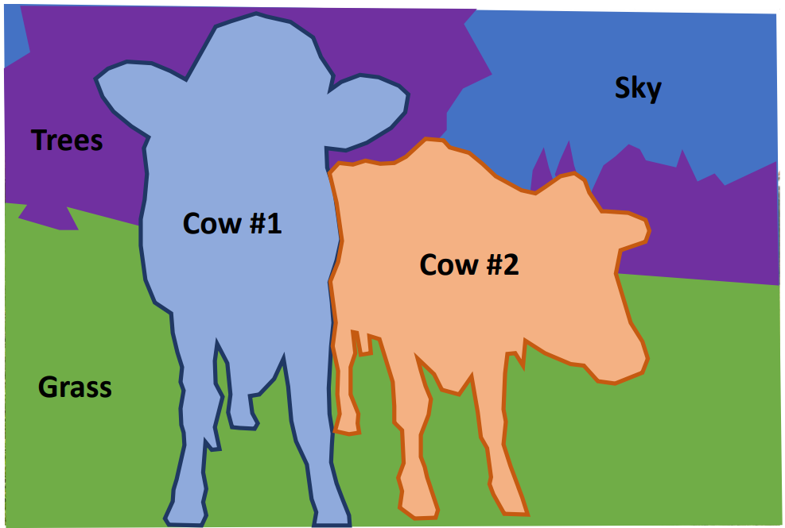Whilst instance segmentation only separates individual things (not stuff), and semantic segmentation identifies both things and stuff but can’t separate individual instances, **panoptic segmentation** labels all pixels in the image (both things and stuff) whilst separating all thing categories into individual instances.

### Beyond Instance Segmentation: Human Keypoints

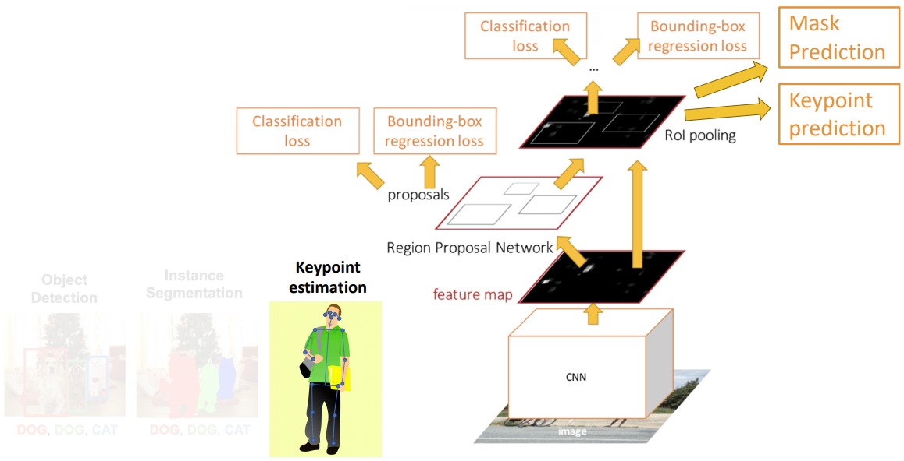Estimating the post of a human can be done by predicting the location of a set of keypoints, e.g. 17 keypoints (nose, left/right eye, left/right ear, left/right shoulder, left/right elbow, left/right wrist, left/right hip, left/right knee, left/right ankle). This can be done by adding yet another head to the Faster/Mask R-CNN network that performs keypoint prediction on each of the region image features.

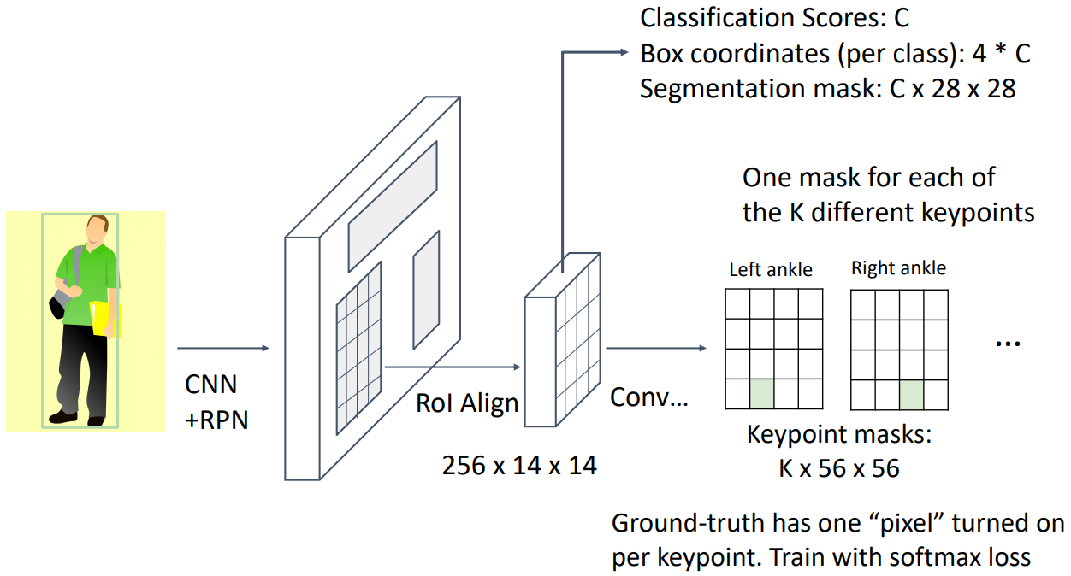The head is responsible for predicting one mask for each of the $K$ different keypoints (e.g. 17 keypoints), where the ground truth masks has one pixel turned on per keypoint. This head is trained with softmax loss.

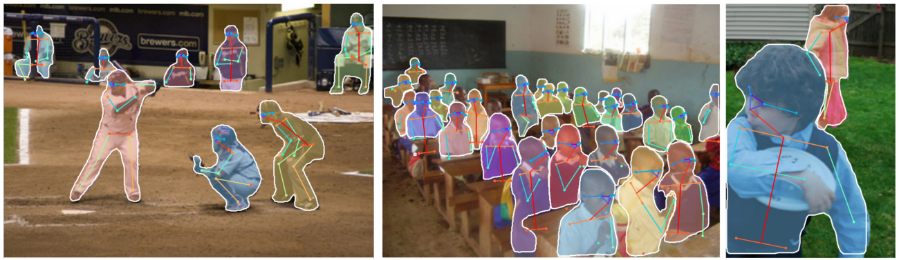Therefore, it is possible to keep adding additional per-region heads to make parallel predictions per-region. Below is an example of joint instance segmentation and human pose estimation:

### Beyond Instance Segmentation: Dense Captioning

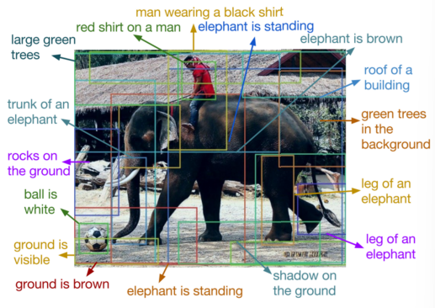By adding a caption prediction head (e.g. LSTM) we can also predict an image caption per-region.

### Beyond Instance Segmentation: 3D Mesh Prediction

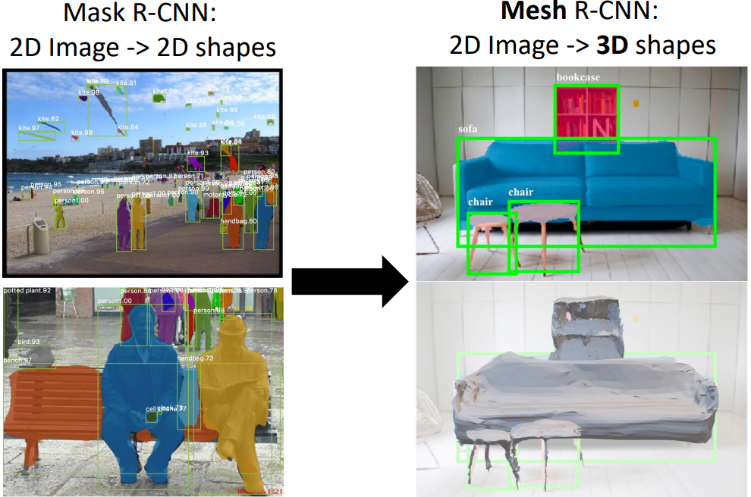By adding a 3D mesh prediction head [e.g. in Mesh R-CNN (2019)] we can also predict 3D shapes from a single 2D image.

# Lecture 16 – Recurrent Networks

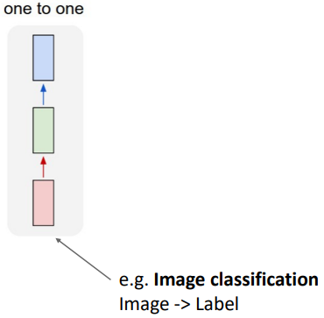One limitation of vanilla neural networks (e.g. MLPs and CNNs) is that their API is too constrained: they only accept a fixed-sized vector as input (e.g. an image) to produce a fixed-sized vector as output (e.g. probabilities of different classes), using a fixed number of computational steps (e.g. the number of layers in the model). I.e. there are essentially “one to one”.

Recurrent neural networks (RNNs) allow us to operate over *sequences* of vectors. That can be sequences in the input, or the output, or both:

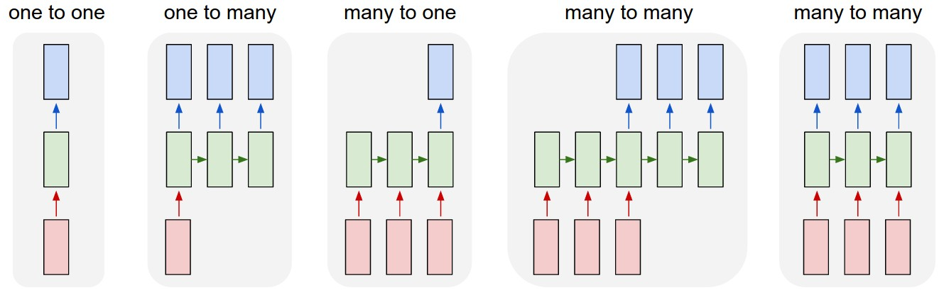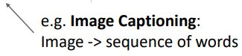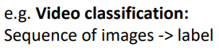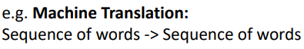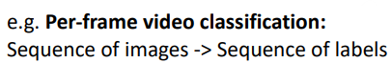

## Sequential Processing of Non-Sequential Data

Before we look at how RNNs work, it is important to note that they can be used even if your inputs/outputs are fixed vectors (i.e. not sequences), it is still possible to process them in a sequential manner.

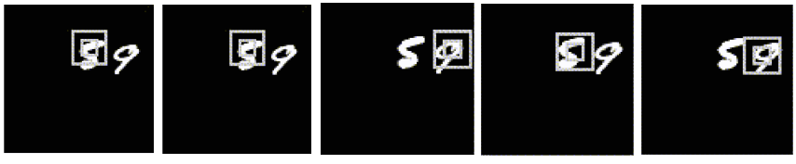As an example, Ba et al. (2014) trained an RNN to read multiple digits, and the network learned to select which regions of the image to *glimpse* in order to make its classification (example given below).

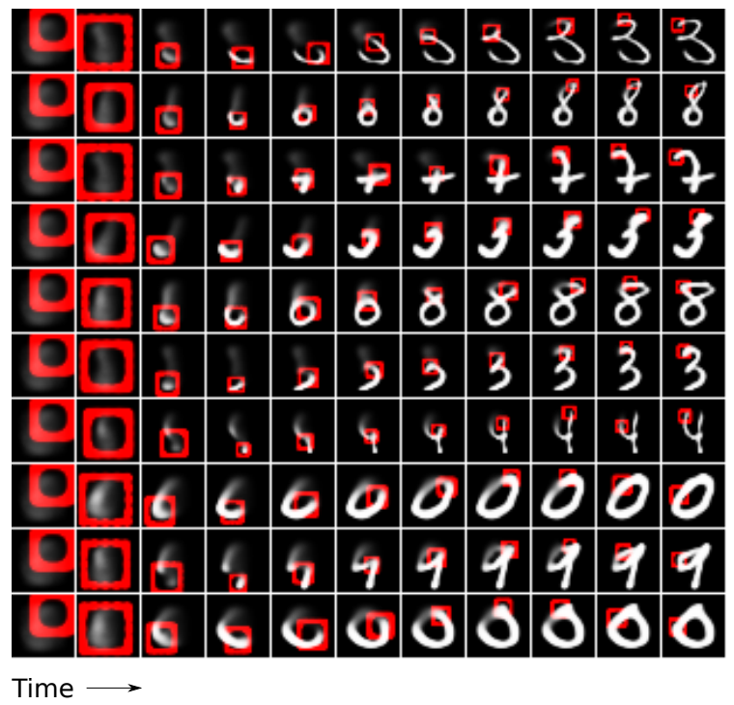As another example, Gregor et al. (2015) trained an RNN to generate images of digits by sequentially adding colour to a canvas (example below).

## Recurrent Neural Networks (RNNs)

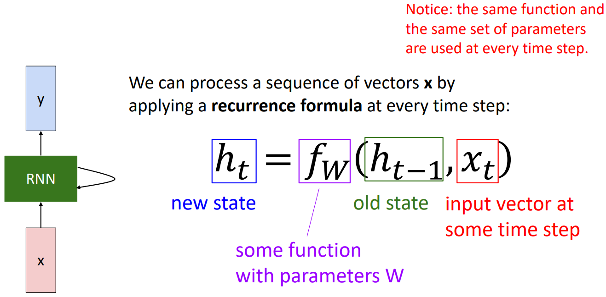The basic idea of RNNs is that they have an “internal state” that is updated as the input sequence is processed. The internal state at time $t$ is a function of the old internal state at time $t-1$ and the input vector at time $t$, that is:

Note: The function $f$ with weights $W$ is the same at every time step.

### Vanilla RNNs

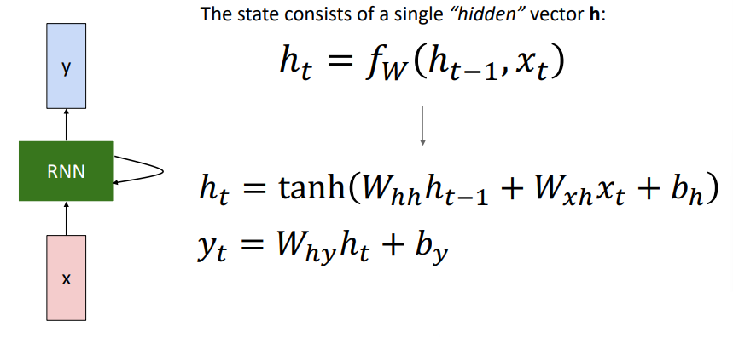The simplest RNN, with a single hidden state vector $h_{t}$ that exists at every time step $t$, is sometimes called a vanilla RNN or an Elman RNN (after Prof. Jeffrey Elman).

#### Computational Graph

We can visualise what the vanilla RNN is doing using a computational graph.

* + - 1. 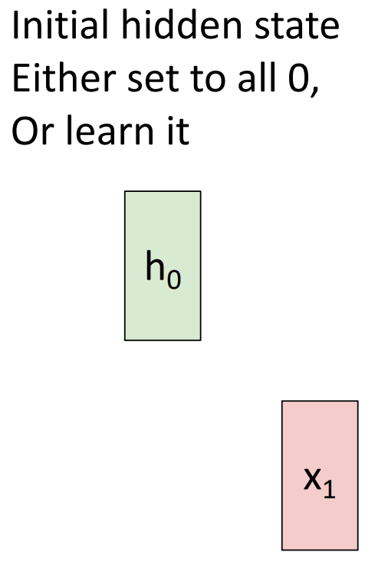We can either initialise the hidden state $h_{0}$ to all zeros, or we can learn it:
      2. 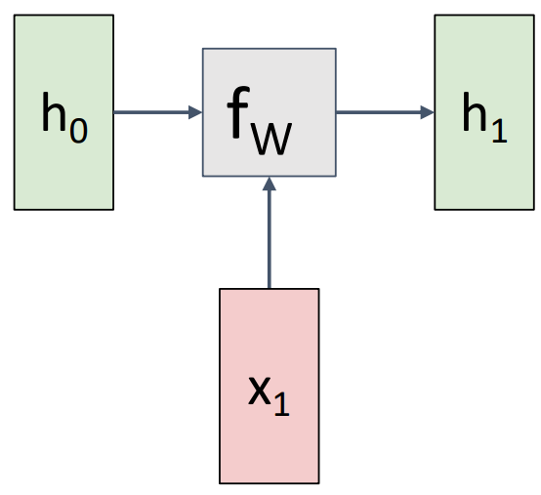Given the hidden state $h_{0}$ and input vector $x_{1}$, we can feed them to the recurrence relation $f_{W}$:
      3. 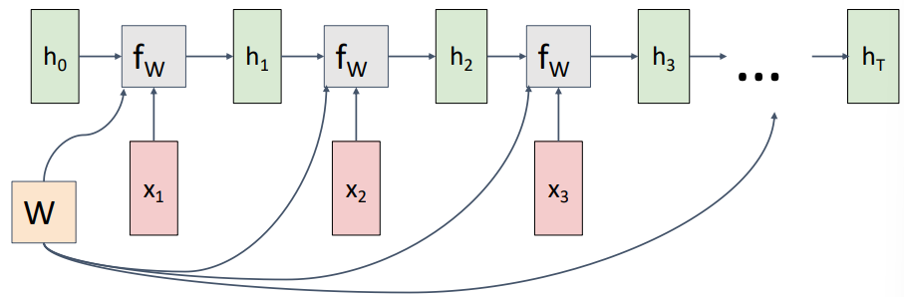Repeat this for all input vectors in the sequence, **reusing the same weight matrix $W$ at every time step**:
      4. 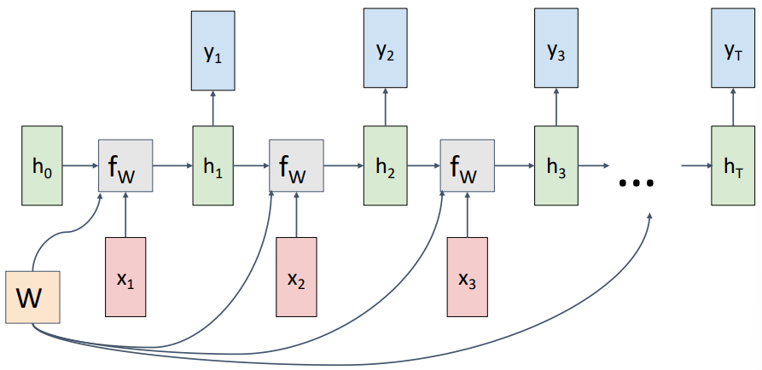Get the output $y$ at whatever time steps we want at. For example, a many-to-many network may look like:
      5. 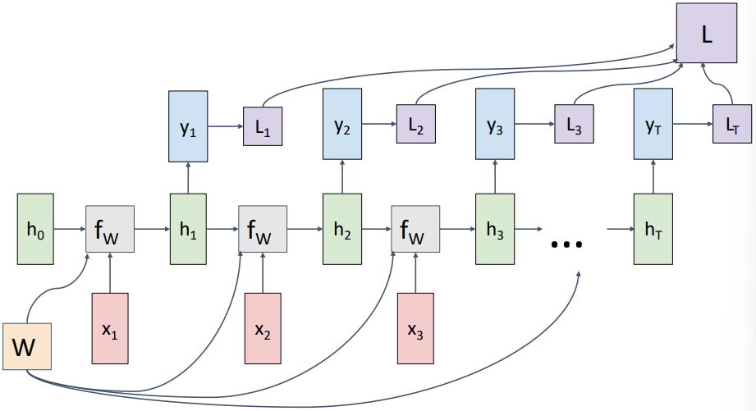Compute the loss at each output, then sum together to get a final loss:

#### Sequence to Sequence (seq2seq) RNNs

Whilst the many-to-many RNN shown in the computational graph example above has a sequence input and gives a sequence output, it is not suitable for all such applications due to:

1. The output sequence starts before the input sequence has finished (i.e. not all of the available information has been processed before predictions are made)
2. Each time step has both an input and an output, therefore the input and output sequences are equal length

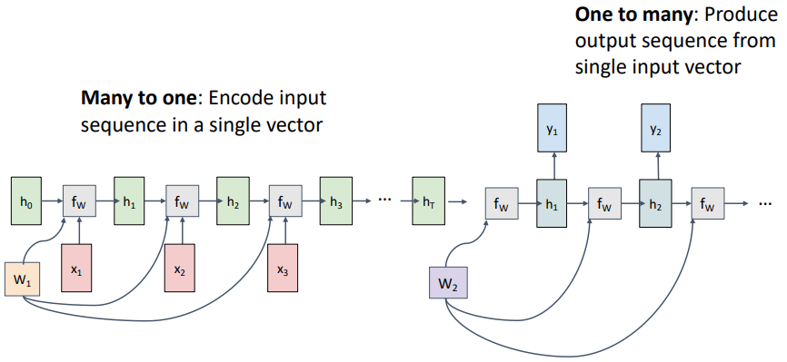For applications such as machine translation (e.g. from English to French) we want a sequence to sequence network without the above limitations. **Seq2seq RNNs** serve this purpose and are effectively a many-to-one RNN (the “encoder”) followed by a one-to-many RNN (the “decoder”), each with their own weight matrices $W_{1}$ and $W_{2}$:

#### Example: Language Modelling

We’ll call the problem of predicting the next character in a sequence based on previous input characters “language modelling”.

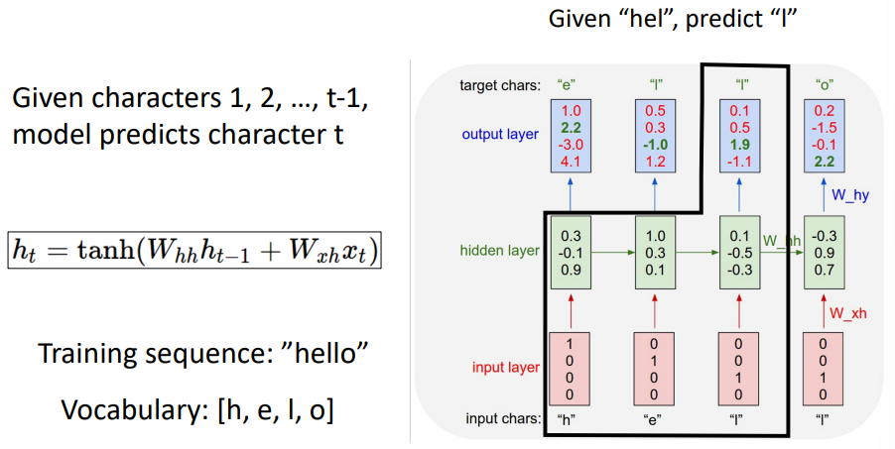**During training:** We need to define our vocabulary as some fixed size, in the example below we use $\left[h,e,l,o\right]$. After entering each input layer and calculating the hidden state using the input and the previous hidden state, we compare the output with the target character:

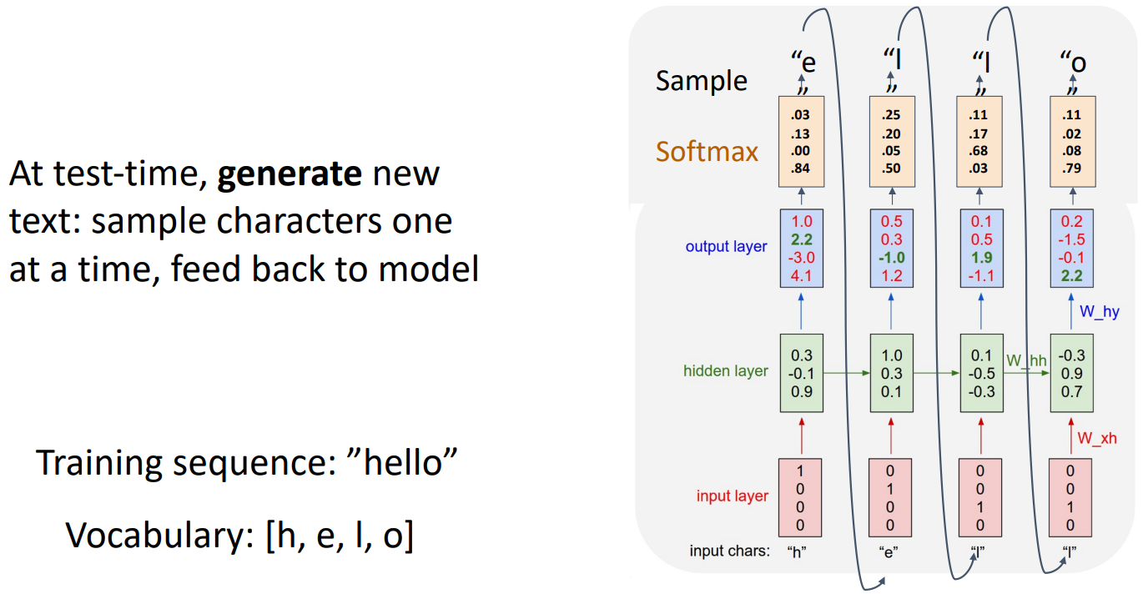**At test-time:** To generate new text in the same style as the training text, we give an initial “seed” token (e.g. “h” below) to get the first output and then feed each output character back to the model to get the following character.

Note: The input vectors are one-hot-encoded vectors, so their matrix multiplication with the weight matrix simply extracts a column from the weight matrix. In practice it is more efficient to do this extraction in a separate **embedding layer** before the hidden layer.

Andrej Karpathy minimal character-level RNN language model in numpy: <https://gist.github.com/karpathy/d4dee566867f8291f086>

### Training RNNs: Backpropagation Through Time

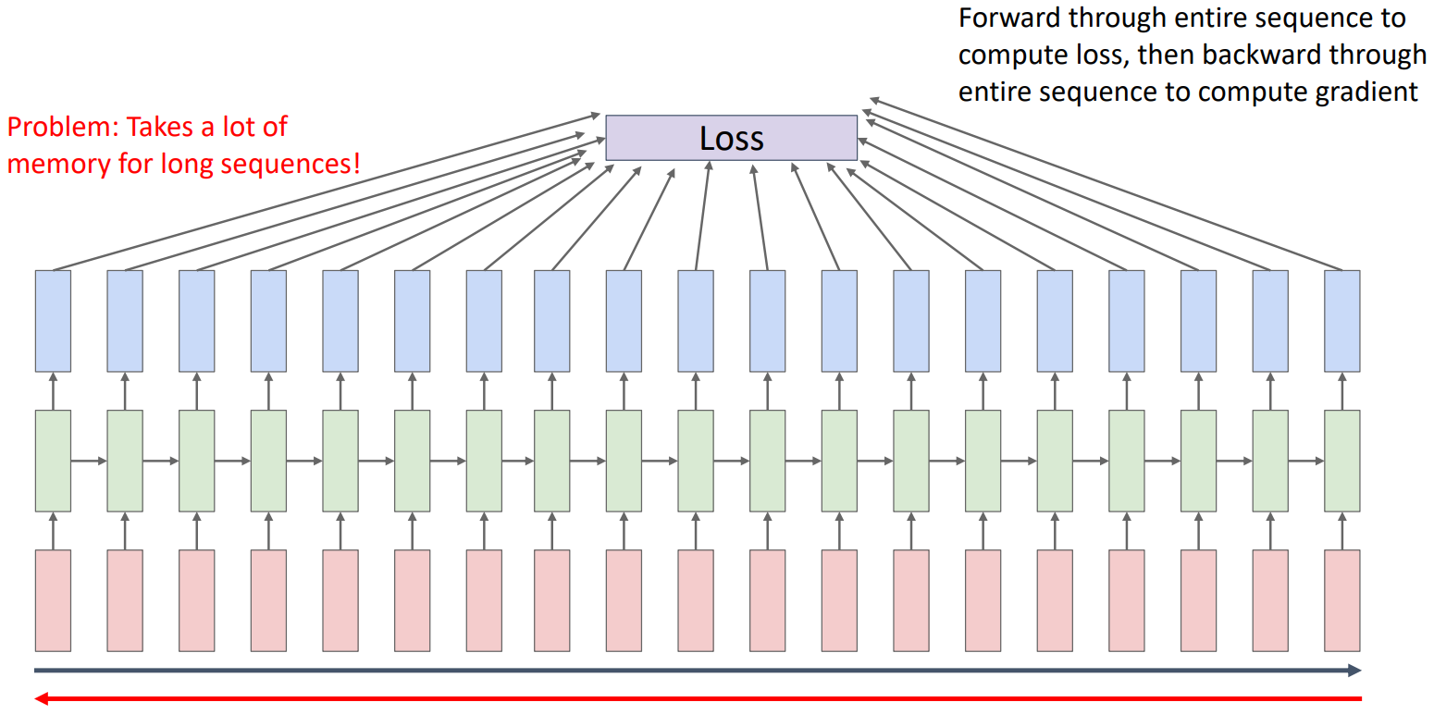Recall from the RNN computational graph example, we calculate a loss per timestep which is then summed to give the total loss. To train an RNN we then need to backpropagate this total loss “through time”.

Problem: This takes a lot of memory for long sequences.

Instead, we can use truncated backpropagation through time.

#### Truncated Backpropagation Through Time

This is an approximate backpropagation algorithm that uses some subset of the sequence to compute a forward and backward pass, before carrying the hidden state on to continue the forward pass over the following subset, whilst only backpropagating over each individual subset:

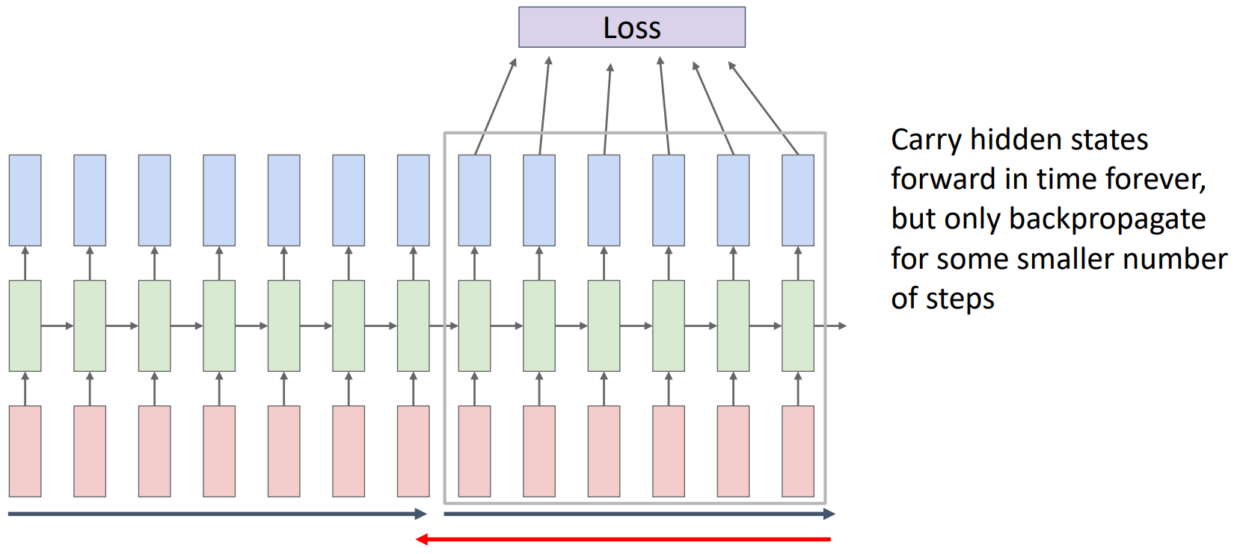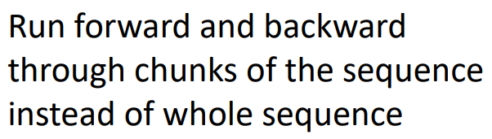

#### Vanilla RNN Gradient Flow

Take a single vanilla RNN “cell”, with the hidden state $h_{t}$ given by:

Problems:

* Tanh activation function kills gradients when saturated
* Backpropagating from $h_{t}$ to $h_{t-1}$ involves a multiplication by $W_{hh}^{T}$
  + Therefore, computing the gradient of $h_{0}$ involves many factors of $W_{hh}^{T}$
    - If the largest singular value is $>1$: exploding gradients
      * 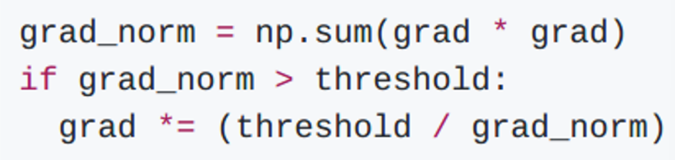Solution: Gadient clipping (scale the gradient if its norm is too big)

Not ideal, no longer computing the correct gradients.

* + - If the largest singular value is $<1$: vanishing gradients
      * Solution: Use an LSTM instead.

Therefore, whilst vanilla RNNs are simple, they don’t work very well and LSTMs or GRUs are used instead.

### RNN Image Captioning

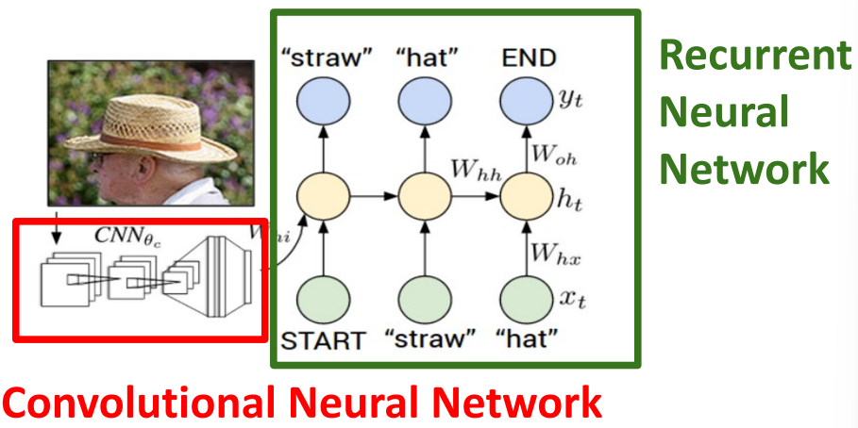One way that image captioning can be achieved is by attaching an RNN head to a CNN.

The basic steps are as follows:

1. Utilise transfer learning: Take a CNN that has been trained on ImageNet, then remove the classification fully connected layer (i.e. FC-1000).
2. Because the sequence is finite length, we usually indicate its beginning by setting the first input to the START token and we don’t stop predictions until the END token is output.
3. Where previously in the vanilla RNN we had two inputs at each timestep of the RNN (i.e. $W_{hh}h_{t-1}$ and $W_{xh}x_{t}$), here we will add a third input ($W_{ih}v$) which includes the image features $v$ from the CNN.
4. 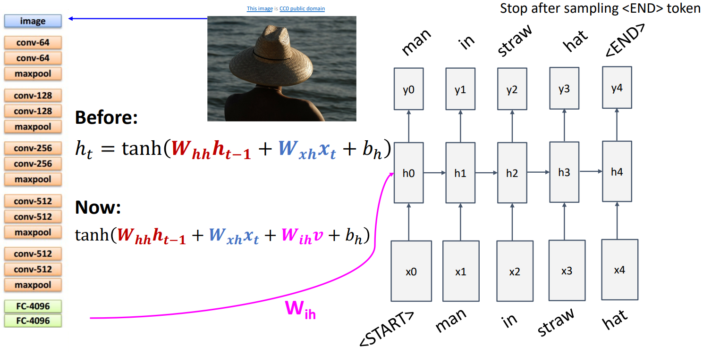From there, things proceed similarly to the language modelling example.

### Long Short Term Memory (LSTM, 1997)

LSTM networks are a type of RNN designed to address the limitations of standard RNNs in handling long sequences and vanishing gradients.

Instead of keeping a single hidden state at every time step, LSTM networks keep two:

* Cell state $c_{t}$
* Hidden state $h_{t}$

Then at every time step, we compute four “gates”:

* Input gate $i_{t}$ (whether to write to cell)
* Forget gate $f_{t}$ (whether to erase cell)
* Output gate $o_{t}$ (how much to reveal cell)
* “Gate?” gate $g_{t}$ (how much to write to cell)

Which are used to update the cell and hidden states.

#### LSTM Gradient Flow

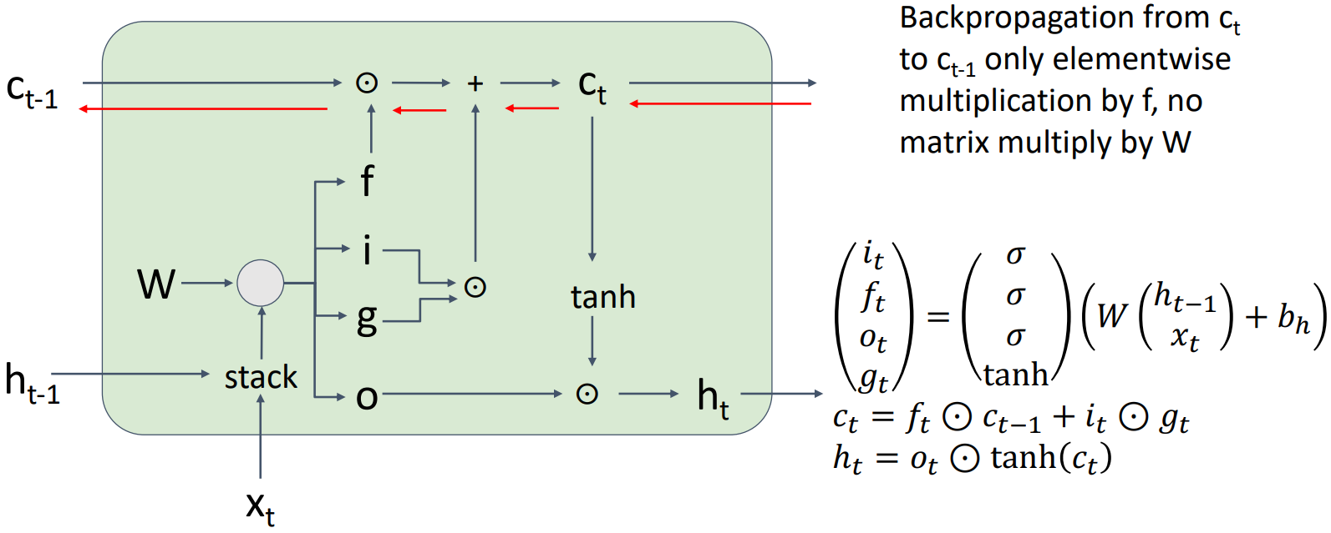Gradients can flow through an LSTM “cell” without the two problems seen in the gradient flow of a vanilla RNN “cell” thanks to the cell state, which involves no matrix multiplication by the weights $W$ and no activation functions. Therefore, there is always a non-exploded/non-vanished source of gradient information along the LSTM network.

This is similar in a sense to how [ResNets](#_Residual_Networks_(Winner) have residual connections which allow training of significantly deeper convolutional networks.

### Multilayer RNNs

We have seen with MLPs and CNNs that using more layers often leads to better models.

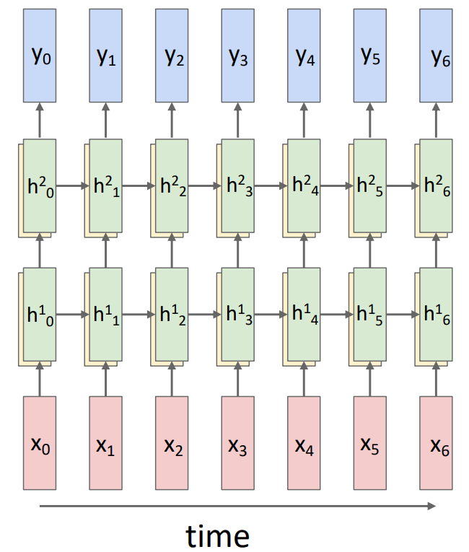A multilayer RNN can be constructed by simply passing the hidden states from one RNN as inputs to another RNN. The computational graph for a two layer RNN looks like:

Whilst the general form for the RNN and LSTM equations for multilayer networks are given by:

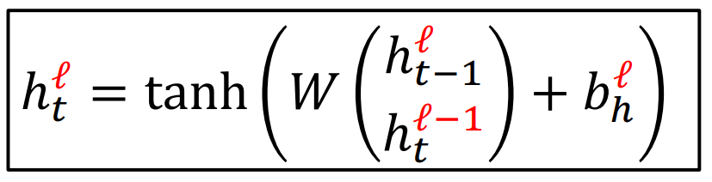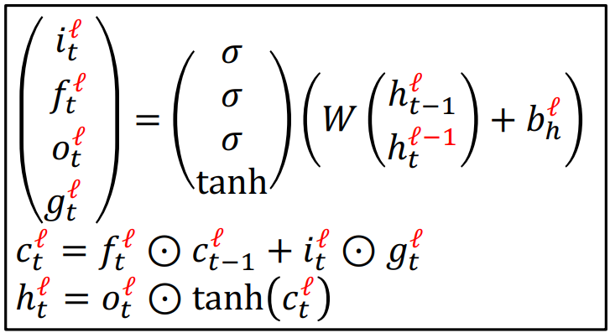

RNN:

LSTM:

In practice, you will likely see improvements up to 3-5 layers in RNNs however, it is not common to have very deep networks like with MLPs and CNNs.

### Gated Recurrent Unit (GRU, 2014)

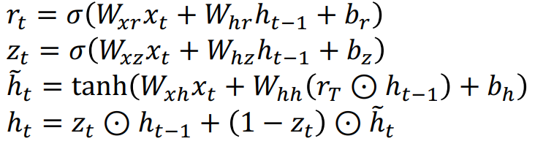Effectively a simplified version of LSTM that still uses additive connections to improve the gradient flow. They combine the input and forget gates into a single update gate, reducing the number of parameters and making the model less computationally expensive to run.

# Lecture 17 – Attention

[]